Standard Operating Procedure

Sodium Azide and Organic Azides

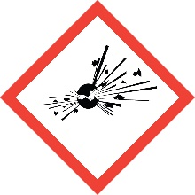
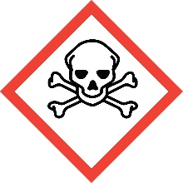
Overview
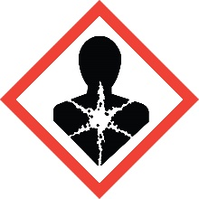
As an anion, azide has a similar toxicity to cyanide, and exposure via all routes can easily become fatal. It is readily absorbed through skin. Also like cyanide, reaction of azide ion with acid produces a toxic gas that is easily inhaled, hydrazoic acid.
Organic azides are potentially explosive substances that can decompose under heat, light or pressure. The violence of this decomposition is dependent on structure (see Special Handling Considerations below)

Special Handling and Storage Concerns
Personal Protective Equipment
- Flame resistant lab coat.
- Nitrile gloves are adequate for possible incidental exposure. Silver Shield gloves under nitrile gloves are recommended if large splashes or other skin contact risk is possible due to scale or procedure, or if there is particular concern about skin permeability.
- ANSI Z87.1-compliant safety goggles. Safety goggles and a face shield if a splash hazard is present.
Special Storage Requirements
Sodium azide is Incompatible with: Chlorinated solvent, Brønsted acids, carbon disulfide, and heavy metals.
Organic azides should be stored at or below -18 °C and away from light. Do not use metal containers or lids.
Engineering Controls
Fume Hood: All azides should be handled in a fume hood. Keep the fume hood sash at the lowest level possible while working, and closed when the hood is not in active use.
Blast Shield: The use of a portable blast shield inside the fume hood is highly recommended.
Special Handling Considerations
Contact of alkali (sodium, etc.) salts with all metals should be avoided. Do not use halogenated solvents, as the formation of explosive azidomethane compounds can occur.
For organic azides, violent decomposition reactions occur for compounds having the ratio of atoms (C+O)/N <3. Avoid isolating and storing these compounds. Do not scale up the synthesis of any organic azide unless its stability is well-characterized.
The following operations can cause the violent decomposition of azides and should be avoided:
- Heating during reaction or workup
- Distillation or sublimation
- Grinding, scratching or other sources of friction
- Contact with metal (spatulas, containers, plumbing, etc.)
Purification should rely on extraction and precipitation only, if possible.
Decontamination
Wearing proper PPE, wipe up any residue with absorbent pads and clean the area with soap and water. Dispose of the contaminated disposables as Extremely Hazardous Waste, as described below.

Waste Management
Azide waste is considered Extremely Hazardous Waste and should be handled as described in the UC Santa Barbara Chemical Hygiene Plan. This includes disposing of the emptied original container as hazardous waste through EH&S.
Do not mix azide waste streams with those containing acids, acid salts, chlorinated solvents or heavy metals! Keep the waste at pH > 9 at all times. Segregate azide waste from all other waste, and have the waste removed from the lab as quickly as possible.
Do not use waste containers or lids made of metal.

First Aid and Emergencies
Spill
Treat all spills of these materials as a major spill. Do not attempt to clean up the spill yourself. Notify others in the area of the spill, including your supervisor. Evacuate the area and call 911. Remain on-site at a safe distance to provide detailed response to first responders. Report any exposures to EH&S.
Fire
Standard firefighting measures apply.
Personnel Exposure
Skin or eye contact: Remove contaminated attire. Wash skin with soap and water. Flush area with water for 15 minutes. Get medical attention immediately.
Inhalation: Move person to fresh air. Get medical attention immediately.
Ingestion: Rinse mouth with water. Get medical attention immediately.

Laboratory Specific Information
Prior Approval Required
☐ NO
☐ YES (describe):

Designated Area
☐ Entire Laboratory Area
☐ Other (describe):

Experimental Conditions of Use
Temperature Range:

Pressure Range:

Scale Range:

Other Relevant Details:

Additional Resources
- Organic Azides Synthesis and Applications Brase, S., Banert, K. Editors, John Wiley and Sons Ltd., 2010
- Brase, S.; Gil, C.; Knepper, K.; Zimmerman, V. Angew. Chem. Int. Ed. 2005, 44, 5188-5240. And all references therein.
- CDC: Facts about Sodium Azide

