Standard Operating Procedure

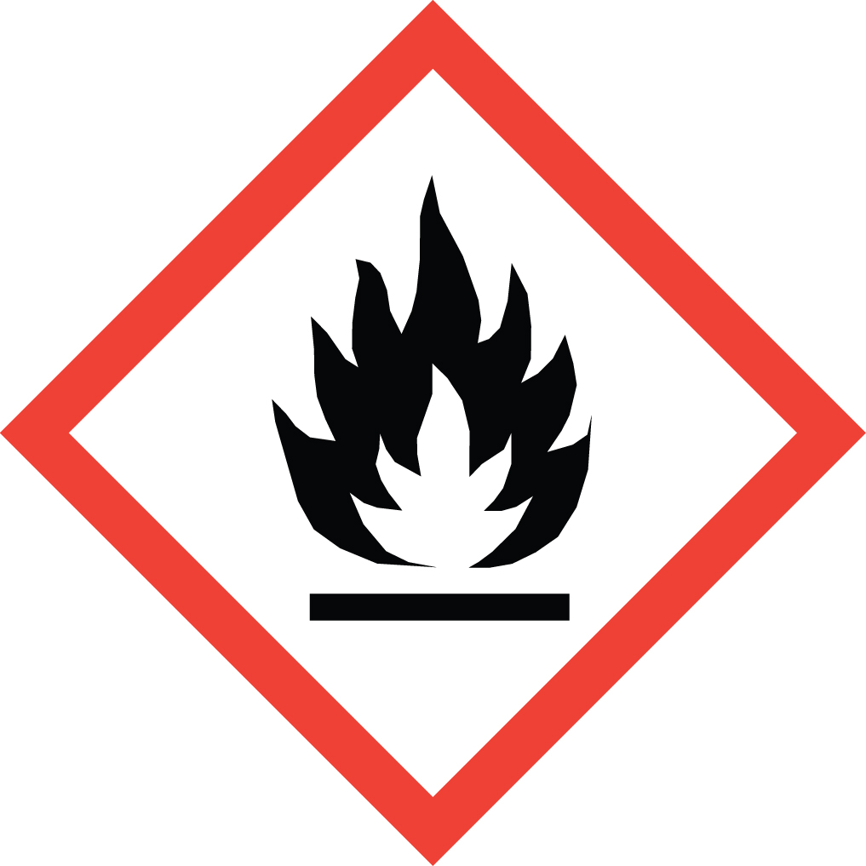 Benzene

Overview
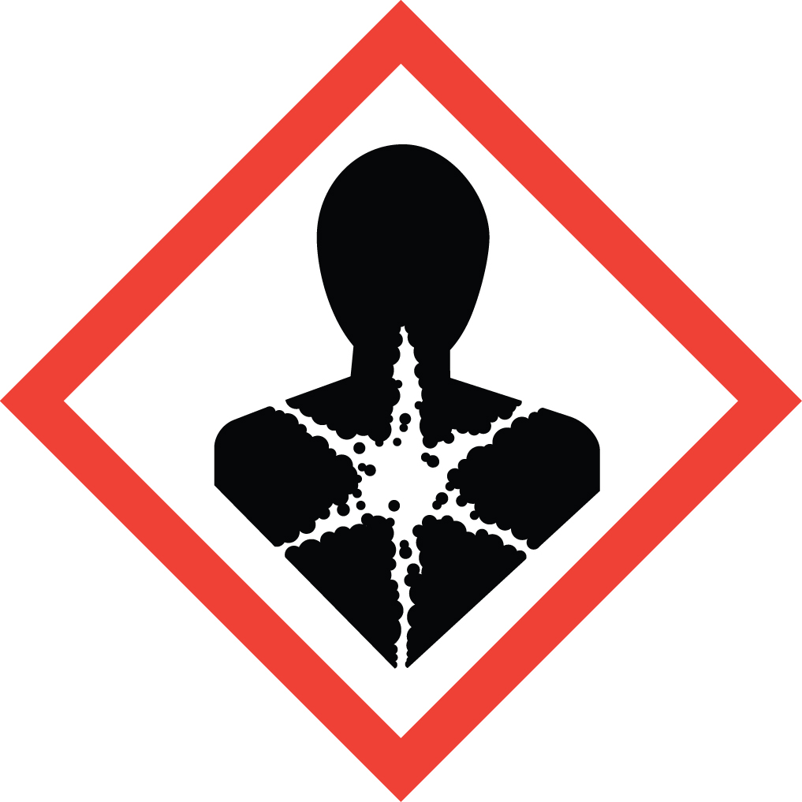Benzene is a known human carcinogen with its own Cal/OSHA regulatory standard. Additional chronic effects include specific target organ toxicity towards blood and bone marrow and germ cell mutagenicity. Acute effects include breathlessness, irritability, euphoria, dizziness, headaches, dizziness, nausea, and irritation of the skin, eyes, nose and respiratory tract. Severe exposures may lead to convulsions and loss of consciousness. Although benzene has a distinct odor, it is only detectable at levels that exceed the Cal/OSHA Permissible Exposure Limit (PEL) of 1 ppm (8 hr. time weighted average). Benzene is considered a Particularly Hazardous Substance (PHS).

Special Handling and Storage Concerns
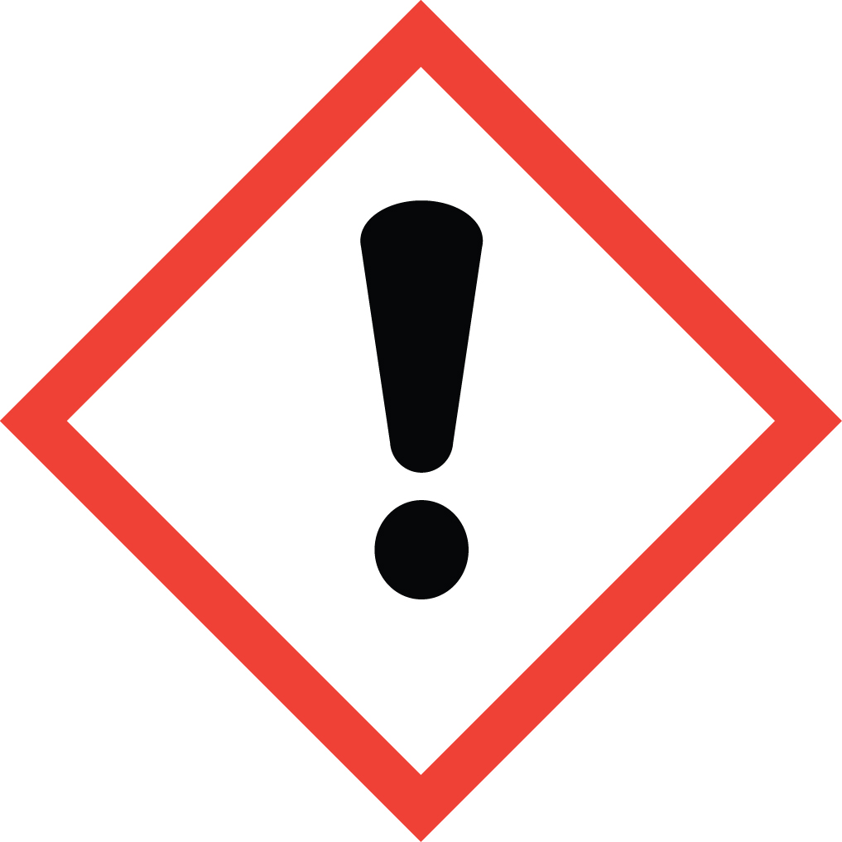Personal Protective Equipment
- Flame Resistant Lab Coat.
- Fluorinated Rubber gloves (a.k.a. Viton) are recommended for all aromatic solvents.
- ANSI Z87.1-compliant safety glasses. Safety goggles if a large splash hazard is present.
Special Storage Requirements
Store benzene away from other non-PHS chemicals, in a flammable storage cabinet with self-closing hinges. Each container must include all applicable hazard warnings. It is recommended that the appropriate GHS pictograms also be on the container. The storage area must be within a PHS designated area, and all containers stored in secondary containment.
Engineering Controls
Fume Hood: Benzene must be handled in a fume hood. If this is not possible due to scale or equipment, contact EH&S to determine alternate ventilation/isolation approaches or respiratory protection needs.
Special Handling Considerations
Only use benzene in a PHS in a designated area. This designated area may be the entire laboratory, or only a portion of it.
Decontamination
Standard decontamination procedures apply. Use great caution in avoiding exposure.

Waste Management
Standard waste disposal procedures apply.

First Aid and Emergencies
Spill
Treat all spills of benzene as major spills. Do not attempt to clean up the spill yourself. Notify others in the area of the spill, including your supervisor. Evacuate the area and call 911. Remain on-site at a safe distance to provide detailed response to first responders. Report any exposures to EH&S.
Fire
Standard firefighting measures apply.
Personnel Exposure
Skin or eye contact: Remove contaminated attire. Flush affected area with water for 15 minutes. If symptoms persist, get medical attention.
Inhalation: Move person to fresh air. Consult a physician.
Ingestion: DO NOT induce vomiting. Rinse mouth with water. Consult a physician.

Laboratory Specific Information
Prior Approval Required
☐ NO
☐ YES (describe):

Designated Area (required for Particularly Hazardous Substances)
☐ Entire Laboratory Area
☐ Other (describe):

Experimental Conditions of Use
Temperature Range:

Pressure Range:

Scale Range:

Other Relevant Details:

