Standard Operating Procedure

Hydrogen Cyanide and Cyanide Salts

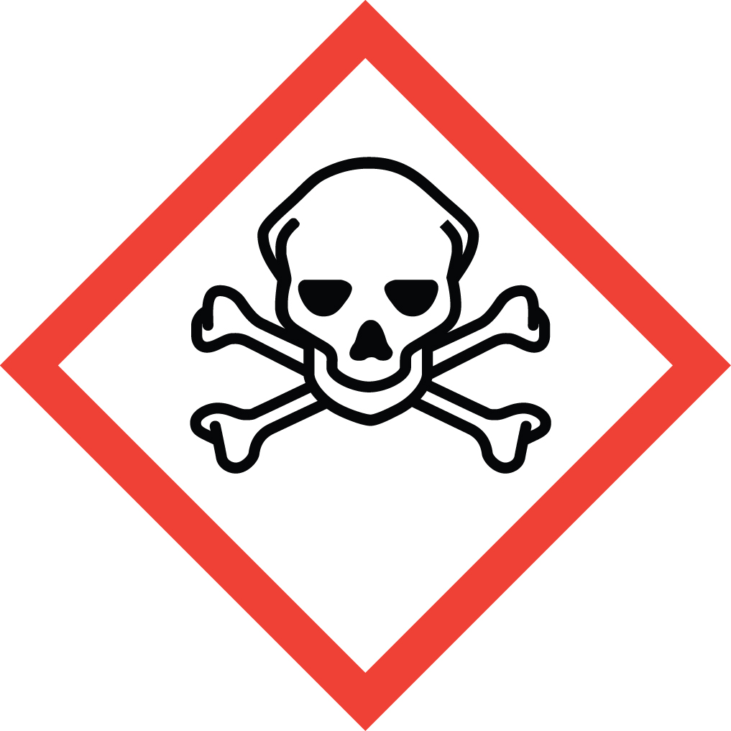Overview
Hydrogen cyanide and its salts are extremely toxic. Exposure to as little as 50-150 mg can cause immediate collapse and death.
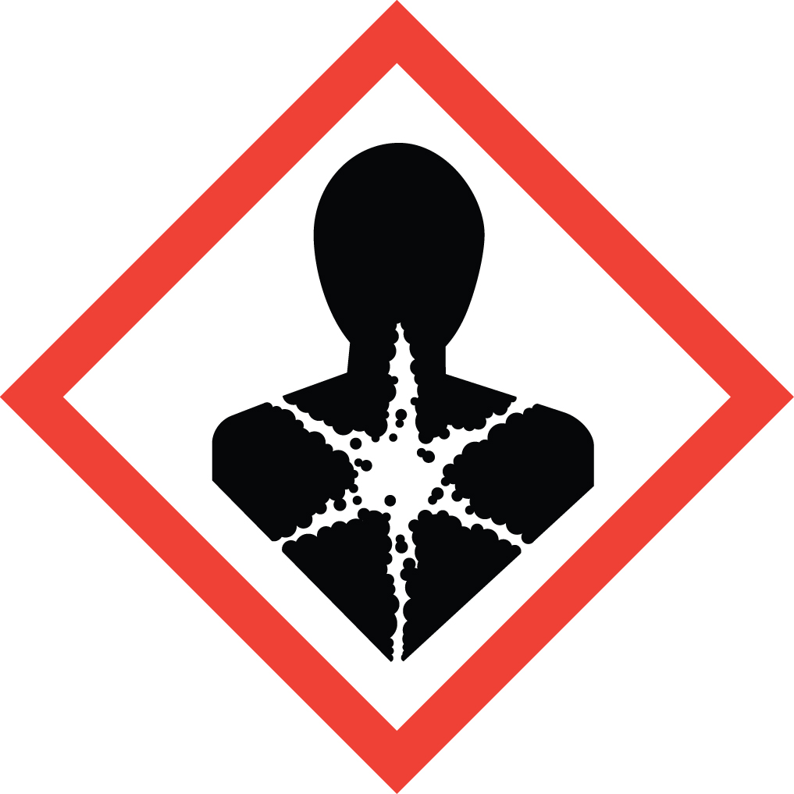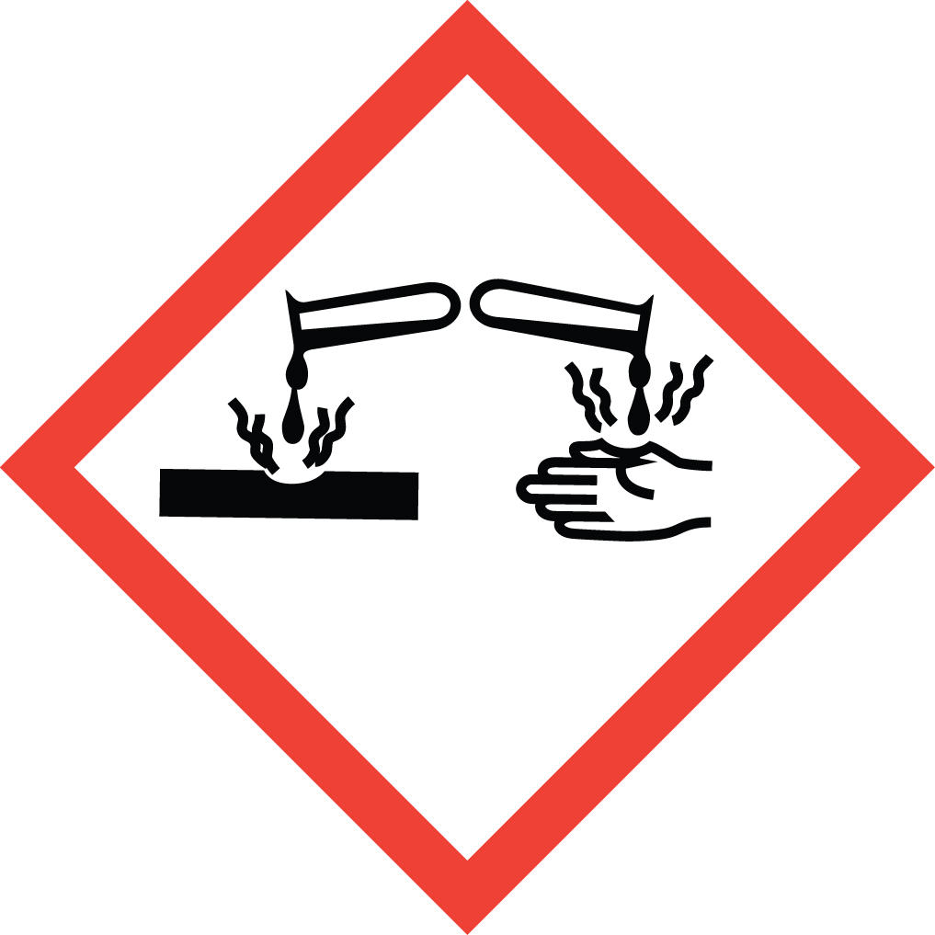Inhalation is a prominent route of exposure for HCN gas. All other routes of exposure are also fatal. Notably, aqueous solutions of HCN are readily absorbed through the skin and eyes, and absorption of as little as 50 mg can be fatal. Cyanide salts, such as sodium and potassium cyanide, are solids. However, they convert quickly to gaseous HCN when exposed to acid or moisture. Therefore, great care must be taken to absolutely avoid inhalation of vapors, as well as any aerosolized dust. Repeated low level exposure to cyanide can cause damage to the Thyroid.
Initial symptoms of cyanide exposure include weakness, headache, dizziness, rapid breathing, nausea and vomiting. If these symptoms are observed while in an area where cyanide is being handled, get medical attention immediately by calling 911.

Special Handling and Storage Concerns
Personal Protective Equipment
- Traditional white lab coat. Chemical resistant apron when working with large quantities.
- Nitrile gloves for cyanide salts. Viton or Butyl rubber for hydrogen cyanide.
- ANSI Z87.1-complinat safety goggles. Safety goggles and a face shield if a large splash hazard is present.
Special Storage Requirements
Cyanides are Particularly Hazardous Substances and should be stored and handled as such. Hydrogen cyanide containers should be protected from physical damage and stored in a ventilated area away from ignition sources and other materials. It should not be stored for extended periods (>90 days) due to explosion risk as a result of decomposition.
Cyanide salts should be stored in a cool, dry location, separated from acids and acid salts, strong oxidizers and carbon dioxide.
Engineering Controls
Use a fume hood or hard-ducted Class II B2 biosafety cabinet (BSC). If your protocol does not permit this, EH&S must be contacted to assess alternate ventilation options.
Special Handling Considerations
Cyanides are Particularly Hazardous Substances and should be stored and handled as such. Use only in a PHS designated area. Maintain awareness of the pH of any cyanide salt solutions, as an acidic pH will release the very toxic and flammable hydrogen cyanide gas.
Decontamination
Wearing proper PPE, wipe up any residue with absorbent pads and clean the area with soap and water. Dispose of the contaminated disposables as Extremely Hazardous Waste, as described below.

Waste Management
Cyanide waste is considered Extremely Hazardous Waste and should be handled as described in the UC Santa Barbara Chemical Hygiene Plan. This includes disposing of the emptied original container as hazardous waste through EH&S.
Do not mix cyanide waste streams with those containing acids, acid salts or oxidizers! Keep the waste at pH > 9 at all times.

First Aid and Emergencies
Spill
Treat all spills of these materials as a major spill. Do not attempt to clean up the spill yourself. Notify others in the area of the spill, including your supervisor. Evacuate the area and call 911. Remain on-site at a safe distance to provide detailed response to first responders. Report any exposures to EH&S.
Personnel Exposure
Skin or eye contact: Remove contaminated attire. Wash skin with soap and water. Flush area with water for 15 minutes. Get medical attention immediately.
Inhalation: Move person to fresh air. Get medical attention immediately.
Ingestion: Rinse mouth with water. Get medical attention immediately.

Laboratory Specific Information
Prior Approval Required
☐ NO
☐ YES (describe):

Designated Area
☐ Entire Laboratory Area
☐ Other (describe):

Experimental Conditions of Use
Temperature Range:

Pressure Range:

Scale Range:

Other Relevant Details:

