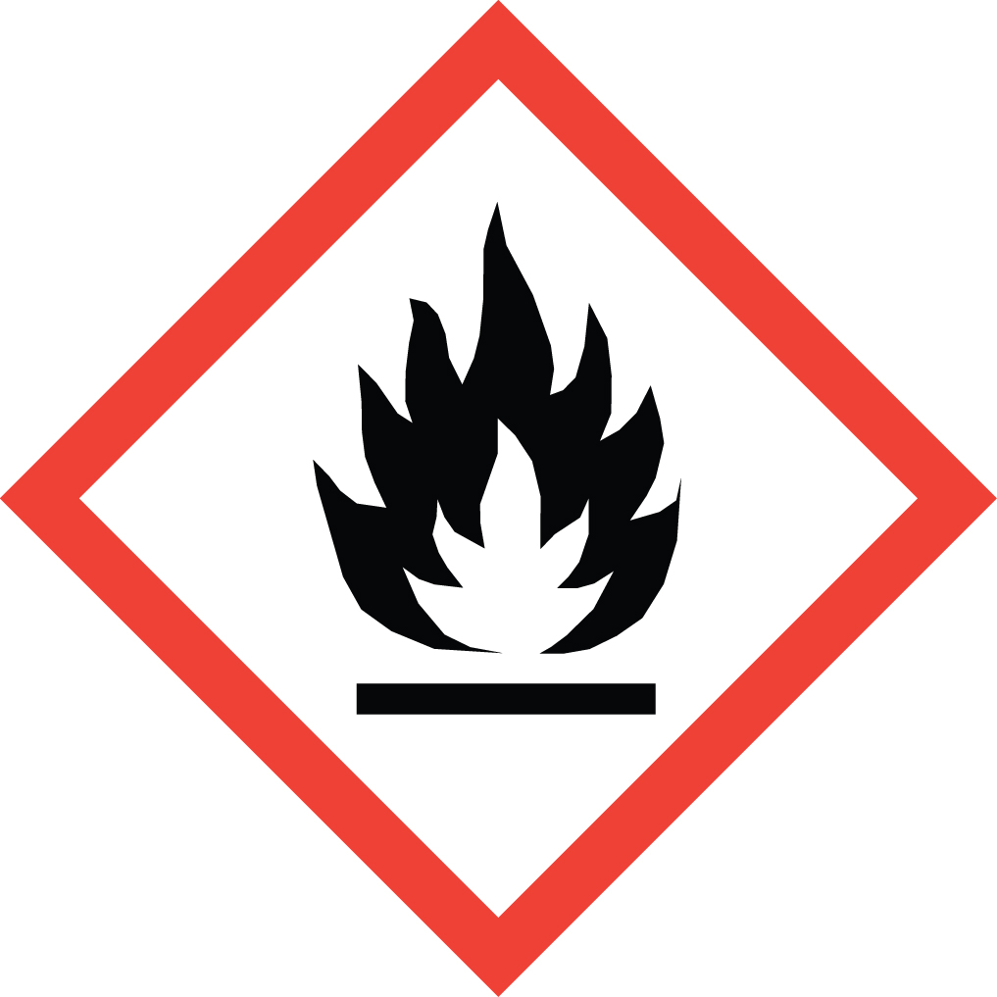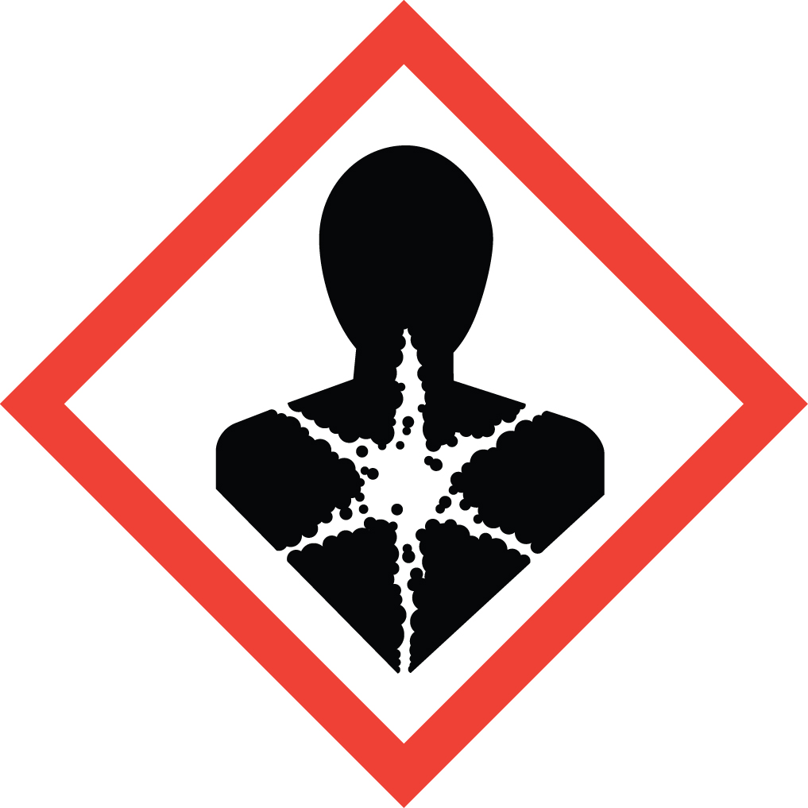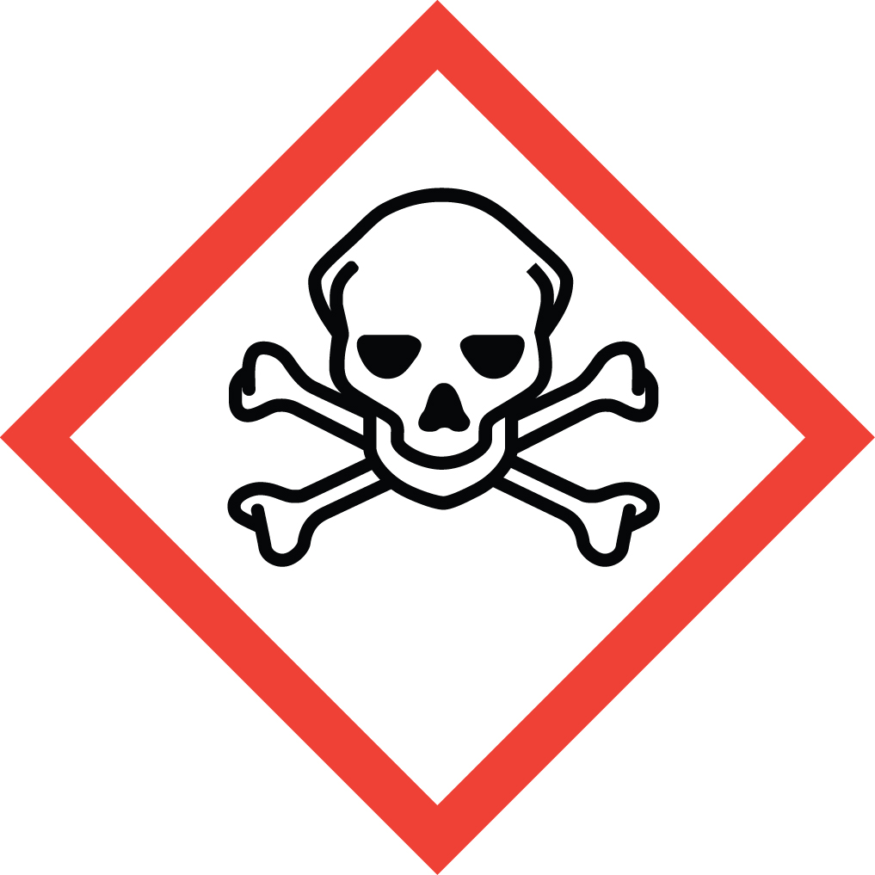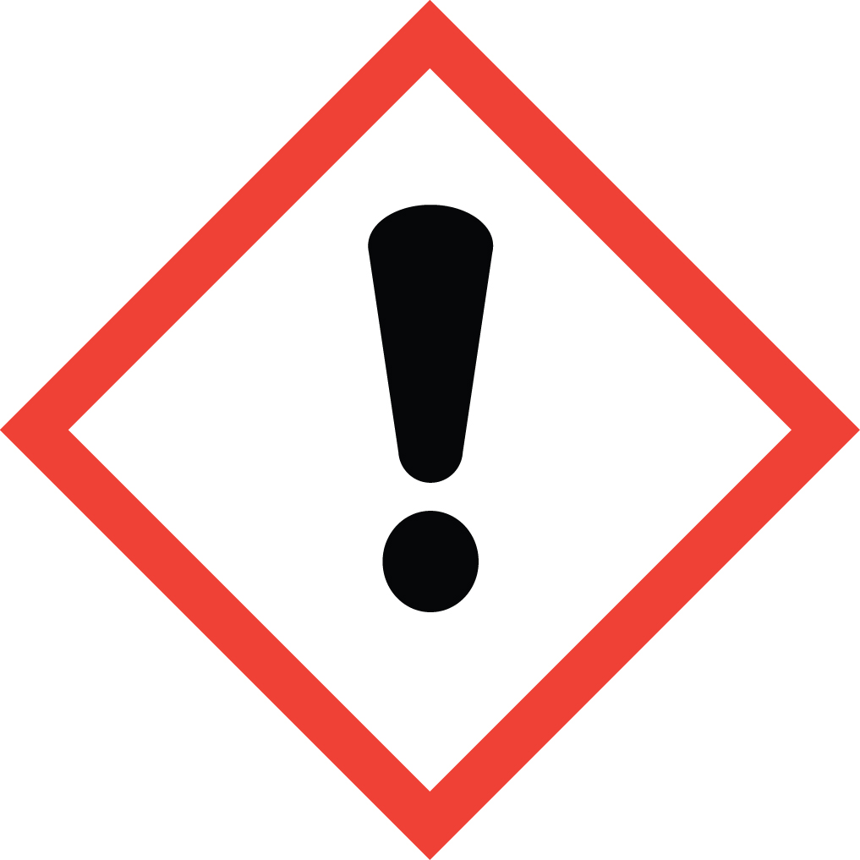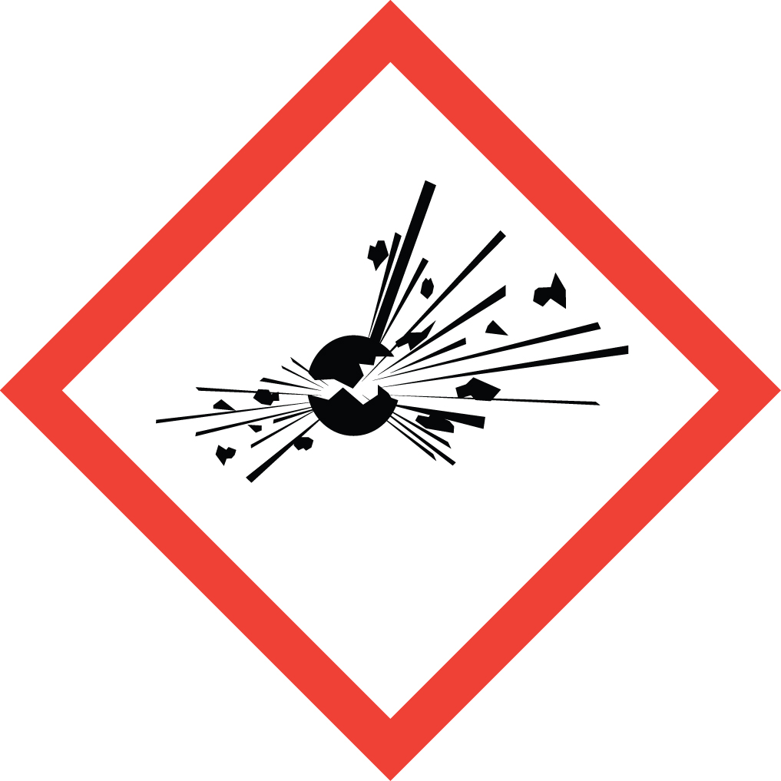 Standard Operating Procedure

Diazomethane

Overview
EXTREMELY TOXIC GAS! EXPLOSION HAZARD! Diazomethane vapor causes severe irritation of the skin, eyes, mucous membranes and lungs. Symptoms include pulmonary edema, which can be fatal. It is a strong sensitizer, so repeated or prolonged exposure can cause fever and asthma like symptoms at concentrations that previously caused no symptoms. These asthma like symptoms can also be fatal. Diazomethane is readily flammable and can explode easily. Explosion can be caused by contact with rough surfaces such as ground glass joints, etched or scratched flasks, and glass tubing that has not been fire-polished. Temperatures >100 °C, direct sunlight and strong artificial light may also cause explosions. Violent reactions may occur on exposure of diazomethane to alkali metals, including drying agents. Diazomethane is also a possible human carcinogen. Note that the OSHA Permissible Exposure Limit for diazomethane is 0.2 ppm TWA, in comparison to 10 ppm TWA for hydrogen cyanide.

Special Handling and Storage Concerns
Personal Protective Equipment
- Flame Resistant Lab Coat.
- Double glove with nitrile or neoprene gloves.
- ANSI Z87.1-compliant safety goggles and face shield.
Special Storage Requirements
Diazomethane should be used as soon as possible after preparation. Small amounts may be stored for a short time in a freezer in a tightly stoppered and parafilm-sealed bottle free of scratches, chips, cracks or ground glass joints. Do not add drying agent. Do not store below -145 °C.
Engineering Controls
Fume Hood: Diazomethane is a toxic gas and must absolutely be generated and handled in a fume hood.
Blast Shield: A portable blast shield or other form of shielding should be between the apparatus and the user. A fume hood sash is not an adequate shield for an explosion hazard of this magnitude.
Special Handling Considerations
Diazomethane is not sold commercially, as it is not safe to transport. However, there are a number of reagents available for its synthesis. It is generally isolated as an ethereal solution via one of a number of procedures. These procedures, and any subsequent operations with diazomethane, should be conducted in glassware specially designed for diazomethane (e.g. with Clear-Seal joints) or in carefully inspected glassware free from scratches, chips, cracks and ground glass joints.
Consider trimethylsilyldiazomethane as an alternative, as it is less explosive and commercially available. Its toxicity however is still very high.
Decontamination
Items that have been in contact with diazomethane should be left in a fume hood overnight to allow any traces to evaporate. Solutions that may contain diazomethane can be quenched with acetic acid as described in the WASTE MANAGEMENT section below.

Waste Management
Do not dispose of unreacted diazomethane. Quench solutions by adding acetic acid dropwise until the yellow color is gone and gas evolution ceases. The resulting mixture can then be disposed of in regular waste streams.

First Aid and Emergencies
Spill
Evacuate the building immediately: Leave the laboratory and close the door. Notify nearby personnel that they should leave the building. Pull the fire alarm. Remain in the building’s emergency assemble area and inform emergency responders of the situation when they arrive.
Fire
Do not attempt to fight a diazomethane fire. Leave the laboratory and close the door. Notify nearby personnel that they should leave the building. Pull the fire alarm. Remain in the building’s emergency assemble area and inform emergency responders of the situation when they arrive.
Personnel Exposure
Inhalation: Move person to fresh air. Call 911.
Skin and Eye contact: Flush with large quantities of water for 15 minutes. If symptoms persist, get medical attention as soon as possible.
When seeking medical attention, bring an SDS for trimethylsilyldiazomethane to inform healthcare workers of the hazards of diazomethane (SDS for diazomethane are not available as it is not sold commercially or transported).

Laboratory Specific Information
Prior Approval Required
☐ NO
☐ YES (describe):

Designated Area
☐ Entire Laboratory Area
☐ Other (describe):

Experimental Conditions of Use
Temperature Range:

Pressure Range:

Scale Range:

Other Relevant Details:

