Standard Operating Procedure

Formaldehyde, Formalin and Paraformaldehyde

Overview
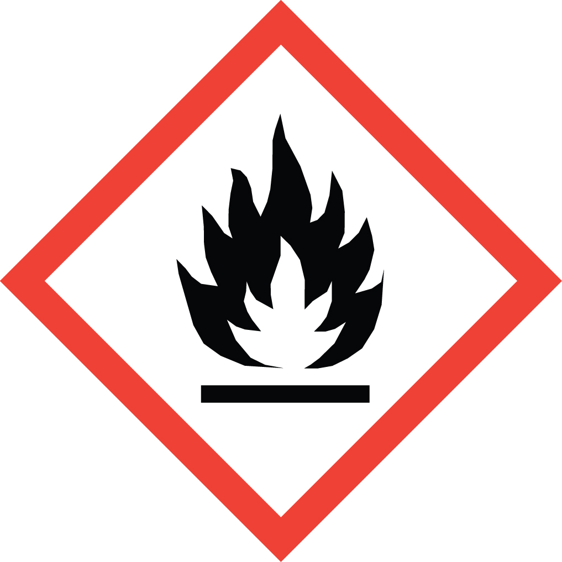Formaldehyde is a toxic, flammable gas known to cause cancer. It is also a sensitizer and produces eye irritation at concentrations ≥0.3 ppm. Above 25 ppm it can cause severe injury, including pulmonary edema and permanent clouding of the cornea.
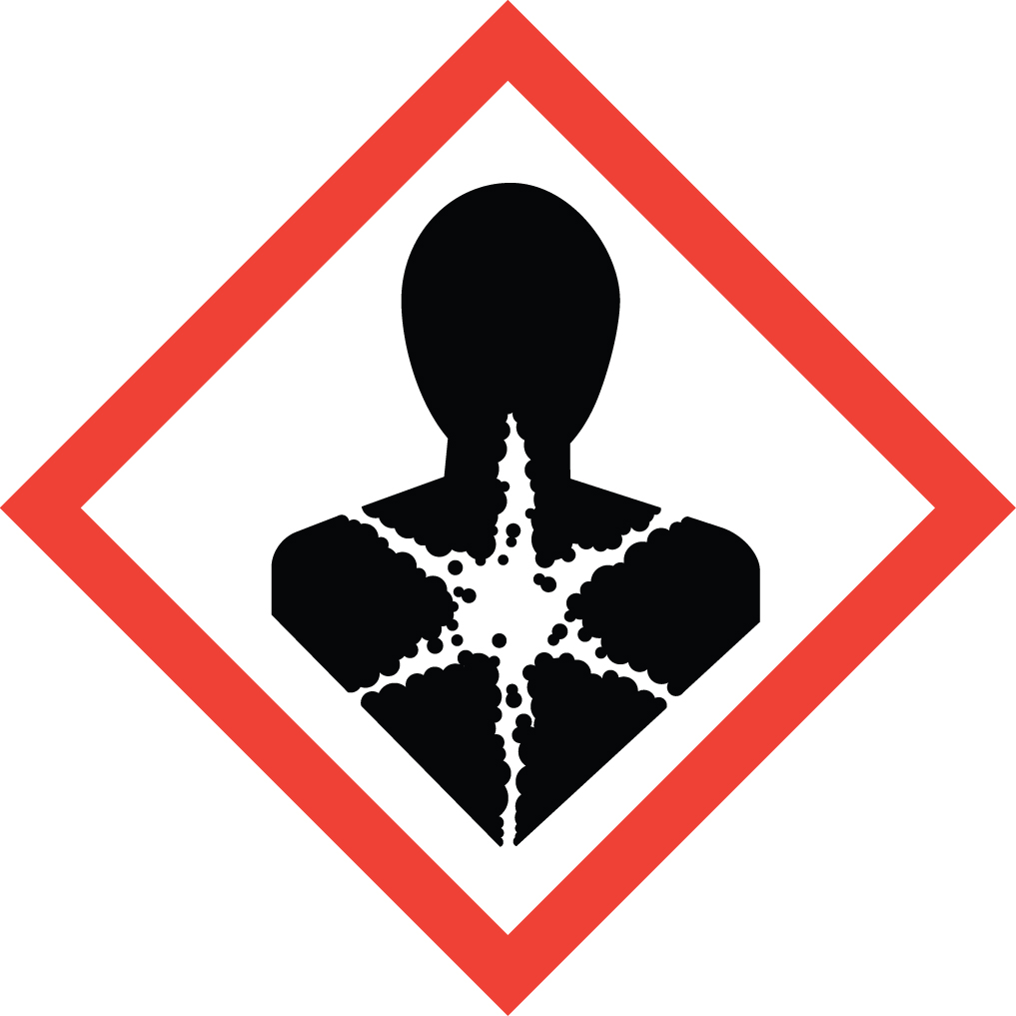Formalin is a solution of formaldehyde and methanol in water which is commonly used as a preservative for biological samples.
Paraformaldehyde is a white, crystalline solid resulting from the polymerization of formaldehyde. It can decompose to formaldehyde gas by dry heating and to formaldehyde solution by dissolving it in water in the presence of acid or heat.
Cal/OSHA regulations state that measured exposures above 0.5 ppm (inhalation) require that the researcher be monitored by EH&S.
Formaldehyde is classified as a Particularly Hazardous Substance (PHS).

Special Handling and Storage Concerns
Personal Protective Equipment
- Flame Resistant Lab Coat.
- Nitrile, neoprene, natural rubber or PVC gloves. Use medium or heavyweight gloves for concentrations >10%.
- ANSI Z87.1-compliant safety goggles. Goggles and face shield if a splash hazard is present. Safety glasses are not recommended due to potential damage to the eye.
Special Storage Requirements
Store in a PHS designated area within secondary containment. Flammable mixtures of formaldehyde should be stored in a flammable storage cabinet.
Engineering Controls
A fume must be used to keep exposure to formaldehyde as low as possible. If your protocol does not permit the handling of formaldehyde in a fume hood, EH&S must be contacted to: a) assess alternate ventilation options and b) initiate exposure monitoring to ensure that exposures are below the 0.5 ppm action level. Note: the odor threshold for formaldehyde is 0.8 ppm.
Special Handling Considerations
Wash thoroughly after handling. Minimize quantities as much as your protocol allows.
Decontamination
Decontaminate work space with 70-75% ethanol. Wash hands and arms with soap and water after finished. Contaminated items and gloves should be discarded as hazardous waste.

Waste Management
Formaldehyde waste is considered Extremely Hazardous Waste. Empty containers and PPE that come into contact with HF must be tagged and disposed of as hazardous waste.

First Aid and Emergencies
Spill
Clean spill only if you can do so without exposing yourself to fumes. Otherwise notify others in the area of the spill, including your supervisor. Evacuate the area and call 911. Remain on-site at a safe distance to provide detailed response to first responders. Report any exposures to EH&S.
Fire
Standard firefighting measures apply.
Personnel Exposure
Report any exposures to EH&S. Seek medical attention if symptoms arise.

Laboratory Specific Information
Prior Approval Required
☐ NO
☐ YES (describe):

Designated Area
☐ Entire Laboratory Area
☐ Other (describe):

Experimental Conditions of Use
Temperature Range:

Pressure Range:

Scale Range:

Other Relevant Details:

