Standard Operating Procedure

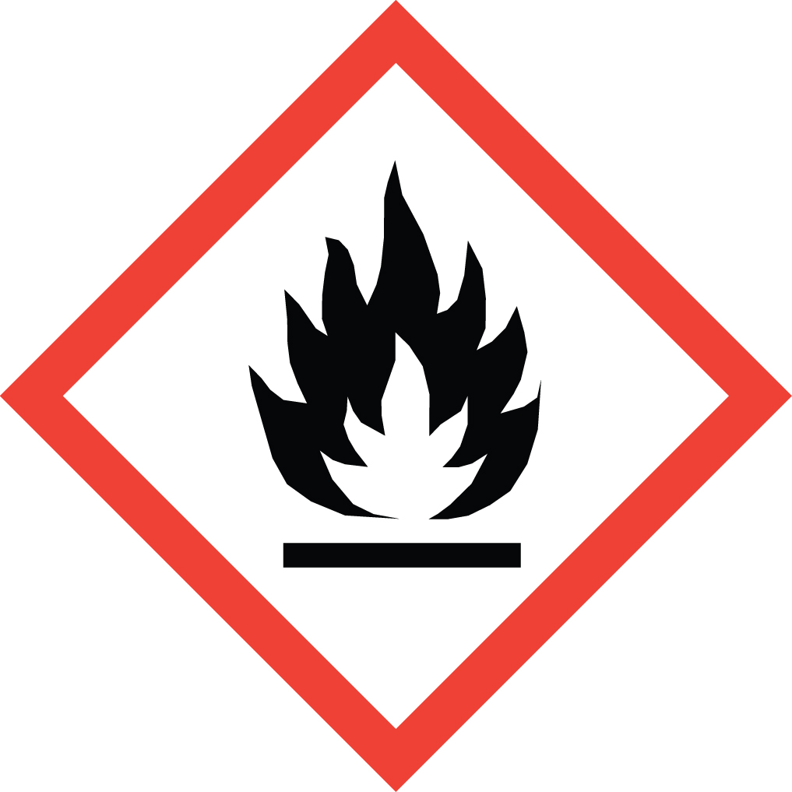 Hydrazine

Overview
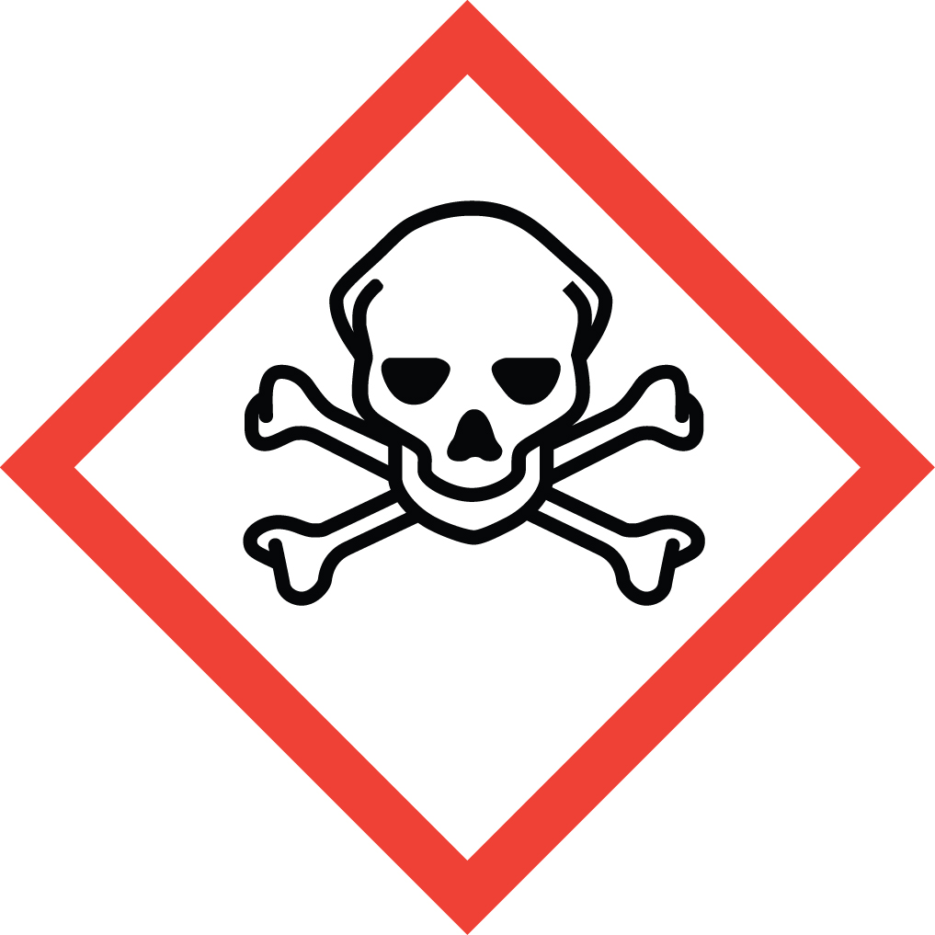Hydrazine is acutely toxic via ingestion, inhalation and dermal contact. It is corrosive and causes severe damage to the skin and eyes upon contact. It is also a carcinogen, a sensitizer, and a reproductive toxin. Both acute and chronic exposure should absolutely be avoided.
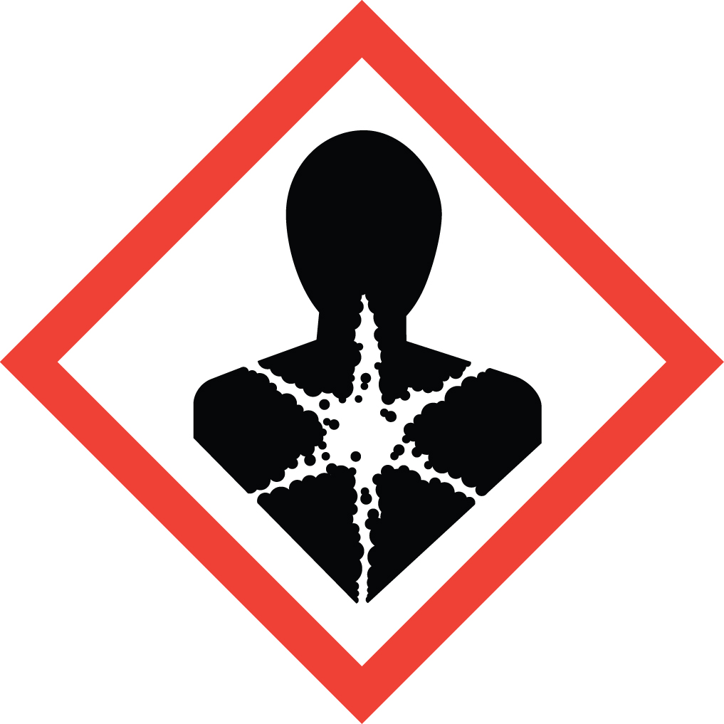Hydrazine is also reactive and unstable, as illustrated by its use as a rocket propellant. It is flammable and air, moisture, heat, light and friction sensitive. Great care must be used in its storage and handling.
Acute symptoms of exposure may include irritation of the eyes, nose and throat, dizziness, headache, nausea, pulmonary edema, seizures, and coma. If these symptoms are observed while in an area where hydrazine is being handled, get medical attention immediately by calling 911.

Special Handling and Storage Concerns
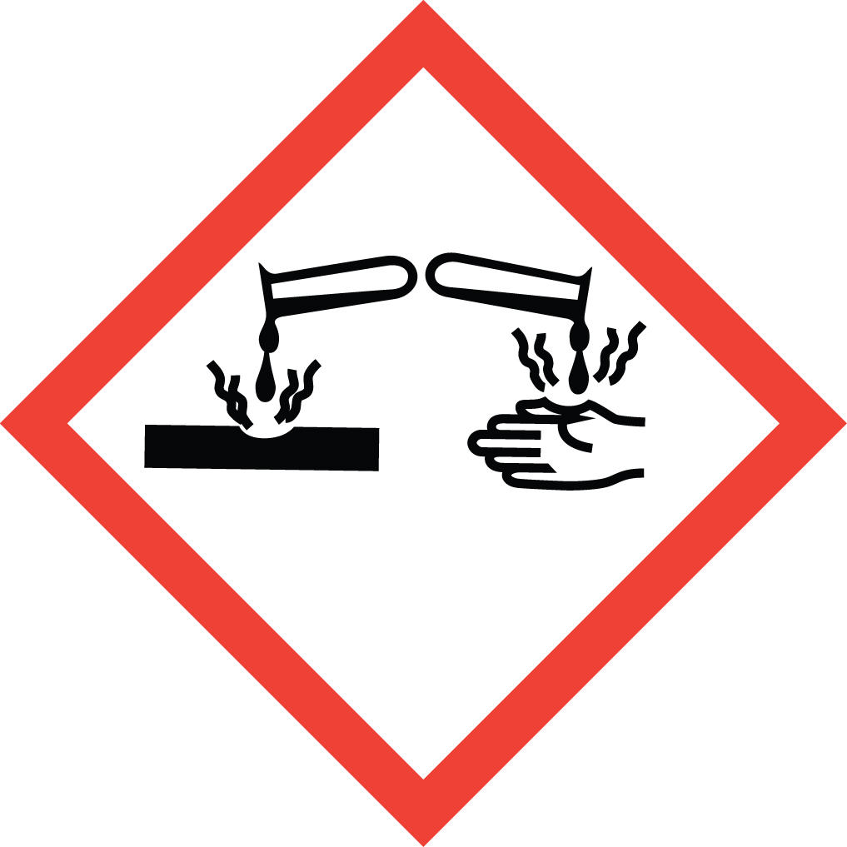Personal Protective Equipment
- Flame Resistant Lab Coat.
- Nitrile gloves. Chloroprene gloves if there is a large splash hazard.
- ANSI Z87.1-compliant safety goggles. Safety goggles and face shield if a large splash hazard is present.
Special Storage Requirements
Hydrazine is a Particularly Hazardous Substance. . Each container must include all applicable hazard warnings. It is recommended that the appropriate GHS pictogram also be on the container. The storage area must be within a PHS designated area, and all containers stored in secondary containment away from non PHS chemicals.
Engineering Controls
Fume Hood: All PHS must be handled in a fume hood. If this is not possible due to scale or equipment, contact EH&S to determine alternate ventilation approaches or respiratory protection needs.
Special Handling Considerations
Hydrazine is a Particularly Hazardous Substances and should be stored and handled as such. Use only in a PHS designated area. Hydrazine hydrates (from 15 to 64 wt%) are considered less toxic and flammable, and should be used instead of anhydrous hydrazine whenever possible. Avoid static electricity buildup: Transfer flammable chemicals from glass containers to glass or from glass to plastic whenever possible. Use bonding and grounding wires if plastic or metal containers must be used.
Decontamination
Standard decontamination procedures apply.

Waste Management
Hydrazine waste is considered Extremely Hazardous Waste and should be handled as described in the UC Santa Barbara Chemical Hygiene Plan. This includes disposing of the emptied original container as hazardous waste through EH&S.

First Aid and Emergencies
Spill
Treat all spills of these materials as a major spill. Do not attempt to clean up the spill yourself. Notify others in the area of the spill, including your supervisor. Evacuate the area and call 911. Remain on-site at a safe distance to provide detailed response to first responders. Report any exposures to EH&S.
Fire
Standard firefighting measures apply.
Personnel Exposure
Skin or eye contact: Remove contaminated attire. Wash skin with soap and water. Flush area with water for 15 minutes. . Get medical attention immediately.
Inhalation: Move person to fresh air. Get medical attention immediately.
Ingestion: Rinse mouth with water. Get medical attention immediately.

Laboratory Specific Information
Prior Approval Required
☐ NO
☐ YES (describe):

Designated Area
☐ Entire Laboratory Area
☐ Other (describe):

Experimental Conditions of Use
Temperature Range:

Pressure Range:

Scale Range:

Other Relevant Details:

