Standard Operating Procedure

Hydrofluoric Acid

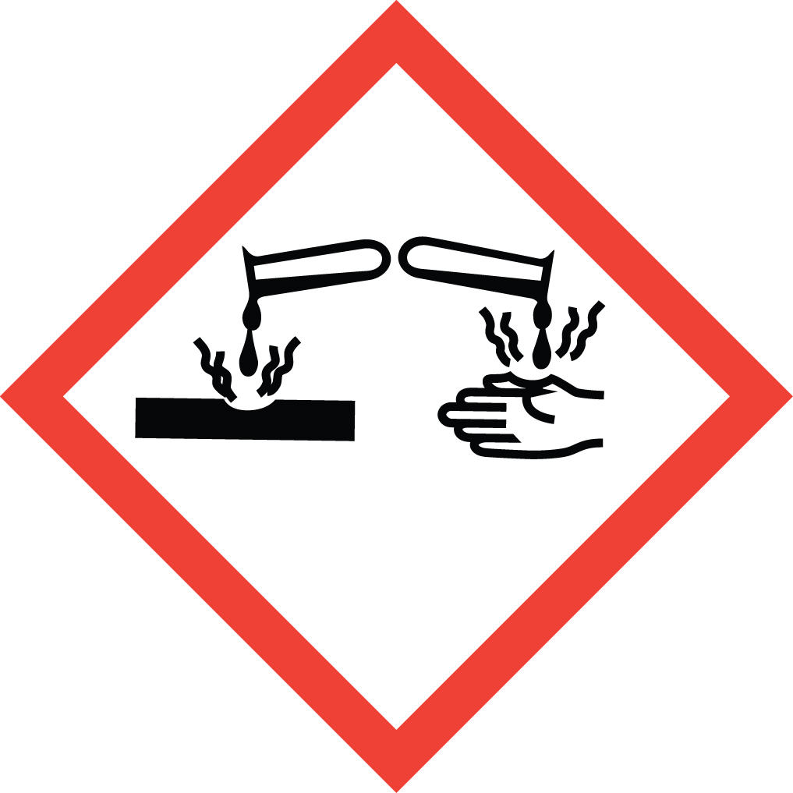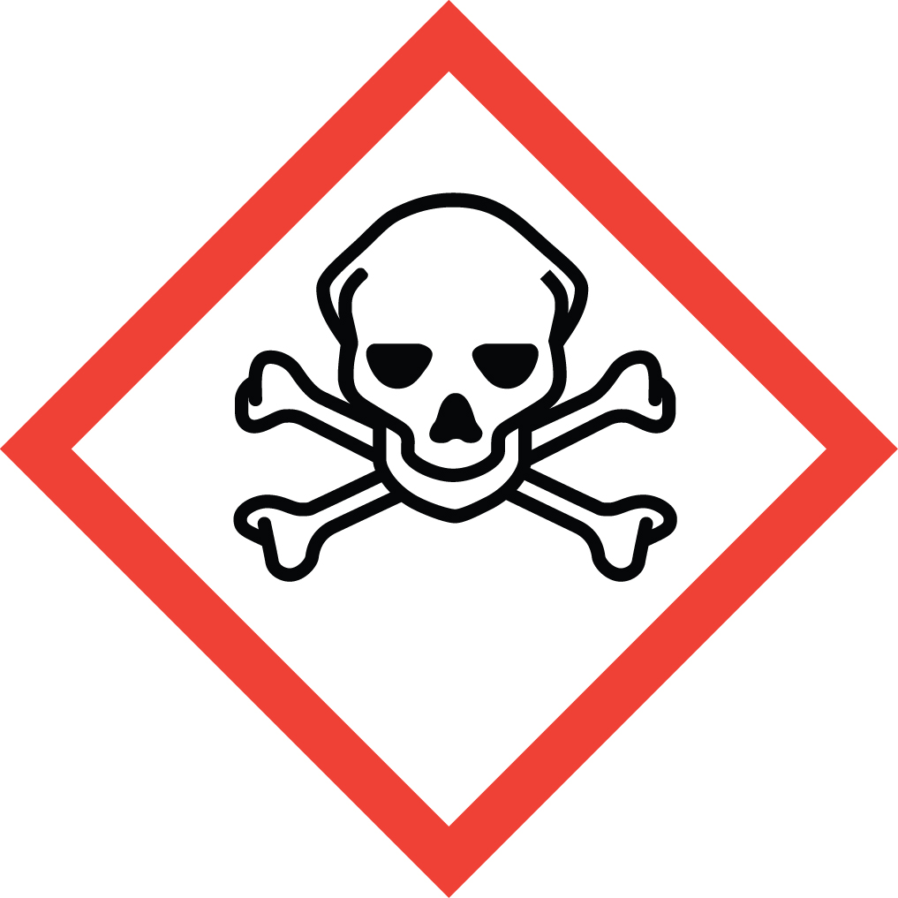Overview
Hydrofluoric acid is a mineral acid which, in addition to its corrosivity, is highly toxic due to the biological activity of the fluoride ion. Due to its low dissociation constant, HF is lipid-soluble and penetrates tissue very quickly. Poisoning can occur via all routes of exposure, therefore all contact must be rigorously avoided. Symptoms range from local tissue damage to systemic toxicity and death. HF interferes with nerve function so, unlike other mineral acids, the user may not be immediately aware of exposure. This can delay treatment and greatly increase the severity of the injury.
Hydrogen Fluoride is classified as a Particularly Hazardous Substance (PHS).

Special Handling and Storage Concerns
Personal Protective Equipment
- Traditional white lab coat and a chemical resistant apron.
- Use gloves specific for HF. Examples:
  - Ansell Barrier (laminated film)
  - Best Viton (Viton)
  - Best Ultraflex Nitrile (22R Nitrile)
- ANSI Z87.1-compliant safety goggles and face shield.
All skin and eye contact MUST be avoided. Long gauntlet-style or arm length gloves are preferable. Safety glasses are not recommended. Cleanroom gowns may be substituted for the traditional lab coat.
Special Storage Requirements
DO NOT store HF in glass containers! HF must be stored in its original container or plastic bottles and placed in secondary containment. Do not store with oxides, organic chemicals, bases or metals. Do not store above eye level. Cylinders of hydrogen fluoride gas should be vented regularly to prevent the buildup of hydrogen gas! Store within a PHS designated area.
Engineering Controls
If your protocol does not permit the handling of HF in a fume hood, EH&S must be contacted to assess alternate ventilation options. Exposure to fumes MUST be avoided.
Special Handling Considerations
All laboratories handling or storing HF must possess Calcium Gluconate Gel exposure antidote. It is recommended that this be adhered to the frame of the fume hood in which the work is being conducted for rapid access.
Decontamination
Standard decontamination procedures apply. Wear proper PPE as described above.

Waste Management
HF waste is considered Extremely Hazardous Waste. Empty containers and PPE that come into contact with HF must be tagged and disposed of as hazardous waste.

First Aid and Emergencies
Spill
Treat all spills of HF as a major spill. Do not attempt to clean up the spill yourself. Notify others in the area of the spill, including your supervisor. Evacuate the area and call 911. Remain on-site at a safe distance to provide detailed response to first responders. Report any exposures to EH&S.
Personnel Exposure
Skin contact: Call 911. Immediately flush the affected area for at least 15 minutes. Remove all contaminated clothing. Wearing appropriate gloves, massage calcium gluconate gel into the affected area. Re-apply every 15 minutes until medical help arrives.
Eye contact: Call 911. Flush the eyes with water until medical help arrives.
Inhalation: Call 911. Move person into fresh air.
Ingestion: Call 911. Rinse mouth with water. DO NOT induce vomiting.

Laboratory Specific Information
Prior Approval Required
☐ NO
☐ YES (describe):

Designated Area (required for HF)
☐ Entire Laboratory Area
☐ Other (describe):

Experimental Conditions of Use
Temperature Range:

Pressure Range:

Scale Range:

Other Relevant Details:

