Standard Operating Procedure

Metal Carbonyls

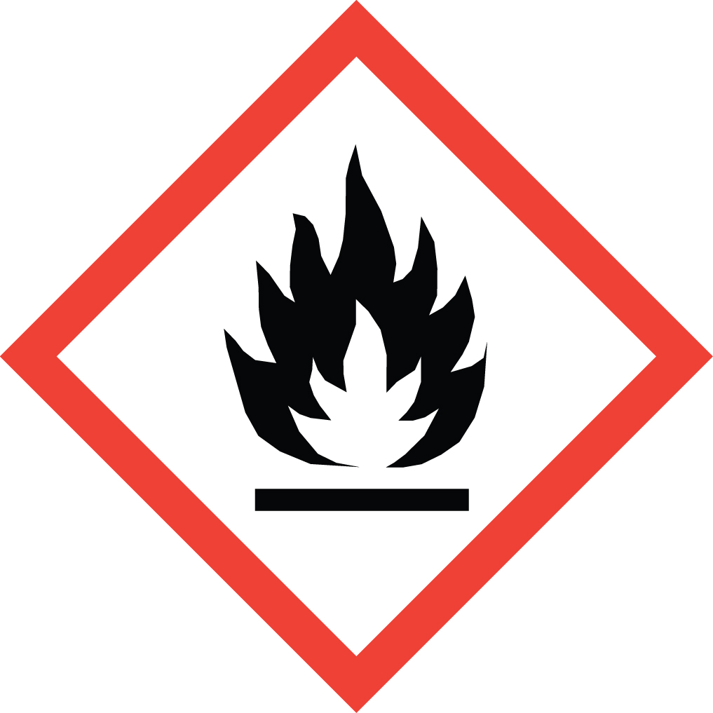Overview
Inhalation: May be fatal if inhaled. May cause respiratory tract irritation.
Skin: May be fatal if absorbed through skin. May cause skin irritation.
Eyes: May cause severe eye damage.
Ingestion: May be fatal if swallowed.
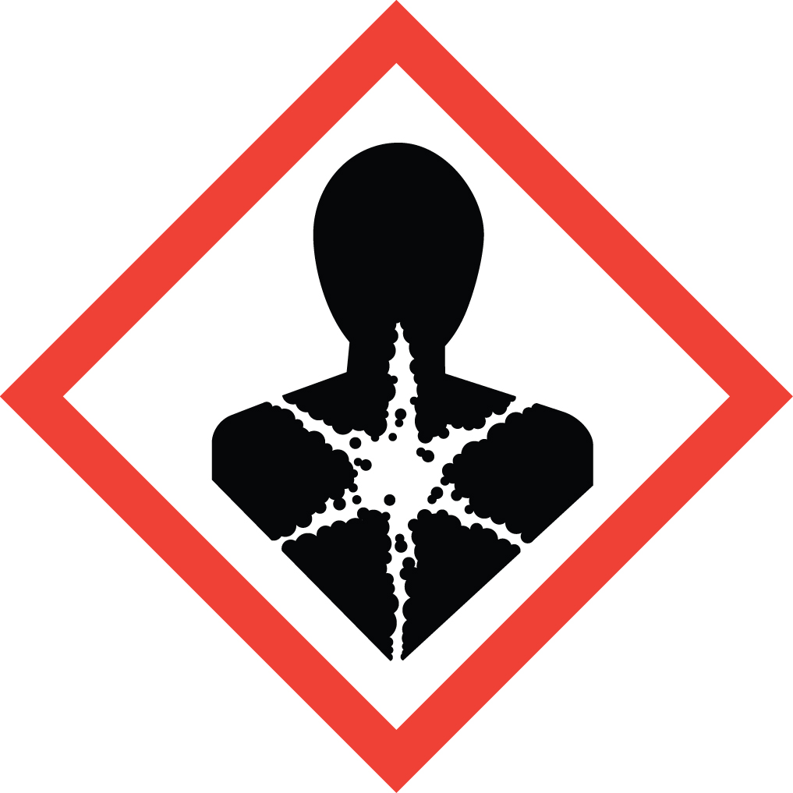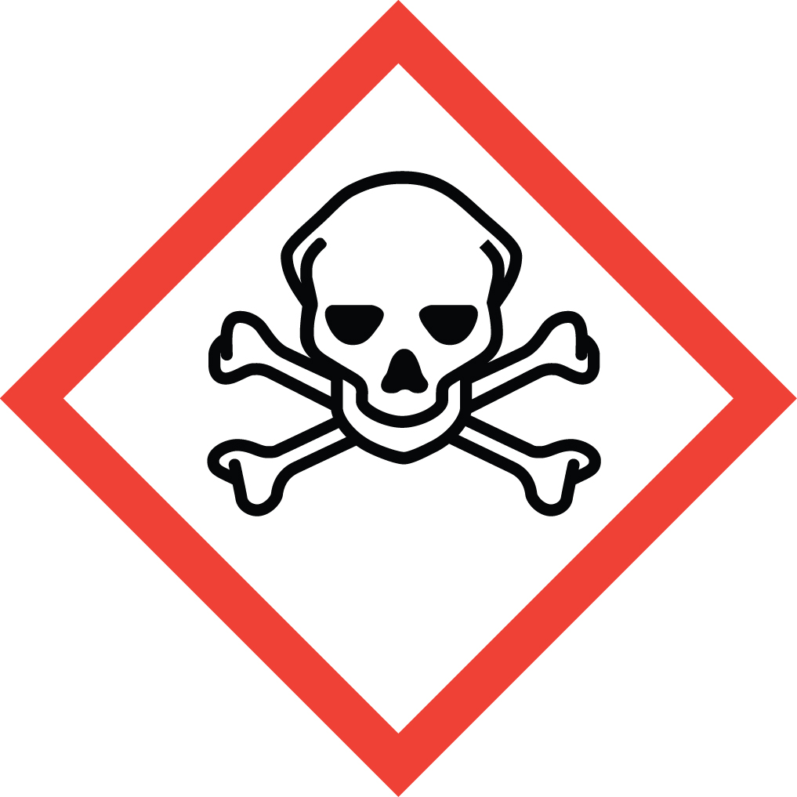Metal carbonyls are extremely toxic and extremely flammable materials. Their extreme toxicity is due to the release of carbon monoxide (both in storage and once inside the body), to the toxicity inherent to the metal center, and to the reactivity of each individual metal carbonyl complex. Nickel carbonyl, in addition to being the most flammable of the class and one of the strongest known inhalation poisons, is a cancer suspect agent and a reproductive toxin. Great care must be taken in their storage and handling.

Special Handling and Storage Concerns
Personal Protective Equipment
- Flame Resistant Lab Coat.
- Gloves: Skin protection is imperative. Check SDS of your specific chemical to see if data is available for determining glove selection (e.g. Cobalt carbonyl = 0.11 mm nitrile gloves). If no data is present, consider using nitrile gloves over the extremely protective Silvershield gloves.
- Tightly sealed ANSI Z87.1-compliant safety goggles.
Special Storage Requirements
Heat sensitive: recommended storage temperature is 2-8 °C. Store in a refrigerator rated for flammable material storage. Air sensitive: store under inert gas. Many are light sensitive and should be stored in a dark area and in tinted glass containers. Seal containers tightly, as carbon monoxide can be released during storage. Follow any additional storage information provided by the supplier.
Engineering Controls
These materials must be handled in a fume hood or glove box. If the experimental apparatus cannot be located in either of these, EH&S must be contacted to determine acceptable entirely closed systems and local ventilation options.
Special Handling Considerations
It is preferable that these materials be handled in entirely closed systems. Handle under inert gas. Prevent the formation of aerosols. Keep away from all sources of ignition, including static electricity. Use grounding and bonding techniques to prevent static buildup. Avoid contact with skin, eyes and respiratory tract.
Decontamination
Standard methods apply. Dispose of resulting cleaning materials as extremely flammable waste (and extremely hazardous waste in the case of nickel carbonyl).

Waste Management
Nickel carbonyl is defined as extremely hazardous waste. A maximum of 1 quart of waste may be stored in the laboratory. Empty containers of nickel carbonyl must be disposed of as hazardous waste and may not be recycled or placed in the trash.

First Aid and Emergencies
Spill
Treat all spills of these materials as a major spill. Do not attempt to clean up the spill yourself. Notify others in the area of the spill, including your supervisor. Evacuate the area and call 911. Remain on-site at a safe distance to provide detailed response to first responders. Report any exposures to EH&S.
Fire
DO NOT USE WATER! Dry sand or ABC dry powder fire extinguisher are acceptable.
Personnel Exposure
Skin or eye contact: Remove contaminated attire. Flush affected area with water for 15 minutes. Get medical attention immediately
Inhalation: Move person to fresh air. Get medical attention immediately.
Ingestion: Rinse mouth with water. Get medical attention immediately.

Laboratory Specific Information
Prior Approval Required
☐ NO
☐ YES (describe):

Designated Area
☐ Entire Laboratory Area
☐ Other (describe):

Experimental Conditions of Use
Temperature Range:

Pressure Range:

Scale Range:

Other Relevant Details:

