Standard Operating Procedure

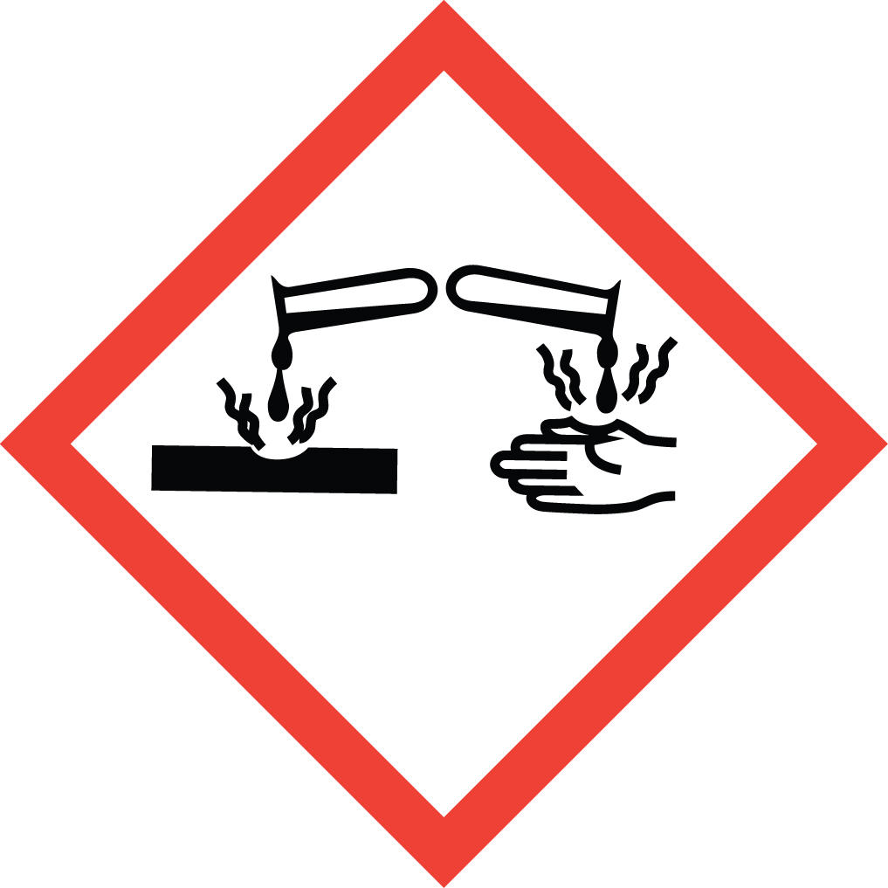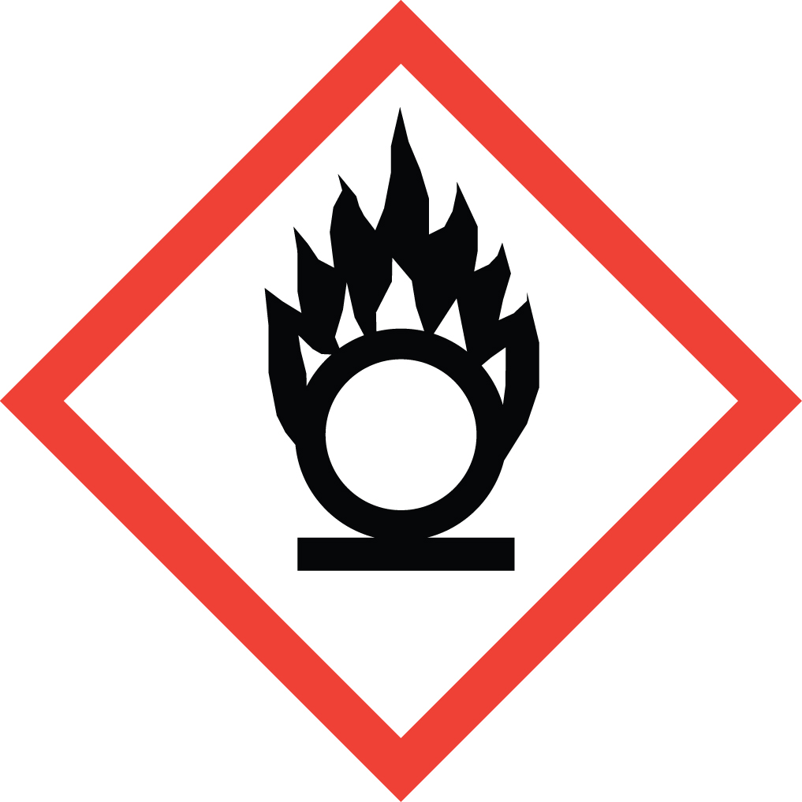 Perchloric Acid

Overview
Explosion Hazard! Perchloric acid is a colorless liquid often used as strong Brønsted-Lowry acid, being comparable in strength to sulfuric acid. It is a powerful oxidizer, but its aqueous solutions up to 72% are remarkably inert, only showing strong acid properties and no other oxidizing properties at room temperature. Upon heating, aqueous solutions below 72% do become very strongly oxidizing and can react violently or explode if not handled carefully. At concentration above 85% (anhydrous), perchloric acid is very unstable and can explode upon contact with organic material. Many heavy metal perchlorates and organic perchlorate salts are extremely sensitive explosives. Mixtures of perchlorates with many oxidizable substances are explosive. Perchloric acid fumes can accumulate on ductwork and equipment. This residue is unstable and extremely dangerous. Great care must be taken to ensure that all perchloric acid fumes are trapped and not allowed to escape into fume hood ductwork.

Special Handling and Storage Concerns
Personal Protective Equipment
- Traditional white lab coat.
- Nitrile or chloroprene gloves are adequate for possible incidental exposure. Thicker (0.3 mm) butyl rubber gloves if large splashes or immersion are possible.
- ANSI Z87.1-compliant safety goggles, or safety goggles and a face shield is a splash hazard is present.
Special Storage Requirements
Store in secondary containment and below eye level, preferably in a corrosives cabinet. Segregate from combustible material, active metals (sodium, potassium, magnesium, etc.) bases and all organic material.
Engineering Controls
If there is any risk of perchloric acid fumes escaping the experimental apparatus, a specially designed and dedicated perchloric acid fume hood with a wash-down system must be used. Failure to do so can result in the buildup of explosive metal perchlorates in the ductwork. EH&S must be contacted if any procedure involving heating of perchloric acid is planned for a standard fume hood.
An eye wash/safety shower unit must be within a 10 second walk (about 35 feet) from where any corrosives are being handled, with only a single intervening door, opening in the direction of travel.
Special Handling Considerations
Do not store organic materials in the fume hood where perchloric acid is used.
When forming solutions/dilutions, to avoid serious splatter risk add the corrosive to water, and never the reverse.
Decontamination
Standard measures apply.

Waste Management
Perchloric acid waste must be segregated from organic or reducing agent waste. Best practice is to store perchloric acid containing waste streams in dedicated containers segregated from all other waste streams. Reduce in-lab storage time by selecting small (<1L) containers that are filled and removed from the laboratory promptly.

First Aid and Emergencies
Spill
Do not neutralize, as many perchlorate salts are explosive.
Fire
Standard firefighting measures apply.
Personnel Exposure
Standard measures apply. Pay extra attention to flushing affected skin/eyes with water for a full 15 minutes using an eyewash/safety shower unit.

Laboratory Specific Information
Prior Approval Required
☐ NO
☐ YES (describe):

Designated Area
☐ Entire Laboratory Area
☐ Other (describe):

Experimental Conditions of Use
Temperature Range:

Pressure Range:

Scale Range:

Other Relevant Details:

