Standard Operating Procedure

Peroxide-Forming Chemicals

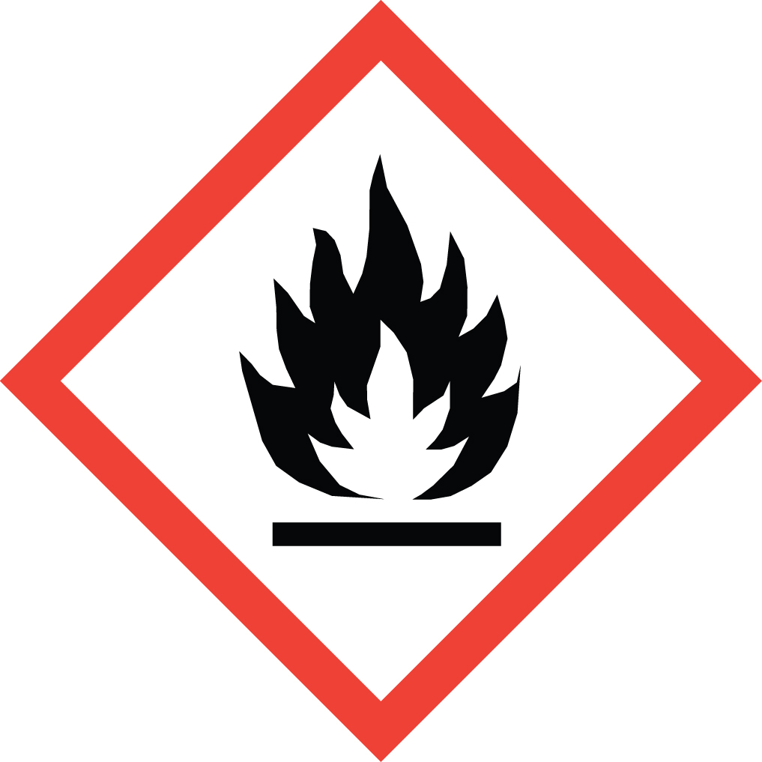Overview
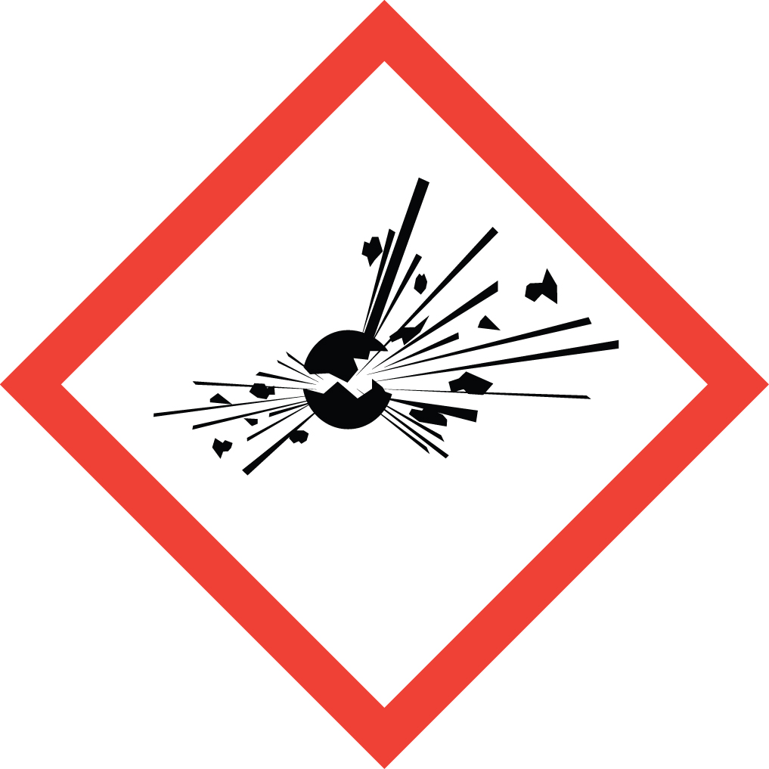Peroxide-Forming chemicals are flammable organic liquids which are capable of forming potentially explosive organic peroxides (R-O-O-R’) upon exposure to air or other oxidizing impurities. Organic peroxides are among the most hazardous substances handled in the laboratory. They are sensitive to oxygen, heat, friction, light, strong oxidizers and reducing agents, and are far more shock sensitive than most primary explosives such as TNT. It is particularly dangerous to allow these materials to evaporate to dryness, such as during distillation. ETHERS are the peroxide-formers most common in the laboratory.

Special Handling and Storage Concerns
Personal Protective Equipment
- Flame Resistant Lab Coat.
- Nitrile or Chloroprene gloves are adequate for incidental exposure. Consult a glove chart if large splashes or immersion are possible.
- ANSI Z87.1-compliant safety glasses. Safety goggles if a large splash hazard is present.
Special Storage Requirements
Store in airtight containers, and in a flammable storage cabinet or refrigerator rated for flammable materials. Containers larger than 4 L are not recommended, due to the time-sensitivity of these materials. Date containers upon receipt and opening. As noted in the UC Santa Barbara Chemical Hygiene Plan:
- Class A peroxide formers must be discarded within 3 months of receipt or formation:
(Divinyl ether, divinyl acetylene, isopropyl ether, sodium and potassium amide, potassium metal.)
- Class B peroxide formers must be discarded 6 months after opening, 12 months if they contain an inhibitor:
(Diethyl ether, Furan, tetrahydrofuran, dioxane, etc.)
- Class C peroxide formers must be discarded after 5 days, 12 months if they contain an inhibitor:
(Acrylic acid, ethyl acrylate, methyl methacrylate, styrene, vinyl acetate, vinyl chloride, vinyl pyridine)
Engineering Controls
Diethyl ether must be used in a fume hood at all times. Solvent mixtures for purification equipment that contain tetrahydrofuran or other higher boiling ethereal solvents must be prepared in the fume hood, but can be used in equipment outside the hood as long as the reservoir container is sealed.

Special Handling Considerations
Static Electricity Risk: Large containers of peroxide-forming chemicals are discouraged due to the time-sensitivity of these materials. If metal drums are used (>20 L), they should always be grounded, and they should be bonded to the receiving container during transfer. Flammable storage cabinets are equipped with a grounding system that should be connected to a building ground. Transferring these materials between unbonded metal containers, or between plastic containers may lead to a fire hazard due to static electricity buildup.
Decontamination
This SOP covers a wide range of materials. Consult the SDS for any possible special decontamination procedures.

Laboratory Specific Information
Prior Approval Required
☐ NO
☐ YES (describe):

Designated Area
☐ Entire Laboratory Area
☐ Other (describe):

Experimental Conditions of Use
Temperature Range:

Pressure Range:

Scale Range:

Other Relevant Details:

