Standard Operating Procedure

Dichloromethane
(Methylene Chloride)

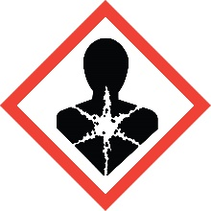
Overview
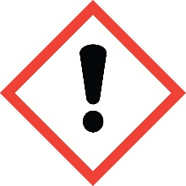
Dichloromethane is an anesthetic. Inhaling the vapor can cause light-headedness leading to unconsciousness and even death. Other symptoms of exposure include skin, eye and respiratory tract irritation. Strong evidence supports that dichloromethane is a human carcinogen upon chronic exposure. Its high volatility makes it imperative that it be handled in a fume hood or other vapor-capturing device. Unlike many organic solvents, dichloromethane is not flammable. Dichloromethane is considered a Particularly Hazardous Substance (PHS).

Special Handling and Storage Concerns
Personal Protective Equipment
- Standard Lab Coat.
- Butyl, Viton and polyvinyl alcohol gloves are recommended. Standard nitrile and neoprene lab gloves are NOT recommended.
- ANSI Z87.1-compliant safety glasses. Safety goggles if a large splash hazard is present.
Special Storage Requirements
Dichloromethane is a PHS. Each container must include all applicable hazard warnings. It is recommended that the appropriate GHS pictograms also be on the container. The storage area must be within a PHS designated area, and all containers stored in secondary containment.
Engineering Controls
Fume Hood: Dichloromethane must be handled in a fume hood. If this is not possible due to scale or equipment, contact EH&S to determine alternate ventilation/isolation approaches or respiratory protection needs.
Special Handling Considerations
Only use dichloromethane in a PHS in a designated area. This designated area may be the entire laboratory, or only a portion of it.
Decontamination
Standard decontamination procedures apply. Use great caution in avoiding exposure.

Waste Management
Standard waste disposal procedures apply.

First Aid and Emergencies
Spill
Treat all spills of benzene as major spills. Do not attempt to clean up the spill yourself. Notify others in the area of the spill, including your supervisor. Evacuate the area and call 911. Remain on-site at a safe distance to provide detailed response to first responders. Report any exposures to EH&S.
Fire
Dichloromethane is not itself flammable. Standard firefighting measures apply
Personnel Exposure
Skin or eye contact: Remove contaminated attire. Flush affected area with water for 15 minutes. If symptoms persist, get medical attention.
Inhalation: Move person to fresh air. Consult a physician is symptoms persist.
Ingestion: DO NOT induce vomiting. Rinse mouth with water. Consult a physician.

Laboratory Specific Information
Prior Approval Required
☐ NO
☐ YES (describe):

Designated Area
☐ Entire Laboratory Area
☐ Other (describe):

Experimental Conditions of Use
Temperature Range:

Pressure Range:

Scale Range:

Other Relevant Details:

