Approved Ergonomics Products – Document Holders and Task Lights
Product | Item No. | Description | Image | Price
3M Flat Panel Doc Holder Model # E6DH445 | Model # E6DH445 | - mount L or R side  - holds up to 35 pages  - user command adhesive to stick to monitor | 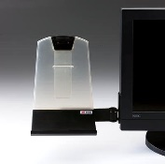 | $28.00
3M Flat Panel Document Clip | 3M Flat Panel Document Clip | - document clip mounts to monitor  - dual-function clip lets you slide in up to 5 sheets one-handed or securely clip up to 30 sheets  - mounts right or left with Command Adhesive  - swings forward and back for easy viewing and storage when not in use | 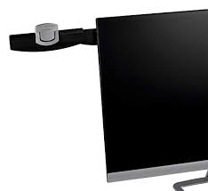 | $8.00
3M - Desktop Document Holder | Document Holder | - holds documents upright in front of you for easy access and viewing  - versatile sliding clip accommodates both portrait and landscape oriented documents.  - grooved ledge and clip | 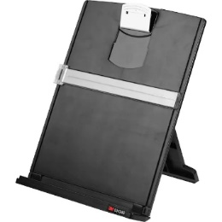 | $20.99
TSJ OFFICE  Glass whiteboard Dry Erase Board | Small Desktop Glass Whiteboard Dry-Erase-Board - | - computer keyboard stand white board surface pad with drawer  - desk organizers for office. | 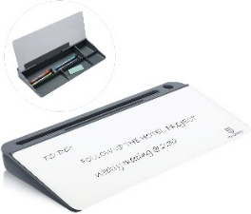 | $29.00
Task Light Workrite - Astra 3 Double Arm | Model #: AST3-DA-WOB-S | - 34.9″ Reach from base/mount  - bright white light output: 3100K 93 CRI  - included occupancy sensor  - continuous dimming from 100% – 5%  - touch button on/off & dimming controls  - UL Certified, Energy Star Compliant Luminaires V1.2  - 50,000+ hour life LED’s (L70 rating | 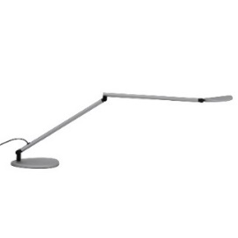 | Verify Price with the vendor for UC pricing
Task Light Workrite – Fundamentals 2 LED Desk Light | Fundamentals 2 LED Desk Light | - sleek contemporary design with single touch button interface  - 82 lumens per watt  - consumes 4.1 watts of power  - supplement ambient lighting with a task light | 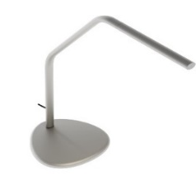 | Verify Price with the vendor for UC pricing
Herman Miller  Task Light  Flute | Flute Task Light | - consumes 30-50+% less energy than traditional task lights,  - generating 48 lumens per watt of energy consumed.  - LED chips require no bulb replacement or service over the estimated 24-year life span with average use. | 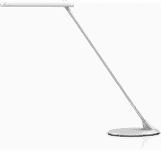 | Verify Price with the vendor for UC pricing
Herman Miller  Task Light Focal | Focal Task Light | - tilting or spinning the lamp head around its slim post  - press the big on-off button to toggle between three levels of brightness  - 4W LEDs  - made of steel and aluminum  - USB port  - powder-coated colors |  | Verify Price with the vendor for UC pricing
Herman Miller Task Light Lolly | Task Light Lolly | - includes both USB 3.0 (Type C) and USB 2.0 (Type B) charging ports  - tilting head and touch-sensitive dimming controls  - shuts off after four hours of inactivity. | 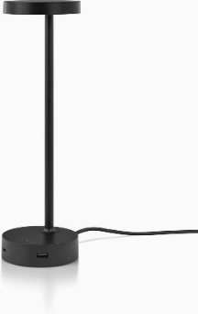 | Verify Price with the vendor for UC pricing
Herman Miller Tone Light | Model #: Y6480.FRMS (Silver) | - LED light  - shuts off automatically after nine hours  - swivels at the base  - articulating joints at the base, head, and midsection | 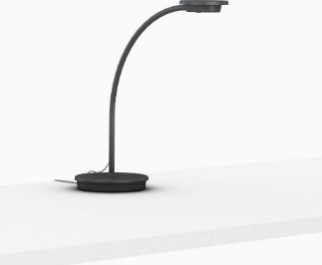 | Verify Price with the vendor for UC pricing
Steelcase Task Light Details Dash LED Task Light Model # LDASHF | Model # LDASHF | - LED light  - convection air flow for heat dissipation  - 360-degree lower arm and head rotation  - three user adjustable tension control knobs  - up to 22” in height | 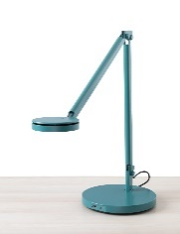 | Verify Price with the vendor for UC pricing
Steelcase Task Light Details Eclipse LED Task and video light | Eclipse Led and video light | - illuminates new ways to work and collaborate  - task light and Video light all in one | 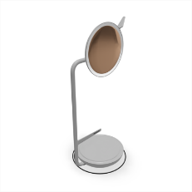 | Verify Price with the vendor for UC pricing
Steelcase Task Light Linear desk light | Linear Task Light | - consistent 3500K color temperature  - programmed to automatically turn off after 10 hours + / – 15 minutes. | 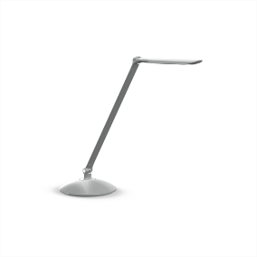 | Verify Price with the vendor for UC pricing
Steelcase Task Light Radial desk light | Radial Task Light | - dimmable, with a soft, blended light pattern and fully articulated body  - LED Radial Desktop provides precisely positioned light.  - LED Radial Desktop can be turned on or off with a single touch. | 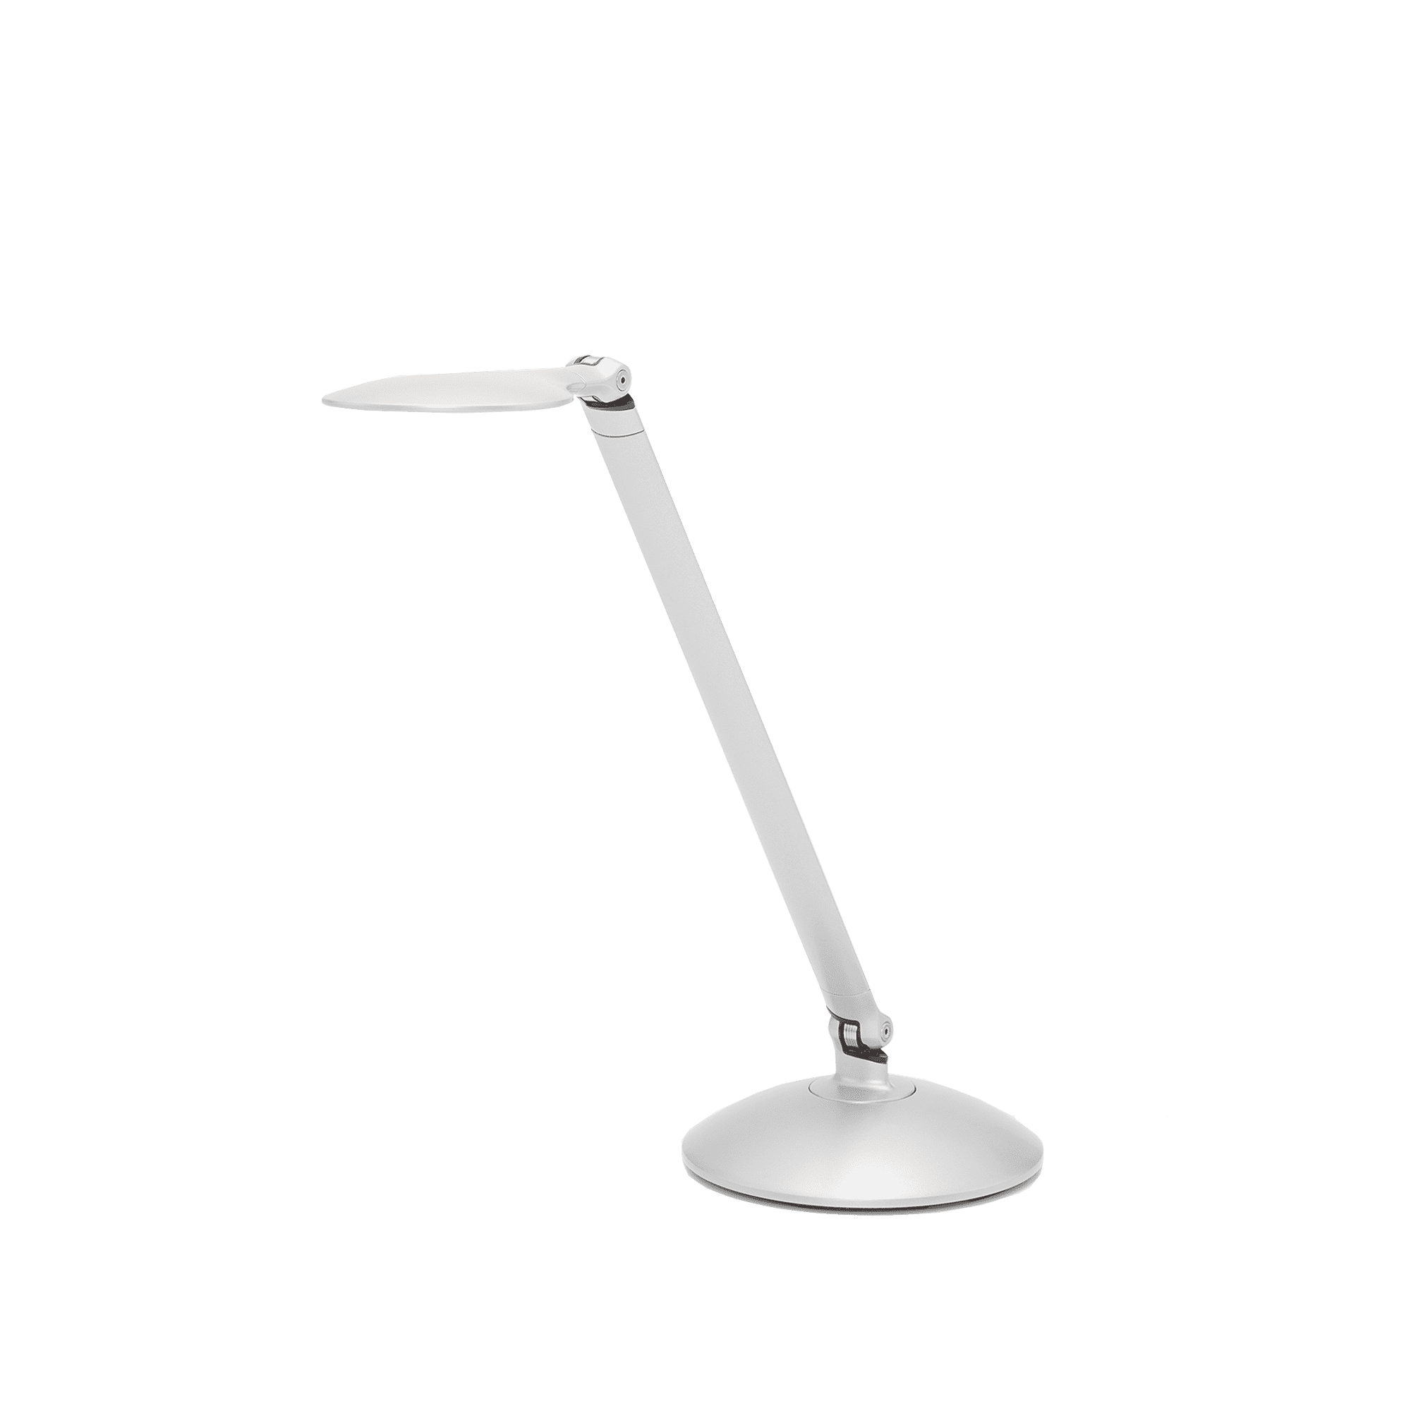 | Verify Price with the vendor for UC pricing
Products Available  Through Gateway at UC Preferred Pricing |  | Please note: Prices, availability, supply chain issues and shipping delays may change without notice or price guarantees | Gateway Vendors: Amazon, CDW, Office Depot, and Office Releif  Task Light Vendors, Santa Barbara Office Interiors, Tangram and Tricounty Office Furniture

