Approved Ergonomics Products – Monitor Arms
Product | Item No. | Description/Features | Image | Price
Grandstands Pro Ergo Flex Single 4.5” Arm | Model #: 8171PE1 -S4 Single 16” Arm Model #: 8561PE2 -16 Ace Sit Stand Arm Model #:ACE20 - S Color: Silver/Grey | - 13" of instant height range plus additional pole height adjustment  - 24" extended reach  - 7-20 lbs. weight capacity  - Full screen tilt and swivel  - Quick desk clamp installation, grommet mount included, wall or panel mount available  - Cable management  - Standard color silver, available in white or black. Option of dual arms | 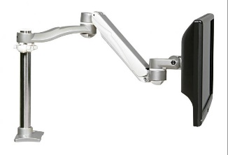 | Verify price with the vendor for UC pricing
Grand Stands' ACE15 | ACE15-S | - 15” of vertical height range with no pole  - tilt adjustment, swivels portrait to landscape  - 23.6” front to back distance, compacts to 4”  - VESA compliant  - clamp and grommet mount included  - 0 to 20 pounds of supported weight, for single monitor  - very stable and limited bounce when the user is typing  - color Silver (-S), Black (-B), White (-W)  - internal cable management  - depth from post (Closed): 0”  - Tilt adjustment: 15°  - display pan swing - side to side: 50”  - VESA Compatibility: 75x75mm/100x100mm  - lifetime warranty | 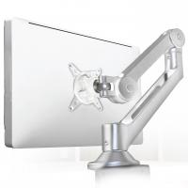 | Verify price with the vendor for UC pricing
Herman Miller Flo Monitor arm Model #: Y91171.CM01 Heavy Duty (20 -40 lbs): Y911741.CM01 (includes clamp and bolt through mount) Color: Silver/Grey | Model #: Y91171.CM01 Heavy Duty (20 -40 lbs): Y911741.CM01 (includes clamp and bolt through mount) Color: Silver/Grey | - Supports monitors 20 -40 pounds  - Multiple mounting options (grommet, slat wall, clamp mount, wall mount)  - integrated cable management  - vertical adjustment: 13”  - height adjustment range: 10” | 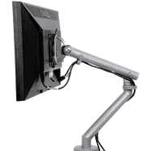 | Verify price with the vendor for UC pricing
Herman Miller Ollin Monitor arm | Ollin | - supports a range of monitors and laptops weighing up to 20 pounds  - integrated thumbwheel adjusters  - available for dual monitors | 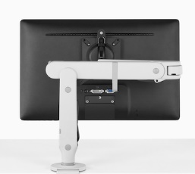 | Verify price with the vendor for UC pricing
Herman Miller Ollin Laptop/Tablet Mount | Ollin Laptop Mount | - attaches to Ollin and Flo monitor arms  - control the height, distance, angle, and orientation of your device. | .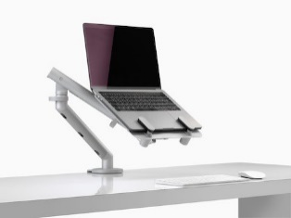 | Verify price with the vendor for UC pricing
Herman Miller Lima Laptop/Tablet Mount | Lima Laptop Mount | - mount easily attaches to the arm  - user can position your laptop off the work surface and at eye level. | 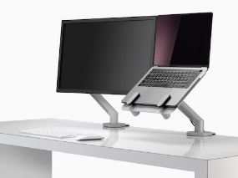 | Verify price with the vendor for UC pricing
Herman Miller Lima Monitor arm/s | Lima | - easy to install and even easier to use. With Lima, people can  - adjust computer screens by height, distance, and angle  - add monitor arm to desk to give flexible screen viewing. | 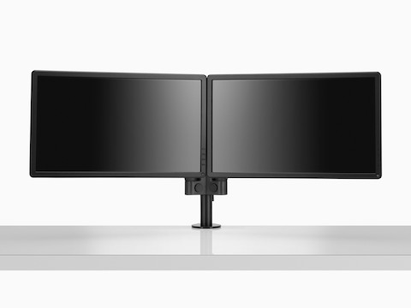 | Verify price with the vendor for UC pricing
Steelcase  CF Series | CF Series | - accommodates a wide variety of user preferences  - available in both single and dual monitor applications. | 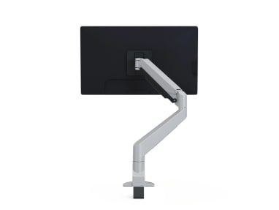 | Verify price with the vendor for UC pricing
Workrite JIBE Monitor arm Single Arm | Single Arm  JIBE | - supports monitors up to 20 pounds  - multiple mounting options (grommet, slat wall, clamp mount)  - integrated cable management hides cables within the arm  - arm reach: 20”  - height adjustment range: 10”  - weight: 5 pounds  - available for dual screens | 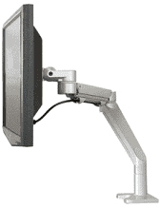 | Verify price with the vendor for UC pricing
WorkRite – Conform Articulatng Arm | Model #: CONF -1HDA -WOB - S | - supports one 17 -40 lb. monitor  - maximum monitor height: 14″ (full range of motion)  - articulation range: 13.5″  - forward reach: 22.5″  - stowed depth: 5.25″  - monitor: tilt: +90°/-45°, pivot: +/ - 90° rotation: +/ -90°  - standard VESA (75 mm & 100 mm)  - available for dual monitors. | 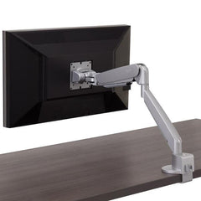 | Verify price with the vendor for UC pricing
WorkRite  Laptop Holder | Laptop Holder | - accommodates most popular 13″ to 15″ laptop  - supports laptops up to 10 lb.  - use with single or dual monitor arms  - depth adjusts from 9.2″ to 11.7″ allowing use of docking stations  - laptop held in place by formed front edge  - anti-vibration pads provide secure foundation and minimize laptop vibration  - vent design for optimal cooling  - silver finish, steel construction | 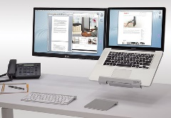 | Verify price with the vendor for UC pricing
Products Available  Through Gateway at UC Preferred Pricing |  | Please note: Prices, availability, supply chain issues and shipping delays may change without notice or price guarantees | Gateway Vendors: Santa Barabara Office Interiors, Tangram and TriCounty Office Furniture

