Approved Ergonomics Products – Ergonomic Mice

Product | Item No. | Description | Image | Price
Goldtouch Wireless  Mouse | 232532  Gtm-100w | - medium size optical mouse  - symmetrical design for right or left-hand use  - wireless, PC/Mac compatible | 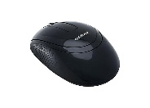 | $40.00
Goldtouch Wireless Mouse Semi Vertical  Right Hand | #564798  Kov-Gsv-Rmw | - comfortable Feel  - Anti-slip texture grip and rubberized coating  - forward/back keys  - page forward or page back with convenient thumb keys  - ideal slope: 66° slope creates optimal comfort and hand/wrist positioning  - flange Accessory  - detachable ergo-grip flange keeps palm off the surface of the desk  - adjustable weights  - four detachable 5g block weights for customized weighting  - Right hand use only | 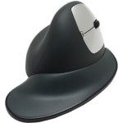 | $99.00
Logitech Performance MX3 Mouse | 7897173 | - cordless  - rechargeable  - contoured  - precision cursor control on more surfaces, including glass  - wireless freedom for multiple devices with plug-and-forget unifying receiver  - flexible recharging through your computer or a wall outlet  - fingertip controls for hyper-fast scrolling  - quick-zoom  - sculpted design cradles your hand for unmatched comfort, right or left handed | 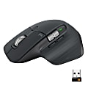 | $99.00
Logitech MX Vertical Wireless Mouse | 4057397 | - MX Vertical is an advanced ergonomic mouse  - the natural handshake position of MX Vertical reduces wrist pressure and forearm strain  - 57° vertical angle optimized for an ergonomic posture  - MX Vertical features a 4000 DPI high-precision sensor, resulting in 4x less hand movement.  - available for right or left hand. | 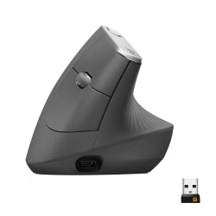 | $99.00
BakkerElkhuizen PRF Wireless Mouse | Bneprf101 | - medium size optical mouse  - symmetrical design for right or left-hand use  - mouse is held in neutral “handshake” position  - mouse puts less stress on the wrist and lower arm | 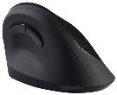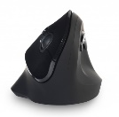 | $79.99
Contour Unimouse  right-hand wireless | Unimouse-R-WL | - fully adjustable designed to perfectly fit any hand  - adjustable hinge (from 35-70 degrees)  - articulating thumb support (length, width, angle)  - mouse is held in neutral “handshake” position | 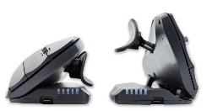 | $79.00
Contour Unimouse  left-hand wireless | Unimouse L-WL | - fully adjustable designed to perfectly fit any hand  - adjustable hinge (from 35-70 degrees)  - articulating thumb support (length, width, angle)  - mouse is held in neutral “handshake” position | 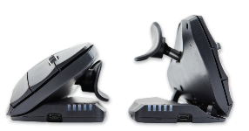 | $79.00
Evoluvent Vertical Mouse 4 - right-hand  wireless | Kov-VM4R | - wireless with auto scroll bar and auto click features  - PC, Mac, Unix compatible  - integrated adjustable laser sensor and speed indicator  - easy to reach, programmable dual thumb buttons  - eliminates forearm twisting | 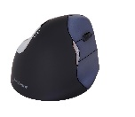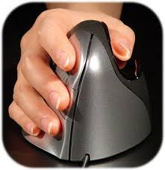 | $110.00
Evoluvent Vertical Mouse 4 - left-hand  wireless | Kov-VM4L | - wireless with auto scroll bar and auto click features  - PC, Mac, Unix compatible  - integrated adjustable laser sensor and speed indicator  - easy to reach, programmable dual thumb buttons  - eliminates forearm twisting | 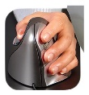 | $110.00
Evoluvent Vertical Mouse 4 - right-hand  Wireless Small | VM4SWR | - wireless with auto scroll bar and auto click features  - PC, Mac, Unix compatible  - integrated adjustable laser sensor and speed indicator  - easy to reach, programmable dual thumb buttons  - eliminates forearm twisting |  | $110.00
Evoluvent Vertical Mouse 4 - left-hand  Wireless Small | VM4SWL | - wireless with auto scroll bar and auto click features  - PC, Mac, Unix compatible  - integrated adjustable laser sensor and speed indicator  - easy to reach, programmable dual thumb buttons  - eliminates forearm twisting |  | $110.00
KeyOvation Goldtouch Gel Filled Mousing Platform – Black Right Hand | 147858 | - soft gel protects the wrist and hand  - from otherwise contacting a harder work surface. When using correct mousing techniques, such as moving with the arm (not bending the wrists), users can enjoy smoother movement of the mouse on the larger tracking surface. The gentle slope and curvature of the Mousing Platform help achieve more neutral postures and keep the mouse on a similar plane to the keyboard. | 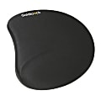 | $30.49
KeyOvation Goldtouch Gel Filled Mousing Platform – Black Left Hand | 871111 | - The unique design of the left handed Goldtouch Mouse Pad allows users to mouse in greater comfort. The left handed mouse pad is uniquely designed to better protect your hand and wrist from hard surfaces and ensure that you're in maximum mousing comfort. The platform is made of dual textured stress-dispersing gel, with a black Lycra cover providing excellent track-ability. The SlimLine Mouse Pad is great for people using today's thinner or mini keyboards, as it helps maintain a consistent product height and the overall flow of your workspace. | 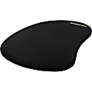 | $21.99
Allsop Wrist Aid Circular Mouse Pad - | 886031 | - With a sleek 7-degree angle, this mouse pad features a slanted surface that prevents pain and soreness during extended use. By rotating the mouse pad on your desk throughout the day or just during periods of high moussing activity, you will avoid keeping your wrist at the same angle all day.Mouse pad is suitable for both right-handed and left-handed users and is Computer User Recommended Ergonomics (C.U.R.E.) approved. | 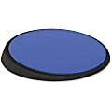 | $15.49
Contour Rollermouse Red Plus | RM-RED-PlusWL | - designed to sit in front of your keyboard  - reduces unnecessary muscle activity in arms, neck and shoulders  - roller bar can be used ambidextrously to control cursor |  | $265.00
Contour Rollermouse Red Plus with Palm Suppport+ | RM-RED-Plus Palm SupportWL | - designed to sit in front of your keyboard  - reduces unnecessary muscle activity in arms, neck  - and shoulders  - roller bar can be used ambidextrously to control cursor  - expanded palm rest for better support |  | $285.00
MouseTrapper Prime  Centrally Positioned Wireless Mouse | MT111 | - super-slim, ergonomic design  - control pad with click and scroll functions  - option to work wirelessly  - 8 programmable buttons for customization using our app  - wrist supports can be cleaned with surface disinfectants  - replaceable wrist supports  - height adjustment with folding non-slip surface  - battery life: up to 4 months  - rechargeable battery  - 2000 dpi | 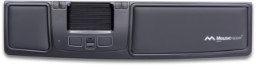 | $265.00
Ortho Via  Ortho Mouse | KOV-ORTHO | - The fully customizable OrthoMouse will gently guide your wrist and hand into an ideal position. This creates a better fit. The right-handed mouse is a fully customizable ergonomic mouse, offering three easily interchangeable (small, medium and large) adapters for the palm of the hand and two upper adapters intended as a guide for the average or longer fingers. All adapters are included in the package. This allows for six configurations in total to fit the size and shape of your hand, "6 mice in 1 | 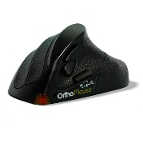 | $100.00
Kinesis DXT Mouse | PD7DXT | - radio Frequency wireless connectivity helps reduce the clutter of wires around your Notebook  - Symmetrically shaped mouse offers friendly usability for both right and left handers | 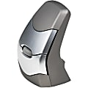 | $115.00
Prestige  International Hippus HandShoe Mouse | UB-LC | - ergonomic comfort design with higher light beam and 1500 dpi resolution, BlueTrack movement detection offers you accurate clicking and scrolling  - from controlling text size to image zoom, opening or closing tabs, the featured scrolling wheel makes it a breeze to perform tasks quickly  - Available in small, med, large or left handed | 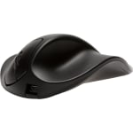 | $130.00
Products Available  Through Gateway at UC Preferred Pricing |  | Please note: Prices, availability, supply chain issues and shipping delays may change without notice or price guarantees | Gateway Vendors: Amazon, CDW, Office Depot, and Office Releif

