Standard Operating Procedure

Carcinogens, Reproductive Toxins and Acute Toxins

(Cal/OSHA Particularly Hazardous Substances)

Overview
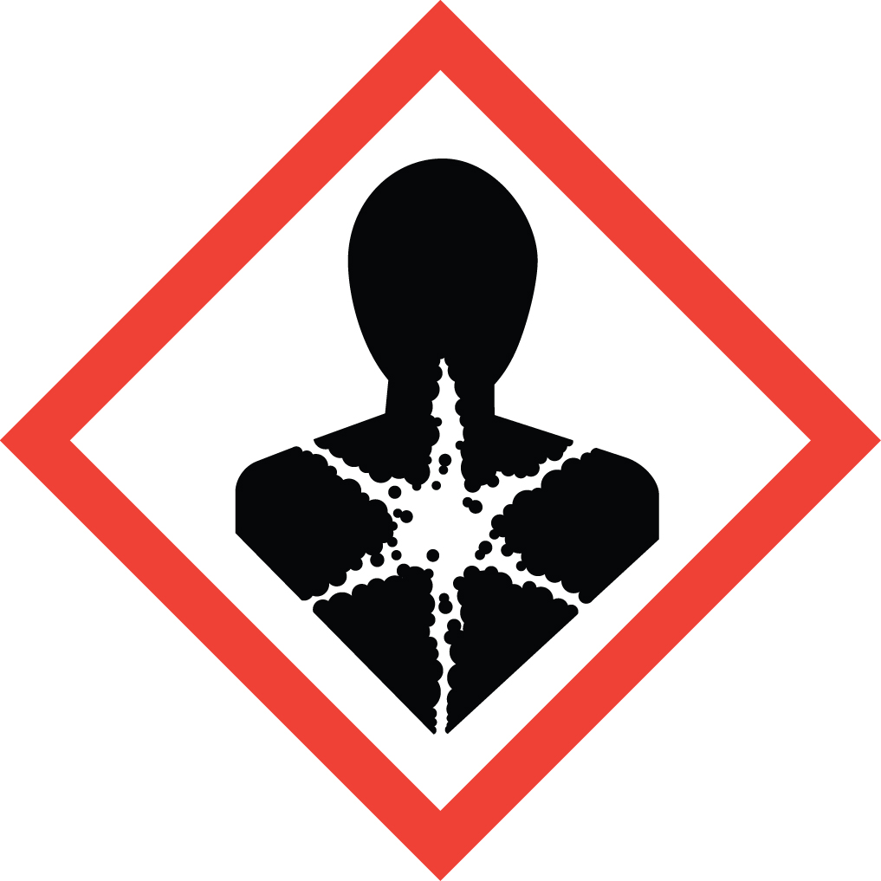Three classes of hazardous chemicals are defined by Cal/OSHA as ‘Particularly Hazardous Substances’ (PHS):
- Carcinogens are materials that have the potential to cause cancer.
- 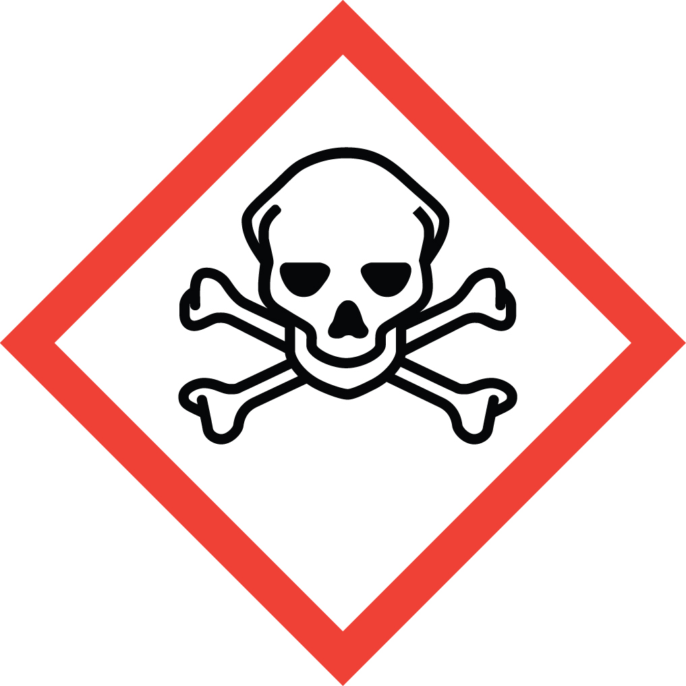Reproductive Toxins are materials that affect reproductive capabilities, including mutagenesis (causing chromosomal damage), teratogenesis (effects on the fetus), and adverse effects on sexual function and fertility.
- Acute toxins are substances that may be fatal as a result of a single exposure (LD₅₀ < 50 mg/kg (oral), 200 mg/kg (dermal), 500 ppm (inhaled).

If the carcinogen you are using is a Listed Carcinogen (8 CCR §5209), EH&S will contact you upon your ordering of that material to address safety requirements that go beyond this SOP.

Special Handling and Storage Concerns
Personal Protective Equipment
- Traditional lab coat. Flame resistant if material is flammable.
- Nitrile or Neoprene Gloves are adequate for possible incidental exposure in most cases. Consult a glove chart if the specific material in use is particularly hazardous, or if the risk of contact is high.
- ANSI Z87.1-compliant safety glasses. Safety goggles if a splash hazard is present.
Special Storage Requirements
Store Particularly Hazardous Substances away from other chemicals. Each container must include all applicable hazard warnings. It is recommended that the appropriate GHS pictogram also be on the container. The storage area must be within a PHS designated area, and all containers stored in secondary containment.
Engineering Controls
Fume Hood: All PHS must be handled in a fume hood. If this is not possible due to scale or equipment, contact EH&S to determine alternate ventilation approaches or respiratory protection needs.
Special Handling Considerations
Only use PHS in a designated area. This designated area may be the entire laboratory, or only a portion of it. Note that the information in this SOP describes the baseline requirements for PHS. You will need to generate or review a chemical-specific SOP if the material you are handling has:
- Unique properties: e.g. cyanide salts, where the risk of exposure varies greatly with pH.
- Multiple hazards: e.g. azide salts, which are highly toxic and potentially explosive.
- Extreme hazards: e.g. methyl mercury, which penetrates the skin and is lethal in tiny doses.
Decontamination
This SOP covers a wide range of materials. Consult the SDS for any possible special decontamination procedures.

Waste Management
Note that some PHS waste may be considered Extremely Hazardous Waste and should be handled as described in the UC Santa Barbara Chemical Hygiene Plan. This includes disposing of the emptied original container as hazardous waste through EH&S.

First Aid and Emergencies
Spill
Treat all spills of these materials as a major spill. Do not attempt to clean up the spill yourself. Notify others in the area of the spill, including your supervisor. Evacuate the area and call 911. Remain on-site at a safe distance to provide detailed response to first responders. Report any exposures to EH&S.
Fire
Standard measures apply.
Personnel Exposure
Skin or eye contact: Remove contaminated attire. Flush affected area with water for 15 minutes. If symptoms persist, get medical attention.
Inhalation: Move person to fresh air. Get medical attention immediately.
Ingestion: Rinse mouth with water. Get medical attention immediately.

Laboratory Specific Information
Prior Approval Required
☐ NO
☐ YES (describe):

Designated Area (required for Particularly Hazardous Substances)
☐ Entire Laboratory Area
☐ Other (describe):

Experimental Conditions of Use
Temperature Range:

Pressure Range:

Scale Range:

Other Relevant Details:

