FACE COVERING GUIDANCE

Face coverings help reduce exposure to droplets in the air that contain the COVID-19 virus. Face coverings complement the public health measures in place to reduce community transmission of COVID-19, including:
- Staying at home if you feel sick
- Working remotely if possible
- Practicing physical distancing from others
- Washing your hands frequently
- Avoiding touching your face
- Increased disinfection of high touch surfaces

This guidance is for those who do not have a medical condition that precludes wearing a face covering. These guidelines are subject to change based on additional information, county health ordinances, University guidelines, and/or guidelines set forth by the University of California Office of the President.

CONSIDERATIONS FOR HAZARDOUS LABORATORY PROCEDURES
Cloth face coverings are a community health measure and are not personal protective equipment (PPE). The concerns of wearing a cloth face covering in the lab are (a) contamination of the cloth face covering during research and (b) suitability of the cloth face covering for the research being performed. Hazardous procedures for which a different face covering could be more appropriate will be evaluated on a case-by-case basis, not as a blanket recommendation for all labs.

Contamination of the cloth face covering during the course of research: You will need to keep a spare, clean face covering in a drawer or nearby space, in case you have had to adjust the face covering mid-operation with potentially infectious or radioactive materials. Cloth face coverings worn during research should be handled as any other piece of clothing (i.e. pants) worn in the lab and taken home to be washed by the wearer. As with any clothing worn in the lab, a back-up cloth face cover should be available if the primary face covering becomes dirty.

In general, people need (to continue) to not touch their faces, and adapt to washing their hands, making any adjustments to the face covering under safety glasses if necessary, and then donning gloves in preparation to conduct hazardous procedures.
There is a period of time during work with hazardous materials in which it is critical that adjustments are not made without doffing gloves and washing hands.
Bare/uncovered faces were not becoming contaminated before the pandemic, and thus face coverings will not become contaminated if procedures continue to be done with the correct containment practices.

Suitability of the cloth face covering for the research being performed: Synthetic materials should not be used for clothing worn under PPE; the same applies to cloth face coverings. If a researcher has concerns regarding handling materials that are reactive while wearing a cloth face covering, a risk assessment should be performed with the entire process being evaluated and the hierarchy of controls implemented to control the risk.
Contact Alex Moretto, Research Safety Division Manager, to coordinate an EH&S risk assessment at 805.893.4899 or amoretto@ucsb.edu.
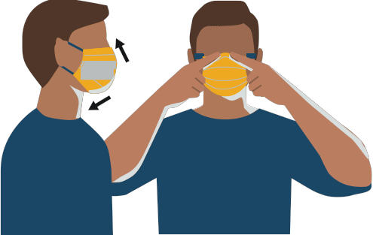
WEARING A FACE COVERING
- Wash your hands before putting on a clean face covering
- Secure the covering over your nose, mouth, and chin
- Fit as snuggly as comfortable along the sides of the face
- Secure with ties or ear loops
- Make sure you can breathe easily
- Clean hands before making adjustments

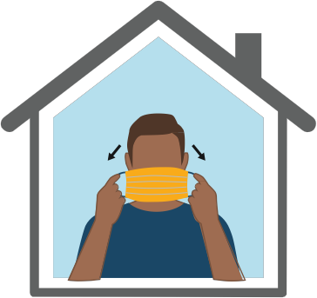
REMOVING A FACE COVERING
- Clean hands before contacting face covering
- Handle by the ear loops or ties
- Do not touch eyes, nose or mouth
- Launder after a day of wearing
- Wash hands after removing face covering

https://www.cdc.gov/coronavirus/2019-ncov/downloads/cloth-face-covering.pdf
CAMPUS DISTRIBUTION OF FACE COVERINGS
The University is providing face coverings to faculty, staff, and students in support of this public health precaution and to enable a safe workplace. Store clean cloth face coverings in a clean bag or container until they can be reused. It is your responsibility to launder face coverings; face coverings are not to be sent out for laundering with lab coats. You are welcome to provide or make your own face coverings

Distribution to Research Groups
Departments may send a roster of names, plus the number of times per week each person will come in. EH&S will notify the lead contact when the face coverings are ready for pick up at EH&S (Lot #17).
Contact Alex Moretto, Research Safety Division Manager, amoretto@ucsb.edu, to submit a roster of names using the template listed here, plus the number of times per week each person will come in.

Distribution to Students
Student Affairs and Student Health will provide undergraduates with face coverings. As specific procedures are determined, this document will be updated accordingly.

Distribution to Essential Staff
Supervisors may email EH&S for assistance in obtaining face coverings for their essential workers. EH&S is currently providing cotton, washable face coverings, one for every day per week that an individual is on campus.
Business officers and supervisors may contact EH&S Director David McHale 805.698.3078 or david.mchale@ucsb.edu with a list of individuals who need to be on campus and have requested coverings.

HOW NOT TO WEAR A FACE COVERING
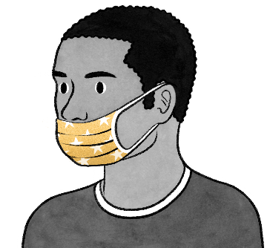 | DON’T: Wear the mask below your nose.
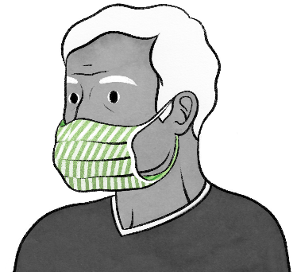 | DON’T: Wear your mask loosely with gaps on the sides.
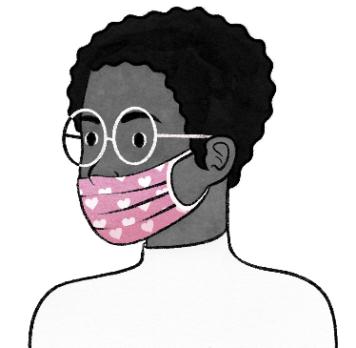 | DON’T: Wear your mask so it covers just the tip of your nose.
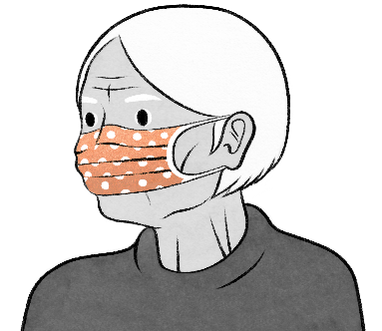 | DON’T: Leave your chin exposed.
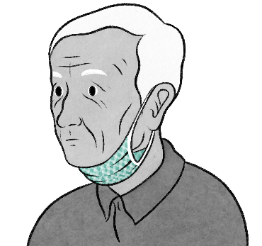 | DON’T: Push your mask under your chin to rest on your neck.
Images adapted from https://www.nytimes.com/2020/04/08/well/live/coronavirus-face-mask-mistakes.html

