LIQUID BIOHAZARDOUS WASTE

Liquid waste is deactivated by aspirating or dispensing into full strength household bleach.   
The advantage is that if there is a spill after collection, the liquid is not biohazardous.

Dilute full strength household bleach to a minimum 10% (final vol/vol) and allow to set for at least 20 minutes before sewering with an excess of water.

**Do not store for longer than 7 days at room temperature**

Tissue culture flasks used to generate viral vectors are solid medical waste.

It is not compliant to only bleach-treat tissue culture flasks that were used to generate viral vectors.

Deactivating large volumes of liquid waste by autoclave must be validated.

Transport solid medical waste in clean, tightly lidded secondary containers using a cart or dolly; do not hand-carry or transport untreated waste in open trays  
Decontaminate the surfaces of transport containers before leaving the lab

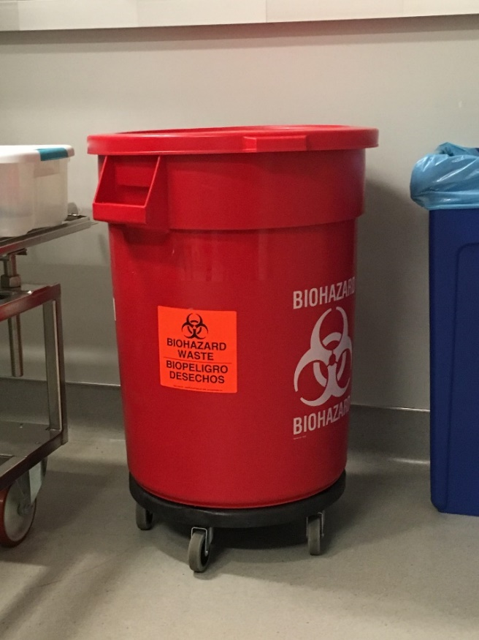

Do not “create a line” for autoclave use by leaving bags unattended in open trays.

**DISPOSAL AFTER AUTOCLAVING**

After you have verified the autoclave cycle, transfer the bags into the red-lidded toters that are designated for lab waste

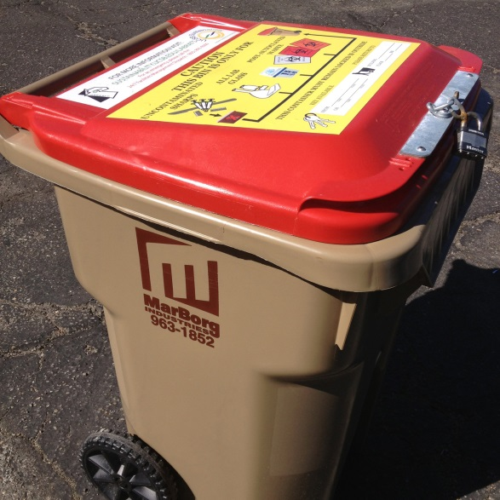

**DISPOSAL BY EXTERNAL VENDOR**

Red biohazard bags must be marked for impact and tear resistance standards, ASTM D1709 (165g) and ASTM D1922 (480g).

SOLID MEDICAL WASTE TRANSPORT

Solid MW must be collected in red bags marked with the biohazard symbol.  
Red bags must be in rigid, lidded and labeled secondary containment up until they are loaded into the autoclave.  
Collection containers must be kept lined and ready.

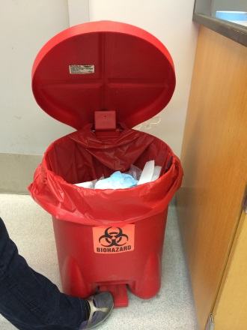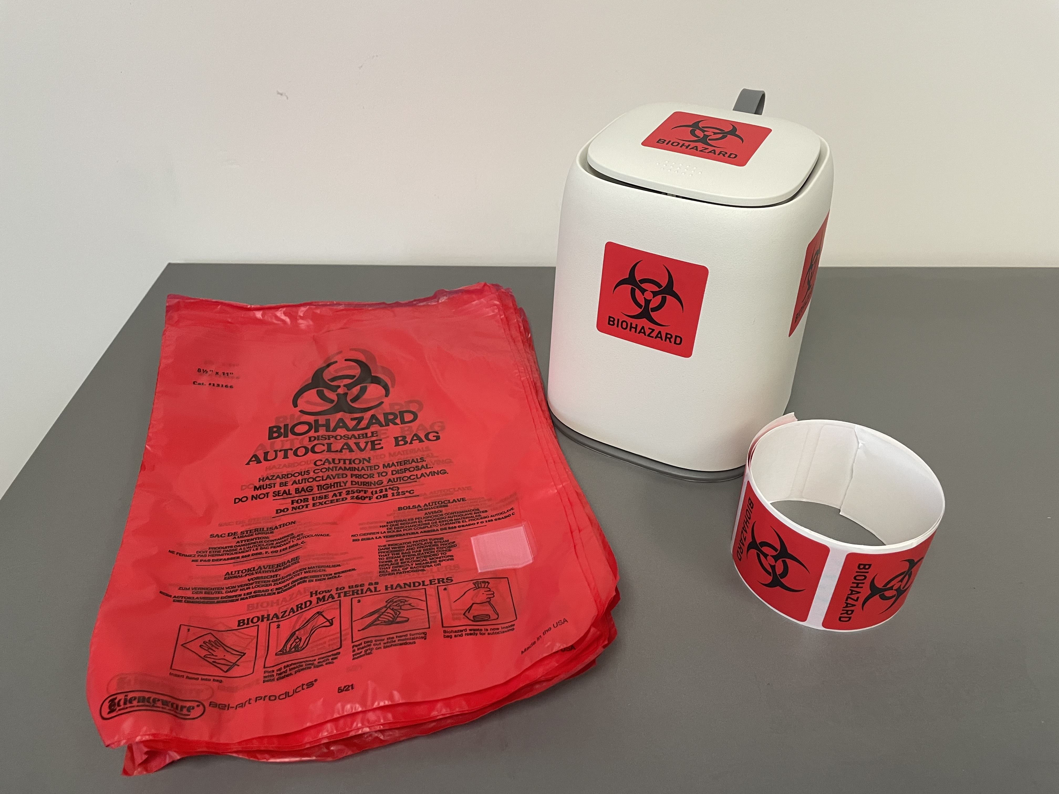

CDPH and EHS/Biosafety will inspect the contents of collection containers to ensure that waste is segregated at the point of generation.

**Solid Medical Waste Accumulation**

7 day storage limit above 0°C and at room temperature;   
90 day storage limit below 0°C.

Decontaminate the surfaces of secondary containers used for collection, accumulation and transport weekly or as needed using the same disinfectant used for lab surfaces.

SOLID MEDICAL WASTE COLLECTION

Biohazardous Sharps

Sharps waste includes waste with edges that are capable of cutting or piercing skin.

Sharps containers are single use; do not line containers with a bag.  
Sharps containers are rigid, leak proof, puncture resistant, and labeled with the biohazard symbol and have a sealable lid.   
Close containers when not in use  
Replace sharps waste containers when 2/3 full and do not overfill.

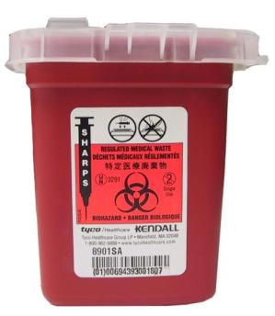  
When the container is no more than 2/3 full:  
Seal the lid, apply heat sensitive tape if there is no integrated temperature sensor, pretreat by autoclave using any autoclave, and label the container “autoclaved.”

Hand carry and leave at the labeled areas in   
**Bio II 4106**, **LSB 2204**, or **LSB 4218**where it will be picked up by EHS.

For other campus buildings, submit a Hazardous Waste pick up on the EHS website. Note on the request that the container has been autoclaved.

Chemo/Pharmaceutical Waste

Disposed of through the EHS Hazardous Waste as chemical hazardous waste   
Submit an online pick-up request; the label is filled out at the time that collection begins.  
Do not collect empty pipette tips as chemical hazardous waste.

Pathology Waste  
Pathology waste includes infectious animal carcasses. Pathology waste is bagged in red biohazardous waste bags, tied closed and secured in a -20°C freezer. Signage on transport and secondary containers needs to read “PATHOLOGY WASTE” with the biohazard symbol.

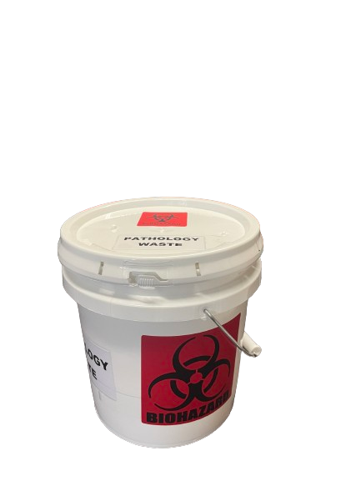

Signage is on the dedicated freezer, or on the secondary container within the freezer for a mixed-use freezer.   
There is a 90-day retention limit below 0°C.

Pathology waste is hand carried to the pickup location used by the medical waste hauler in a rigid and lidded container labeled as “PATHOLOGY WASTE” on the lid and sides so as to be visible from any lateral direction.

**UCSB   
Environmental Health and Safety  
Biological Safety  
Medical Waste Management**

This is designed as a quick reference on waste practices that comply with the California Medical Waste Management Act and that conform to University programs and local municipal waste contracts.

**Questions?** [**Biosafety@ehs.ucsb.edu**](mailto:Biosafety@ehs.ucsb.edu)

Medical waste (MW)is biohazardous waste

Biohazardous materials include human and nonhuman primate primary cells, replication incompetent viral vectors, and infectious risk group 2/BSL2 cultures.

Biohazardous sharps, solid, liquid, and pathology waste are segregated or separated at the time of generation.

<https://www.ehs.ucsb.edu/programs-services/biological-safety/medical-waste>