Standard Operating Procedure

Acrylamide

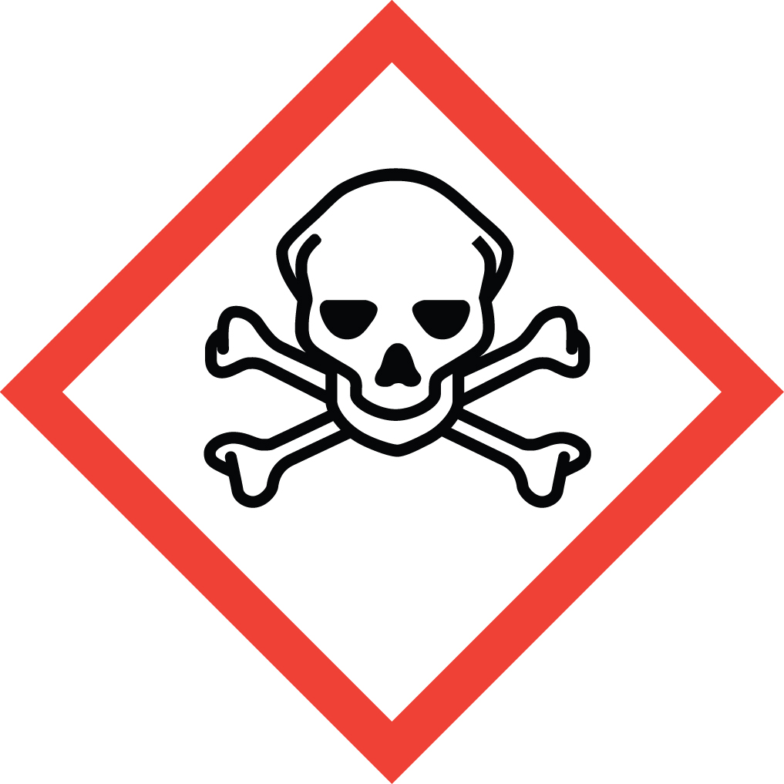Overview
Acrylamide is a Particularly Hazardous Substances (PHS). It penetrates intact skin very quickly. Avoid all direct skin contact. 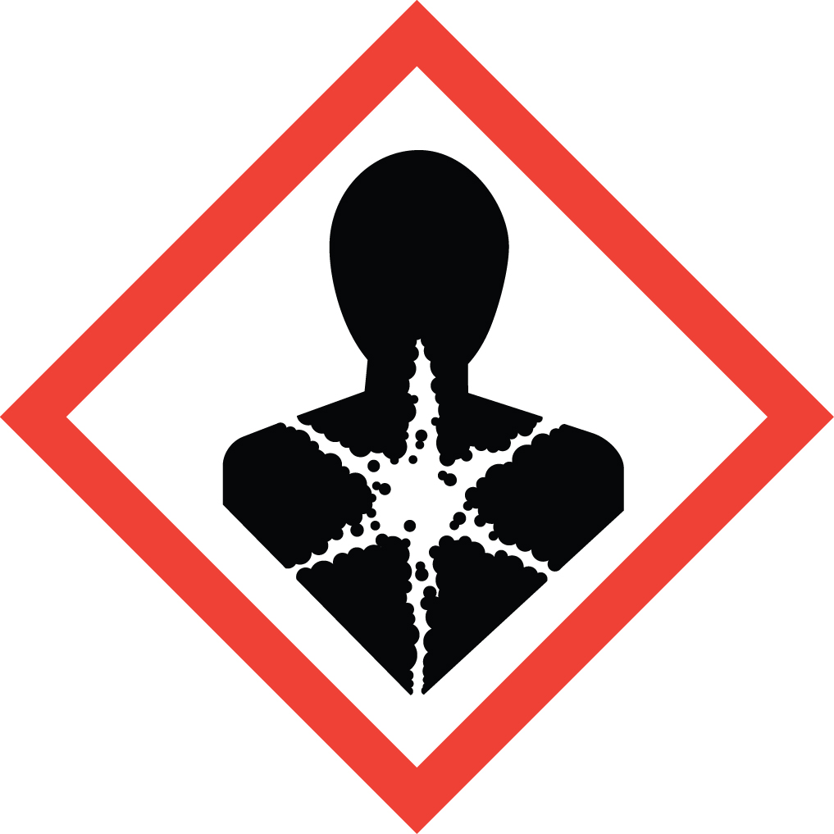Although the acute toxicity of acrylamide is moderate by ingestion or skin contact, the chronic toxicity is high. Chronic exposure causes damage to the central and peripheral nervous system. It is a skin sensitizer. Repeated skin exposure will lead to increasing symptoms of skin irritation and peeling. Additionally, it is listed as a “select carcinogen” by OSHA and is a reproductive toxin. Exposure by all routes must therefore be avoided.

Special Handling and Storage Concerns
Personal Protective Equipment
- Traditional white lab coat.
- Nitrile gloves.
- ANSI Z87.1-compliant safety glasses. Safety goggles if a splash hazard is present.
Special Storage Requirements
Acrylonitrile is a Particularly Hazardous Substance and should be stored and handled as such. May polymerize violently upon strong heating or exposure to strong base. May also react violently with strong oxidizers. Light sensitive. Store in a cool, dark, dry, refrigerated area. Store in a secondary container.
Engineering Controls
Fume Hood: All PHS must be handled in a fume hood. If this is not possible due to scale or equipment, contact EH&S to determine alternate ventilation approaches or respiratory protection needs.
Special Handling Considerations
Only use in a PHS designated area. Be cautious when heating or in the presence of strong base, as this may trigger violent polymerization.
Decontamination
Wearing proper PPE, clean the area with soap and water. Dispose of all the contaminated disposables as hazardous waste.

Waste Management
Standard waste management protocols apply.

First Aid and Emergencies
Spill
Treat all spills of these materials as a major spill. Do not attempt to clean up the spill yourself. Notify others in the area of the spill, including your supervisor. Evacuate the area and call 911. Remain on-site at a safe distance to provide detailed response to first responders. Report any exposures to EH&S.
Personnel Exposure
Skin or eye contact: Remove contaminated attire. Flush affected area with water for 15 minutes. If symptoms persist, get medical attention.
Inhalation: Move person to fresh air. Get medical attention immediately.
Ingestion: Rinse mouth with water. Get medical attention immediately.

Laboratory Specific Information
Prior Approval Required
☐ NO
☐ YES (describe):

Designated Area
☐ Entire Laboratory Area
☐ Other (describe):

Experimental Conditions of Use
Temperature Range:

Pressure Range:

Scale Range:

Other Relevant Details:

