Standard Operating Procedure

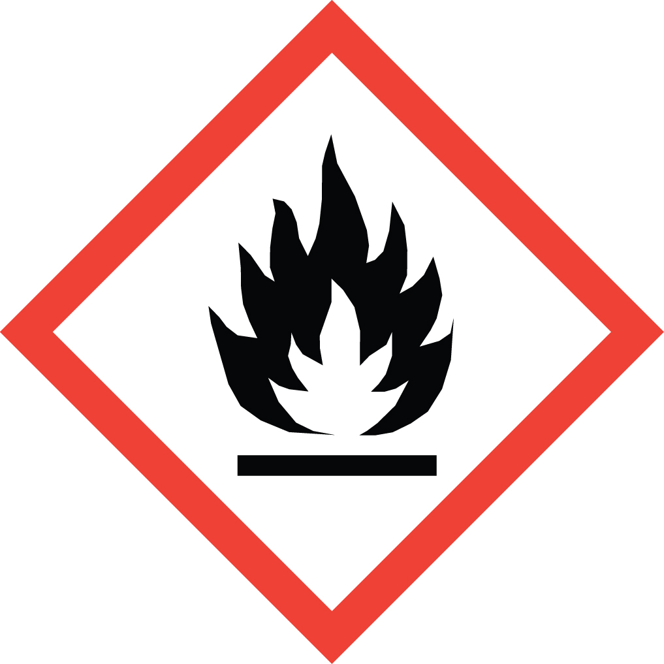 Acrylonitrile

Overview
Acrylonitrile is a Particularly Hazardous Substance (PHS), and has a large number of hazards associated with it:
- 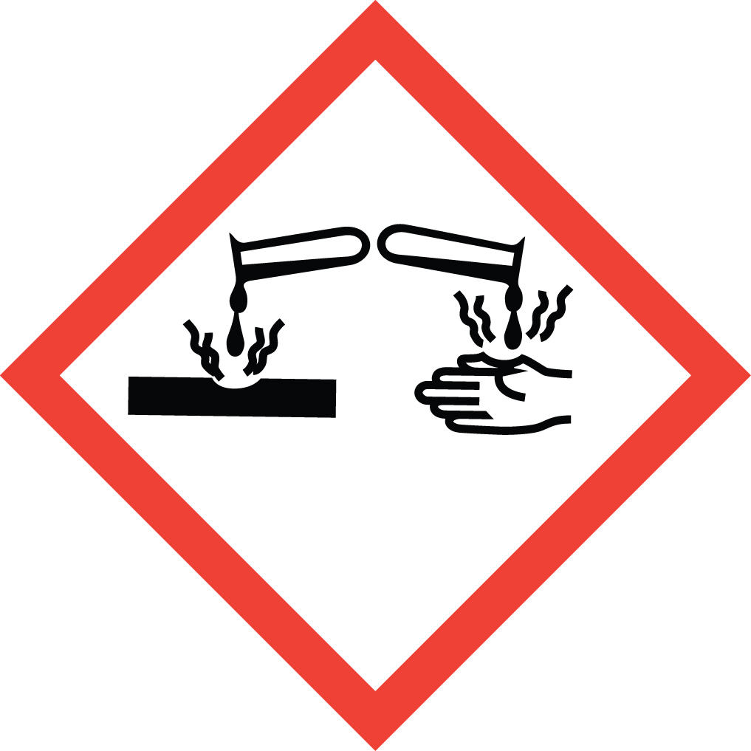Highly flammable
- Toxic if inhaled, ingested, or absorbed through skin
- Carcinogenic and a reproductive toxin
- Skin sensitizer and irritant
- Causes severe eye damage
- 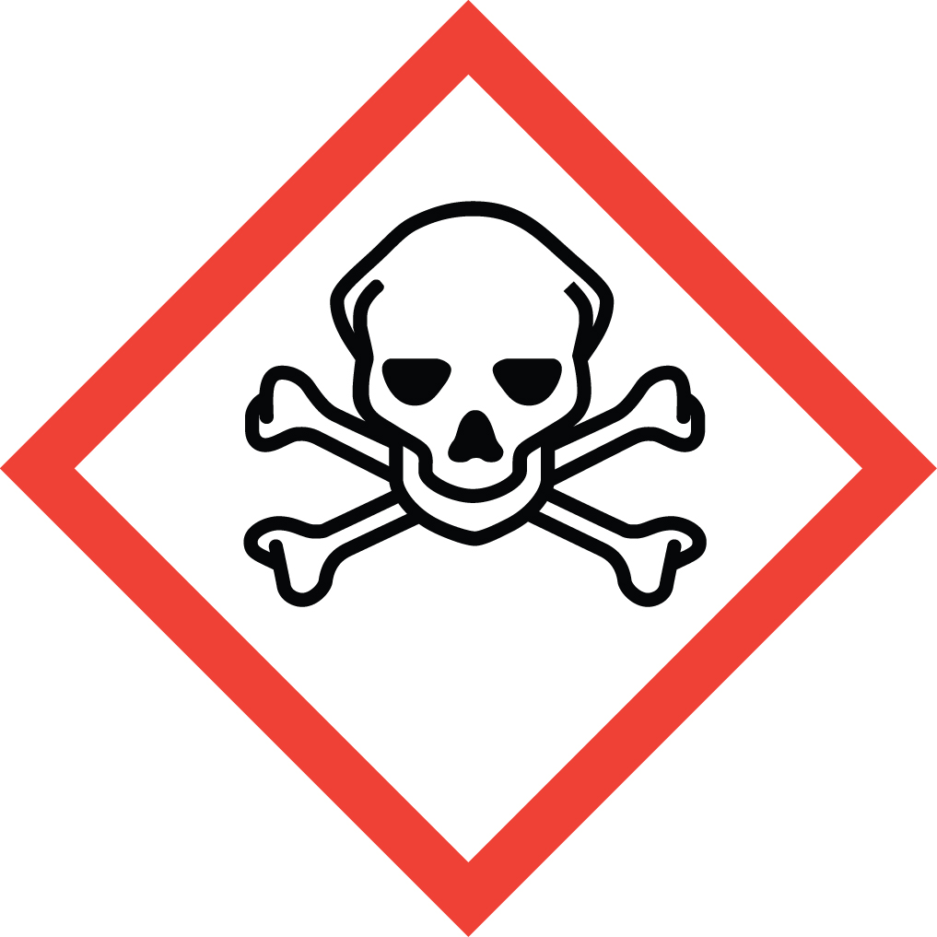Light, heat, strong acid and strong base sensitive (may cause explosive polymerization)

Special Handling and Storage Concerns
Personal Protective Equipment
- Flame resistant lab coat.
- Chloroprene gloves are adequate for possible incidental exposure. Thicker (0.3 mm) butyl rubber gloves are recommended if large splashes or immersion are possible.
- ANSI Z87.1-compliant safety goggles. Safety goggles and a face shield if a splash hazard is present.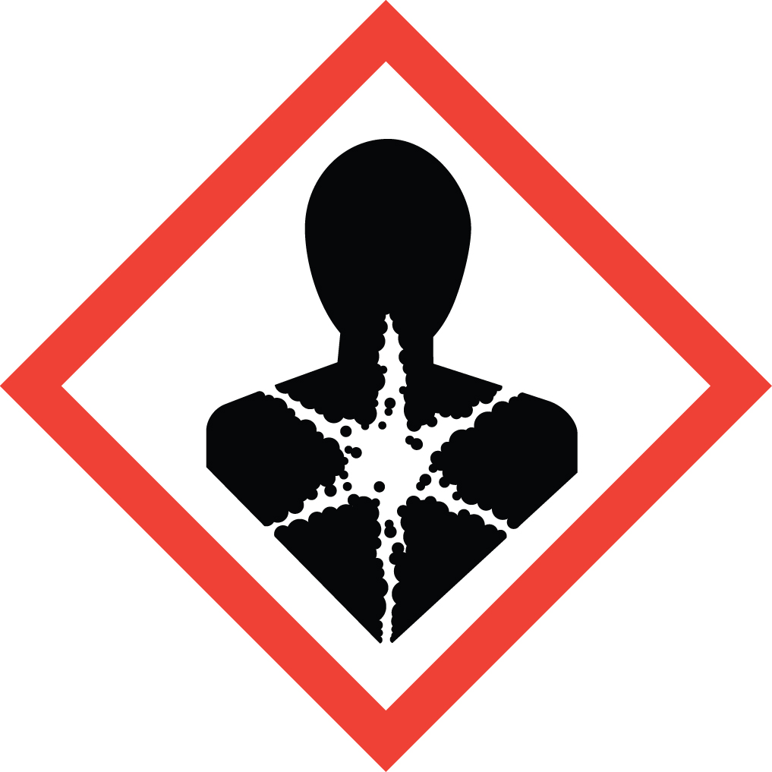
Special Storage Requirements
This material is light sensitive! Store in a dimly lit area away from direct sunlight. Store away from heat sources. Isolate from oxidizers, acids and bases. Label containers with all applicable hazard warnings, as this material has many and diverse hazards
Engineering Controls
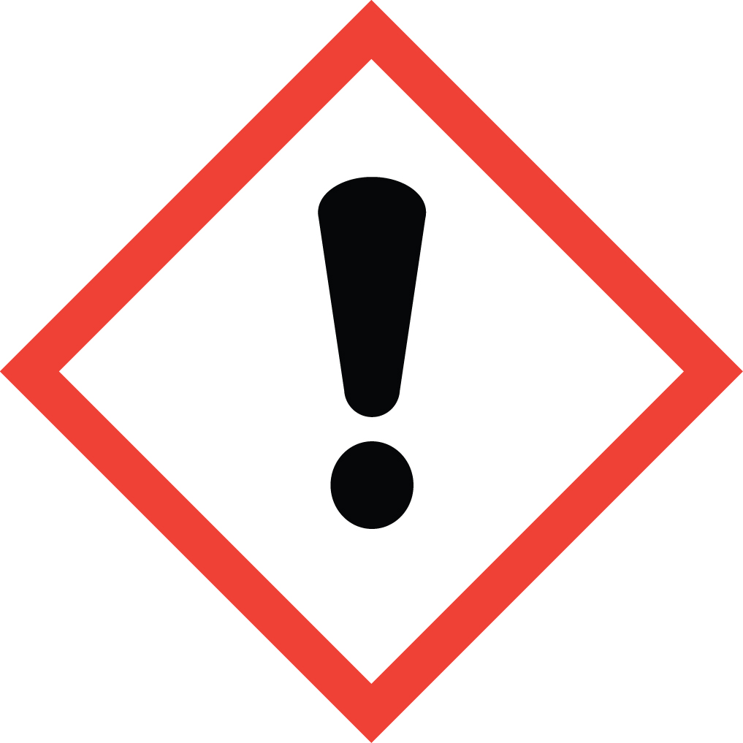If your protocol does not permit the handling of these materials in a fume hood, EH&S must be contacted to assess alternate ventilation options. Recommended exposure limits for acrylonitrile range from 1-2 ppm 8 hour time weighted average (TWA).
Special Handling Considerations
Only use in a PHS designated area. This designated area may be the entire laboratory, or only a portion of it. Be aware of possible explosive polymerization in the presence of heat, light, strong acids and strong bases.
Decontamination
Standard procedures apply. Use great caution in avoiding exposure.

Waste Management
Acrylonitrile waste is considered Extremely Hazardous Waste and should be handled as described in the UC Santa Barbara Chemical Hygiene Plan. This includes disposing of the emptied original container as hazardous waste through EH&S.

First Aid and Emergencies
Spill
Treat all spills of acrylonitrile as a major spill. Do not attempt to clean up the spill yourself. Notify others in the area of the spill, including your supervisor. Evacuate the area and call 911. Remain on-site at a safe distance to provide detailed response to first responders. Report any exposures to EH&S.
Fire
Standard firefighting measures apply.
Personnel Exposure
Skin or eye contact: Remove contaminated attire. Flush affected area with water for 15 minutes. If symptoms persist, get medical attention.
Inhalation: Move person to fresh air. Get medical attention immediately.
Ingestion: Rinse mouth with water. Get medical attention immediately.

Laboratory Specific Information
Prior Approval Required
☐ NO
☐ YES (describe):

Designated Area (Required for Particularly Hazardous Substances)
☐ Entire Laboratory Area
☐ Other (describe):

Experimental Conditions of Use
Temperature Range:

Pressure Range:

Scale Range:

Other Relevant Details:

