Standard Operating Procedure

Aqua Regia

Nitric Acid/Hydrochloric acid, 1:3 V/V

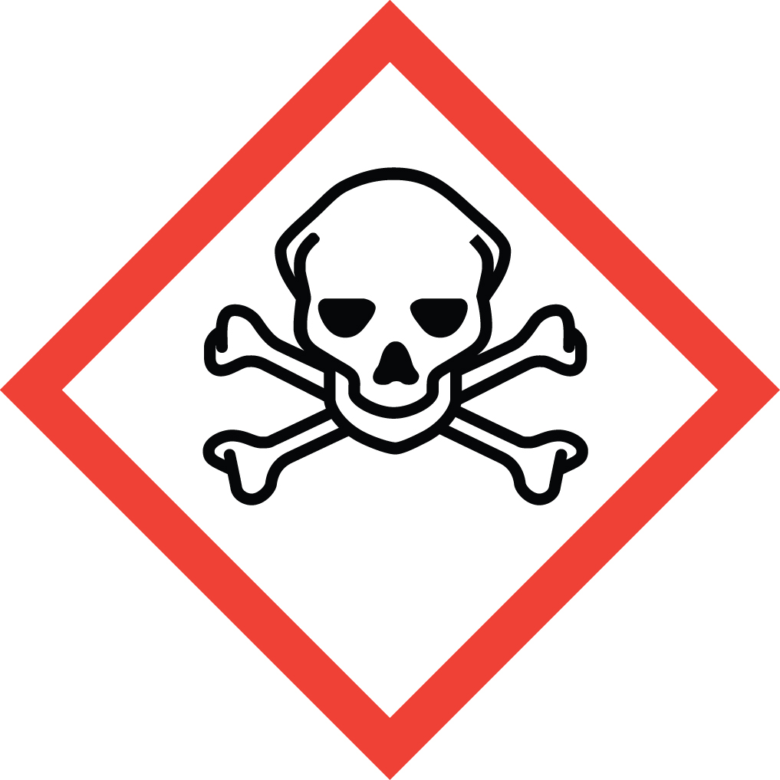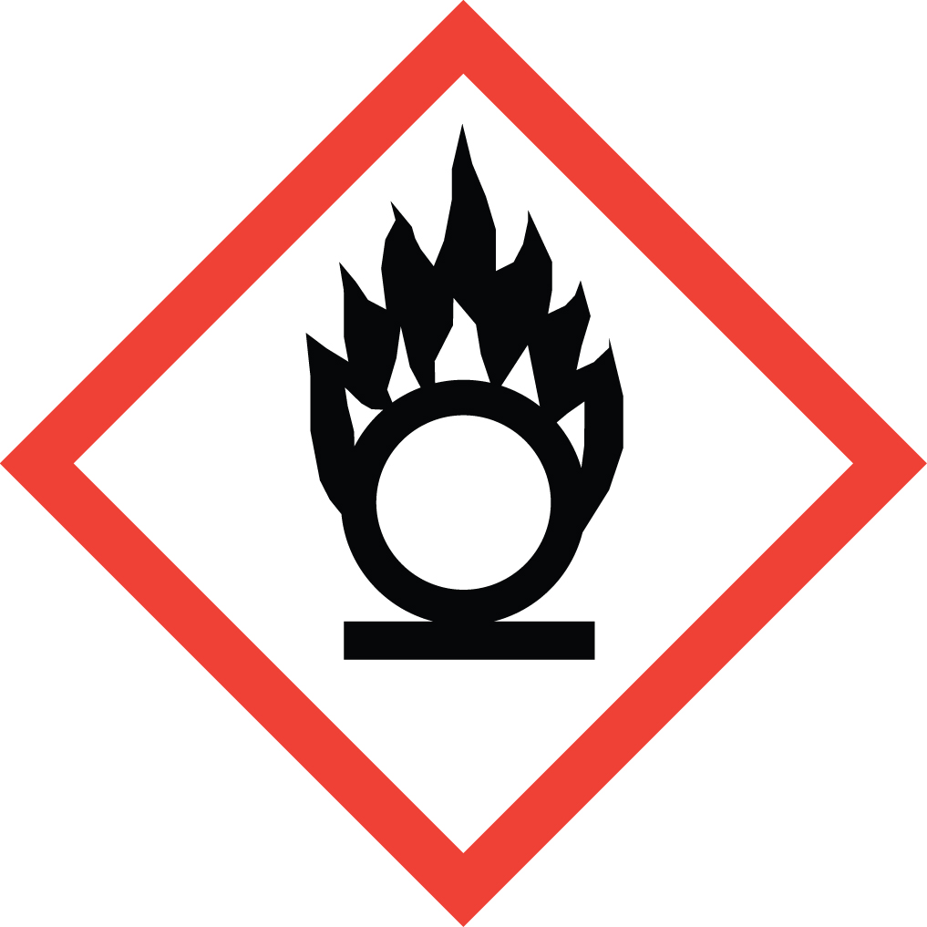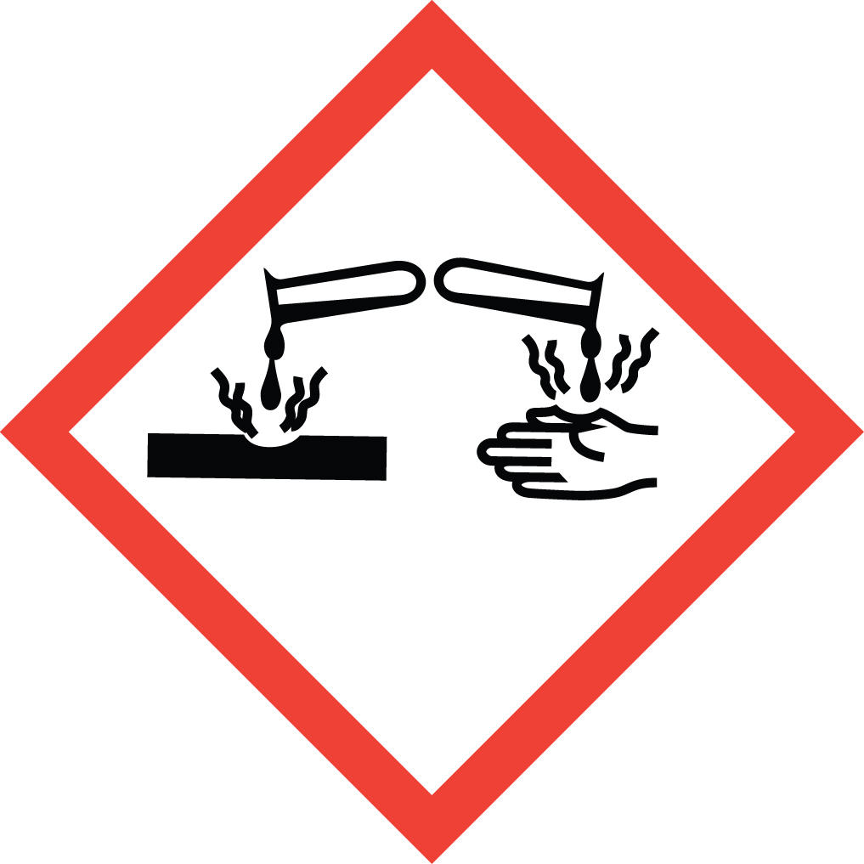Overview
Combination of these two acids forms nitrosyl chloride (NOCl), chlorine (Cl2), and water; both chlorine and nitrosyl chloride are yellow colored and volatile. Aqua regia solutions are extremely corrosive and may result in explosion or skin burns if not handled with extreme caution. It causes destruction of living tissue at site of contact. Corrosive effects can occur not only on the skin and eyes, but also in the respiratory tract. Aqua regia is also a strong oxidizing agent and can cause violent explosions when combined with reducing agents such as organic solvents. Combination of aqua regia waste with other non-compatible waste streams is a major cause of laboratory explosions.

Special Handling and Storage Concerns
Personal Protective Equipment
- Traditional white lab coat. Chemical resistant apron when working with large volumes.
- Nitrile or neoprene gloves are adequate for possible incidental exposure. Viton gloves if large splashes are possible. No latex gloves!
- ANSI Z87.1-compliant safety goggles. Safety goggles or safety goggles plus face shield if a large splash hazard is present.
Special Storage Requirements
Mix a fresh solution for each use. Avoid storing aqua regia. If small amounts are stored, store separately from other all organic materials, reducing agents, bases, alkali metals, cyanides, and powdered metals. Use vented caps, available free of charge from EH&S. Ensure secondary containment is used. Do not store directly on wooden shelves. Dispose of as rapidly as is practical.
Engineering Controls
An eye wash/safety shower unit must be within a 10 second walk (about 35 feet) from where corrosives are being handled, with only a single intervening door, opening in the direction of travel.
Aqua regia generates toxic gases upon formation, and upon use with metals. A fume hood must be used when handling this material. If your protocol does not permit the handling of these materials in a fume hood, contact EH&S for an assessment of alternative ventilation options.
Special Handling Considerations
Mix the solution in a fume hood with the sash between you and the solution. Always use glass, preferably Pyrex, containers. Always add the nitric acid to the hydrochloric acid slowly. The mixture will become hot, therefore leave in an open container until cool. When forming solutions/dilutions, to avoid serious splatter risk add the aqua regia to water, and never the reverse. Mixing aqua regia with organic compounds may cause an explosion.
Decontamination
Standard decontamination protocols apply.

Waste Management
Aqua regia waste must be segregated from organic or reducing agent waste. Best practice is to store aqua regia containing waste streams in dedicated containers segregated from all other waste streams. Reduce in-lab storage time by selecting small (<1L) containers that are filled and removed from the laboratory promptly. Waste pickup should be requested only after the aqua regia waste has cooled and all reaction has stopped. Upon scheduled waste pickup, seal waste bottle using vented caps provided by EH&S. Combination of nitric acid waste with other non-compatible waste streams is a major cause of laboratory explosions.

First Aid and Emergencies
Spill
Standard spill procedures apply
Fire
Standard firefighting measures apply.
Personnel Exposure
Standard measures apply. Pay extra attention to flushing affected skin/eyes with water for a full 15 minutes using an eyewash/safety shower unit.

Laboratory Specific Information
Prior Approval Required
☐ NO
☐ YES (describe):

Designated Area
☐ Entire Laboratory Area
☐ Other (describe):

Experimental Conditions of Use
Temperature Range:

Pressure Range:

Scale Range:

Other Relevant Details:

