Standard Operating Procedure

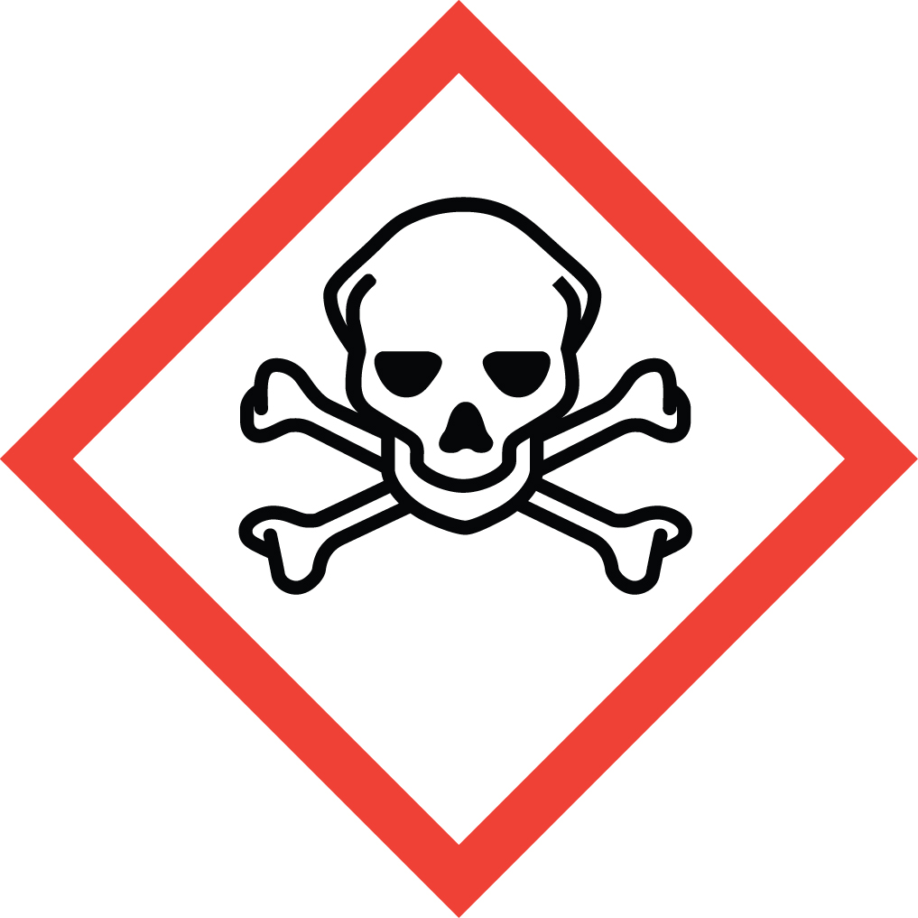 Nitric Acid

Overview

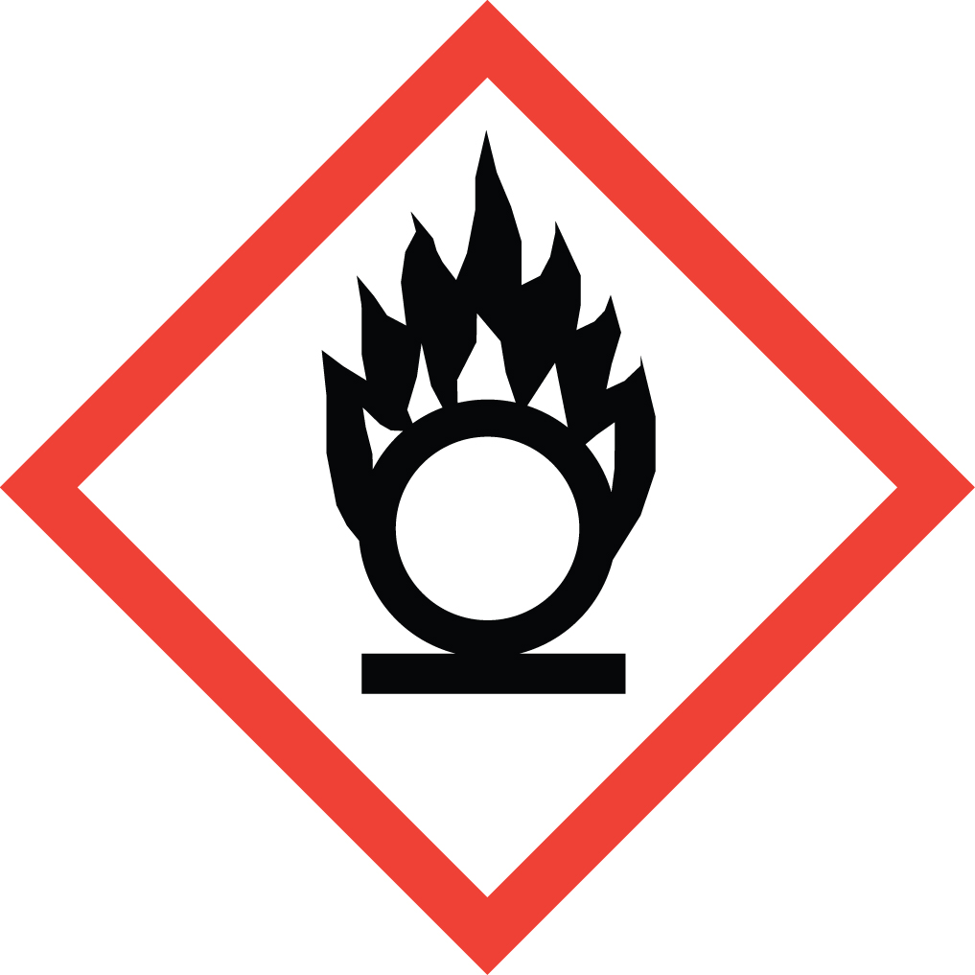Nitric acid is an extremely corrosive acid and strong oxidizing agent. It may be harmful if ingested, inhaled, or absorbed through the skin. It can cause severe skin and eye burns resulting in irreversible damage. It is extremely destructive to the tissue of the mucous membranes and the upper respiratory tract.

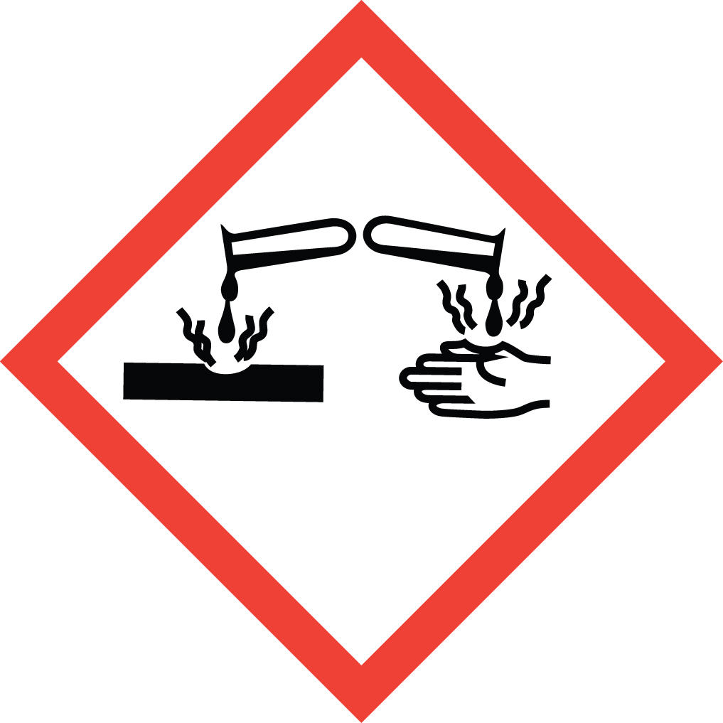As a strong oxidizing agent, it can cause violent explosions when combined with reducing agents such as organic solvents and reagents. Therefore great care must be taken to store it separately from organic acids, flammable and combustible liquids (such as organic solvents), and organic reagents in general. Nitric acid waste must also be segregated from all other organic waste. Combination of nitric acid waste with other non-compatible waste streams is a major cause of laboratory explosions.

Special Handling and Storage Concerns
Personal Protective Equipment
- Traditional white lab coat. Chemical resistant apron when working with large volumes.
- Nitrile or neoprene gloves are adequate for possible incidental exposure. Viton gloves if large splashes are possible. No latex gloves!
- ANSI Z87.1-compliant safety glasses. Safety goggles or safety goggles plus face shield if a large splash hazard is present.
Special Storage Requirements
Store separately from other laboratory chemicals with which it may react. For oxidizing acids such as nitric acid this includes all organic materials including organic acids, reducing agents, bases, alkali metals, cyanides, and powdered metals. Ensure secondary containment is used. Do not store directly on wooden shelves.
Engineering Controls
If your protocol does not permit the handling of these materials in a fume hood, assess the volatility of the material (e.g. hydrochloric acid) and contact EH&S if alternative ventilation options are necessary.
An eye wash/safety shower unit must be within a 10 second walk (about 35 feet) from where corrosives are being handled, with only a single intervening door, opening in the direction of travel.
Special Handling Considerations
When forming solutions/dilutions, to avoid serious splatter risk add the corrosive to water, and never the reverse.

Waste Management
Nitric acid waste must be segregated from organic or reducing agent waste. Best practice is to store nitric acid containing waste streams in dedicated containers segregated from all other waste streams. Reduce in-lab storage time by selecting small (<1L) containers that are filled and removed from the laboratory promptly.
Combination of nitric acid waste with other non-compatible waste streams is a major cause of laboratory explosions.

First Aid and Emergencies
Spill
Standard spill procedures apply
Fire
Standard firefighting measures apply.
Personnel Exposure
Standard measures apply.

Laboratory Specific Information
Prior Approval Required
☐ NO
☐ YES (describe):

Designated Area
☐ Entire Laboratory Area
☐ Other (describe):

Experimental Conditions of Use
Temperature Range:

Pressure Range:

Scale Range:

Other Relevant Details:

