Standard Operating Procedure

Oxidizers

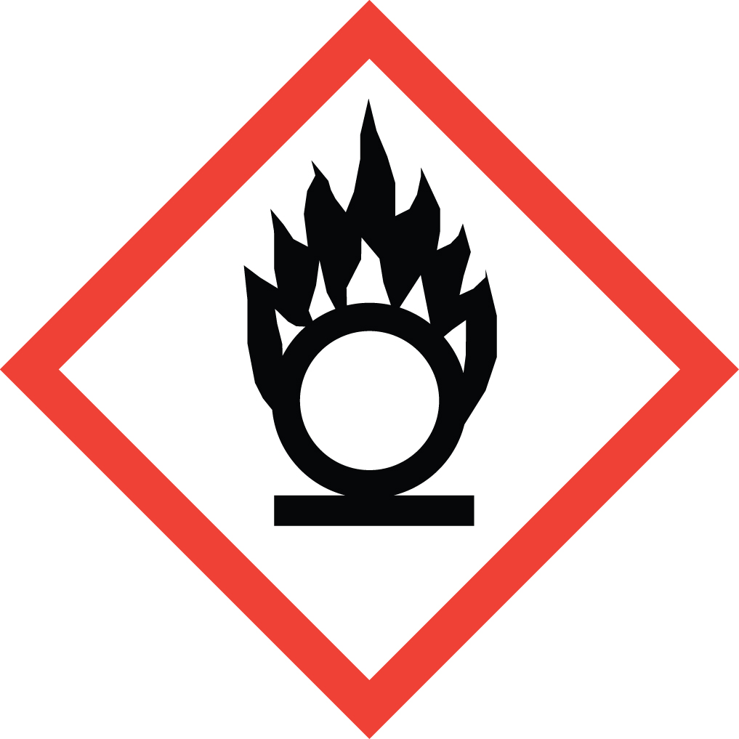Overview
Oxidizers are chemicals that cause or increase the intensity of the combustion of other materials. This can occur at room temperature, or with slight heating. Strong oxidizers are capable of forming explosive mixtures when mixed with combustible, organic, or easily oxidized material.

Special Handling and Storage Concerns
Personal Protective Equipment
- Flame resistant lab coat.
- Neoprene or butyl rubber gloves are adequate for possible incidental exposure. Consult a glove chart if a high risk of skin contact is present.
- ANZI Z87.1-complaint safety glasses or. Safety goggles if a large splash hazard is present.
Special Storage Requirements
It is essential that all strong oxidizers be stored separately from all chemicals with which they may react. Do not store oxidizers directly on wooden shelves. Ensure secondary containment and segregation of incompatible chemicals. Also, follow any substance-specific storage guidance provided in Safety Data Sheet (SDS) documentation.
Engineering Controls
Fume hood: Handle oxidizers in a chemical fume hood to minimize the potential for the spread of a fire should one occur. Note that the handling of perchloric acid may require the use of a specialized perchloric acid fume hood, or an alternative vapor-capturing device. See the Perchloric Acid SOP template for more information.
Blast shield: A blast shield is recommended whenever there is a risk of explosion. Examples of strong oxidizers with high explosion risk include: hydrogen peroxide (52-91% by weight), fuming nitric acid, perchloric acid (60-72% by weight), etc. Refer to the SDS of the material in question for specific information on its oxidizing potential.
Special Handling Considerations
Rigorously label all reagent and waste containers. Inadvertent mixing of oxidizers and organic material is one of the most common causes of laboratory explosions.
Decontamination
This SOP covers a wide range of materials. Consult the SDS for any possible special decontamination procedures.

Waste Management
Carefully segregate oxidizer waste from all organic waste, as combining these waste streams is a serious explosion hazard. Collect oxidizer waste in as small a container as is practical, and schedule a pick-up with EH&S as soon as the container is full, or no further oxidizer waste will be generated. Vented caps must be used on containers for waste streams of oxidizing inorganic acids or pressure-generating materials.

First Aid and Emergencies
Spill
Standard measures apply
Fire
Standard measures apply
Personnel Exposure
This SOP covers a wide range of materials. Consult the SDS for any possible special considerations.

Laboratory Specific Information
Prior Approval Required
☐ NO
☐ YES (describe):

Designated Area
☐ Entire Laboratory Area
☐ Other (describe):

Experimental Conditions of Use
Temperature Range:

Pressure Range:

Scale Range:

Other Relevant Details:

