Standard Operating Procedure

Phosgene

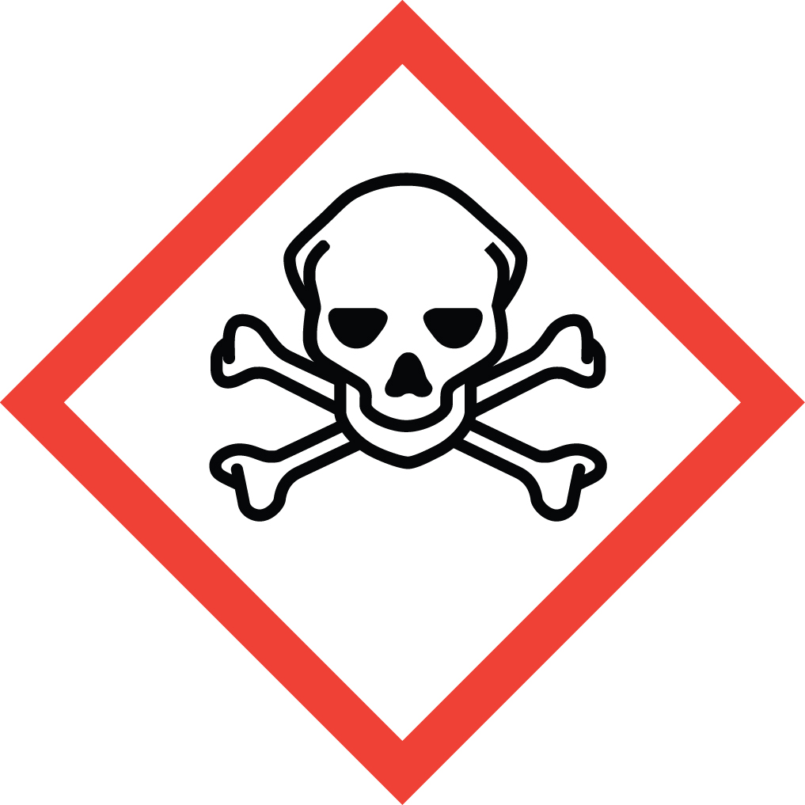Overview
Highly toxic gas! Extreme danger!
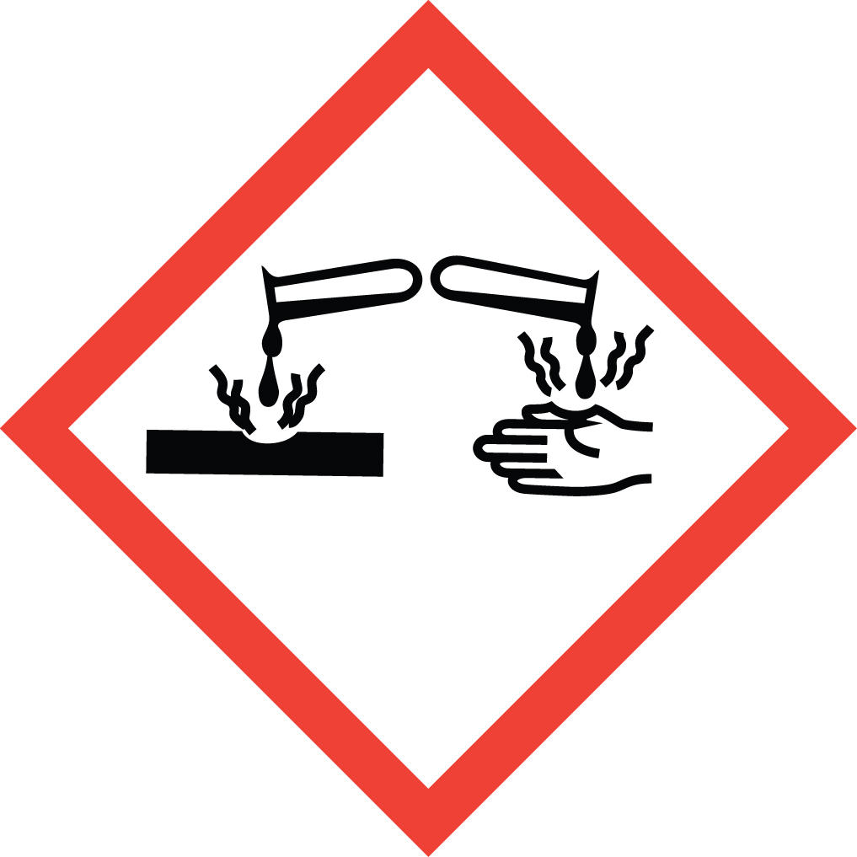Phosgene is a highly toxic, irritating and corrosive gas to all body tissues. Inhalation can cause fatal respiratory damage.
- Exposure by inhalation to 20-30 ppm for as little as 1 minute may cause severe irritation of the upper and lower respiratory tract, with symptoms including burning throat, nausea, vomiting, chest pain, coughing, shortness of breath, and headache.
- Brief exposure by inhalation to 50 ppm can be fatal within a few hours.
The vapor is irritating to the eyes and skin at 4 ppm. As a condensed liquid it can cause severe skin burns and serious eye damage.

Special Handling and Storage Concerns
Personal Protective Equipment
Complete protection of the eyes and skin is essential.
- Traditional white lab coat.
- Nitrile or chloroprene gloves. If using phosgene in solution, ensure that your gloves are compatible with the solvent.
- ANSI Z87.1-compliant safety goggles. Safety goggles and a face shield if working on larger scale.
Special Storage Requirements
Keep quantities to a minimum. Keep containers tightly closed and in a toxic gas cabinet or fume hood. Keep away from water/moisture. Segregate from amines, ammonia and alcohols.
Engineering Controls
Whenever possible, phosgene should be handled inside of a Glove Box. If not, then a Fume Hood must be used.
Special Handling Considerations
Avoid ALL contact with skin and eyes. Absolutely avoid breathing in vapors. Confirm that glove box, fume hood and all other engineering controls are working properly before beginning any work with phosgene. Confirm that gloves, safety goggles and any other personal protective equipment are in good condition and not compromised in any way before beginning work with phosgene.

Decontamination
Rinse any equipment which may have come in contact with phosgene with water inside of a chemical fume hood, then wash with soap and water.

Waste Management
Keep waste to a minimum by keeping quantities in storage to a minimum. Phosgene is considered Extremely Hazardous Waste and should be handled as described in the UC Santa Barbara Chemical Hygiene Plan. This includes disposing of the emptied original container as hazardous waste through EH&S.

First Aid and Emergencies
Spill
In the event of a leaking phosgene cylinder or spilled phosgene solution, EVACUATE the lab immediately and CALL 911. Remain on-site at a safe distance to provide detailed response to first responders.
Personnel Exposure
If you believe that you may have been exposed to phosgene by any route, SEEK MEDICAL ATTENTION IMMEDIATELY. The effects of phosgene poisoning may be delayed. Rescue of a person exposed to phosgene should only be attempted by trained personnel equipped with self-contained breathing apparatus if the presence of phosgene fumes is suspected. Artificial respiration should only be attempted by trained medical personnel. It may be dangerous to the person providing aid to give mouth-to-mouth resuscitation.

Laboratory Specific Information
Prior Approval Required
☐ NO
☐ YES (describe):

Designated Area
☐ Entire Laboratory Area
☐ Other (describe):

Experimental Conditions of Use
Temperature Range:

Pressure Range:

Scale Range:

Other Relevant Details:

