Standard Operating Procedure

Quenching Solvent Drying Still Bottoms

Overview
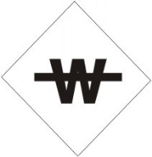
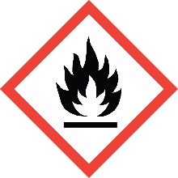
Solvent drying stills utilized water-reactive materials such as sodium, potassium and metal hydrides. The combination of these materials with flammable solvents presents a significantly high level of risk when quenching the bottom of a still that is to be taken down or regenerated. The reaction between water reactive materials and even trace amounts of water produces hydrogen gas and is very exothermic, leading to fire and explosion hazards. Care must be taken when adding water reactives to a solvent, and when adding water/protic solvents to a still as part of the quenching operations

Often the drying agent can become covered in a tar that blocks the ability of protic solvents to react with and quench the material. This can lead to addition of excess quenching agent followed by a sudden runaway reaction once the quenching agent penetrates the tar. Efficient stirring and addition of high boiling inert solvent as described below will mitigate this risk.

Related SOPs: [ADD LINKS]
- Flammables
- Pyrophoric, Water Reactive, and Self-Heating Materials

Special Handling and Storage Concerns
Personal Protective Equipment
- Flame Resistant Lab Coat.
- Nitrile or Neoprene Gloves are adequate for possible incidental exposure. Consult a glove chart if large splashes or immersion are possible.
- ANSI Z87.1-compliant safety glasses. Safety goggles if a large splash hazard is present.
Special Storage Requirements
Solvent stills must be stored in a fume hood
Engineering Controls
This operation must be conducted in a fume hood, with no additional chemicals present.
Special Handling Considerations
Never Perform this operation alone.
All operations must be conducted under an inert atmosphere (Nitrogen or Argon).
Have a class D fire extinguisher or bucket of sand readily available.
- Remove excess unused solvent from the still pot either by careful decantation, or by distillation before dismantling of the still.
- Refill the still pot with dry toluene or xylene. Place in an ice/water bath. Make sure to add ice throughout the quenching procedure.
- Equip pot with a reflux condenser and addition funnel. To the addition funnel add dry tert-butyl alcohol in a quantity sufficient to quench twice the amount of drying agent used.
- Add the alcohol dropwise while stirring vigorously. Slow down or stop addition if solution begins to bubble and boil too vigorously.
- Upon completion, repeat steps 3 and 4 with isopropanol and then methanol.
- When no further bubbling is seen upon the addition of methanol. Ad 1 mL water to confirm that all metal has been quenched.
- Dispose of the final mixture in as hazardous waste. Note that this mixture will be extremely corrosive
Decontamination
Standard decontamination procedures apply.

Waste Management
NO ALUMINUM CONTAINERS! This extremely corrosive waste will react with Aluminum to generate hydrogen gas, heat and pressure. This is a significant explosion hazard!

First Aid and Emergencies
Spill
If the spill includes unquenched drying agent, a spontaneous fire may result. These metal fires require a Class D fire extinguisher, or alternatively a small metal fire can be extinguished by pouring sand over it. However, the resulting solvent fire can be controlled by the more standard Class ABC extinguisher. If the fire is out of control, or you are not comfortable fighting it, leave the laboratory and close the door. Notify your neighbors and pull the manual fire alarm if one is present.
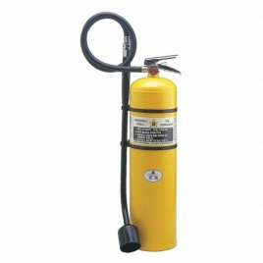
Fire
Pyrophoric and water reactive metal fires require a Class D fire extinguisher. Smaller fires can be extinguished by pouring dry sand over the metal.
Flammable solvent fires can be extinguished with the more standard Class ABC extinguisher.

Laboratory Specific Information
Prior Approval Required
☐ NO
☐ YES (describe):

Designated Area
☐ Entire Laboratory Area
☐ Other (describe):

Experimental Conditions of Use
Temperature Range:

Pressure Range:

Scale Range:

Other Relevant Details:

