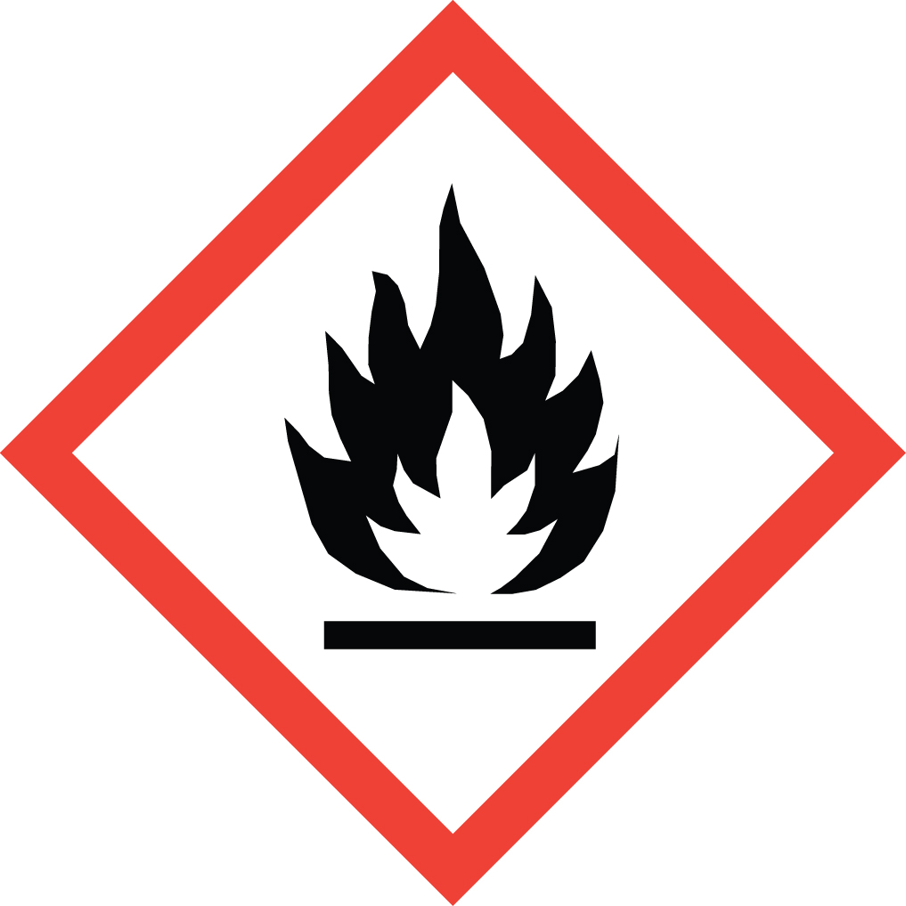 Standard Operating Procedure

(Trimethylsilyl)diazomethane

Overview
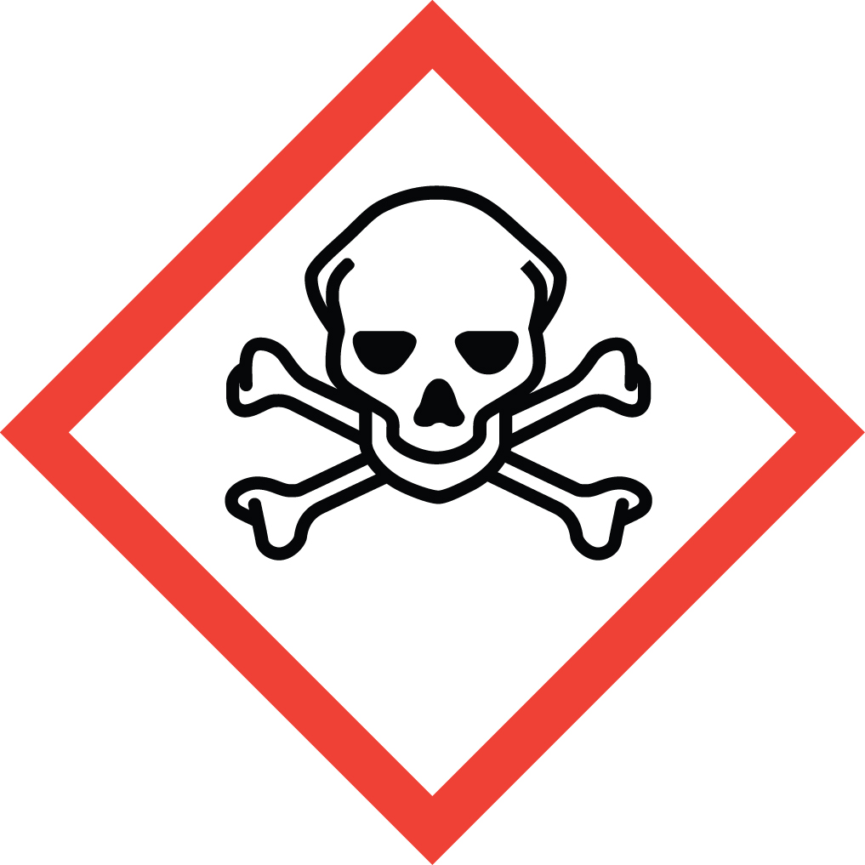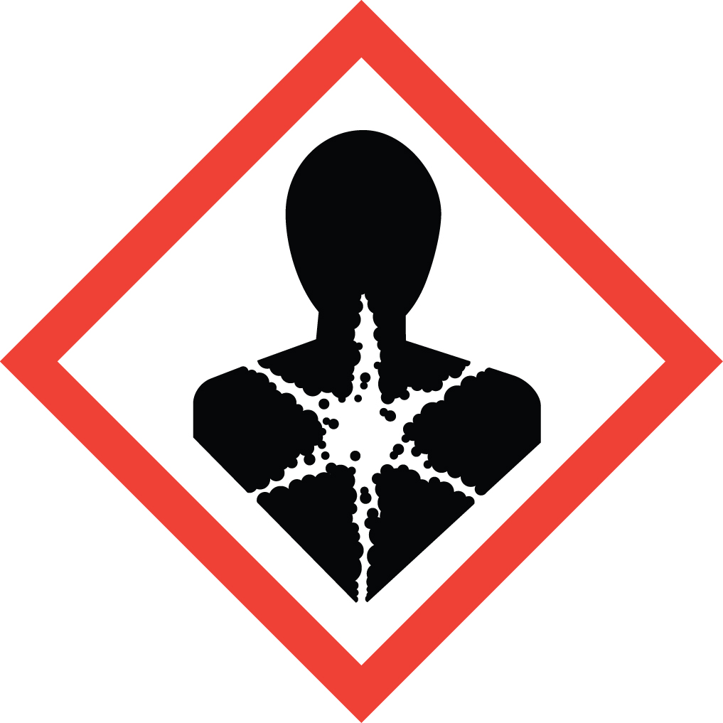EXTREMELY TOXIC! (Trimethylsilyl)diazomethane is a flammable liquid that is very toxic when inhaled. Inhalation can cause pulmonary edema, which can be fatal. It may be harmful if ingested or absorbed through the skin. It causes respiratory tract, skin, and eye irritation. Symptoms may be delayed for hours. It is suspected to cause cancer and damage to fertility. Chronic inhalation exposure may cause damage to the nervous system. It is regarded as a less explosive alternative to diazomethane, but it should still be handled with care. Exposure to TMSD resulting in death from respiratory distress has been reported. TMSD in alcoholic solvents under basic or acidic conditions can lead to the formation of the much more toxic and explosive diazomethane.

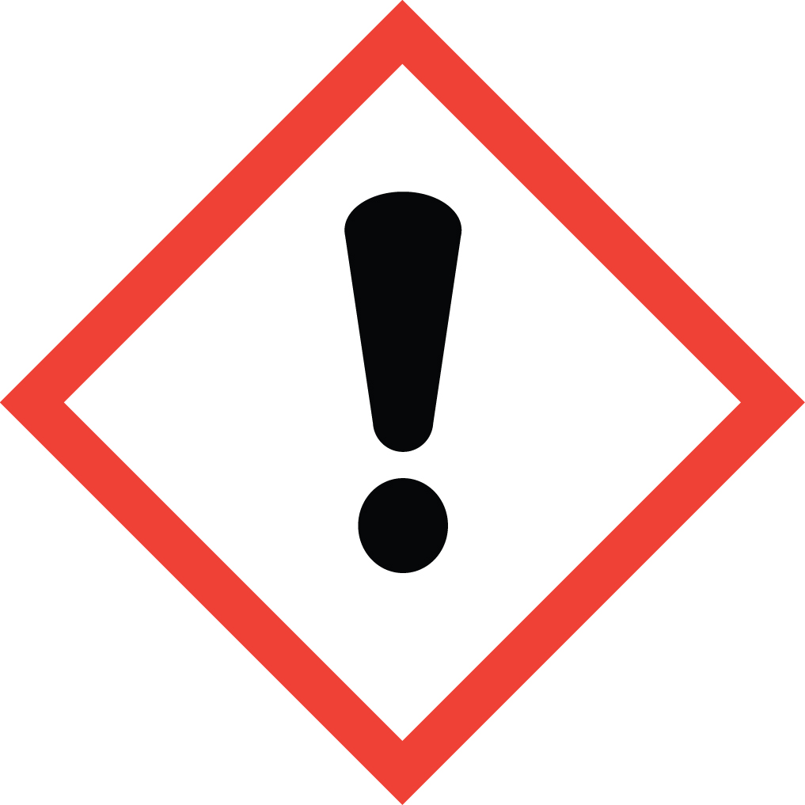Special Handling and Storage Concerns
Personal Protective Equipment
- Flame Resistant Lab Coat.
- Double glove with nitrile or neoprene gloves.
- ANSI Z87.1-compliant safety goggles and face shield.
Special Storage Requirements
Carefully reseal container after opening to prevent leaks. Store under an inert atmosphere.
Engineering Controls
Fume Hood: TMSD must be handled in a fume hood.
Blast Shield: A portable blast shield or other form of shielding should be between the apparatus and the user in case of in situ diazomethane formation and possible resulting explosion. A fume hood sash is not an adequate shield for an explosion hazard of this magnitude.
Special Handling Considerations
Unlike diazomethane, TMSD is a liquid at room temperature. Therefore, if there is any liquid residue on laboratory equipment or gloves, DO NOT REMOVE THEM FROM THE FUME HOOD. Remove contaminated gloves in the fume hood, carefully to avoid skin contact with the material. Follow decontamination protocols as described in the section below.
Decontamination
TMSD reacts quickly with acetic acid. Soak contaminated items in an acetic acid/water bath until gas generation ceases. Add more acetic acid to bath to ensure complete reaction and presence of excess acetic acid. Check the pH of the solution to confirm acidity.

Waste Management
Do not dispose of unreacted (trimethylsilyl)diazomethane. Quench solutions by adding acetic acid dropwise until the yellow color is gone and gas evolution ceases. The resulting mixture can then be disposed of in regular waste streams.

First Aid and Emergencies
Spill
Evacuate the building immediately: Leave the laboratory and close the door. Notify nearby personnel that they should leave the building. Pull the fire alarm. Remain in the building’s emergency assemble area and inform emergency responders of the situation when they arrive.
Fire
Do not attempt to fight a (trimethylsilyl)diazomethane fire. Leave the laboratory and close the door. Notify nearby personnel that they should leave the building. Pull the fire alarm. Remain in the building’s emergency assemble area and inform emergency responders of the situation when they arrive.
Personnel Exposure
Inhalation: Move person to fresh air. Symptoms may be delayed for hours after exposure. Call 911.
Skin and Eye contact: Flush with large quantities of water for 15 minutes. If symptoms persist, get medical attention as soon as possible.
Ingestion: Do not induce vomiting. Rinse mouth with water. Call 911.

Laboratory Specific Information
Prior Approval Required
☐ NO
☐ YES (describe):

Designated Area
☐ Entire Laboratory Area
☐ Other (describe):

Experimental Conditions of Use
Temperature Range:

Pressure Range:

Scale Range:

Other Relevant Details:

