Standard Operating Procedure

Pyrophoric, Water Reactive and Self-Heating Materials

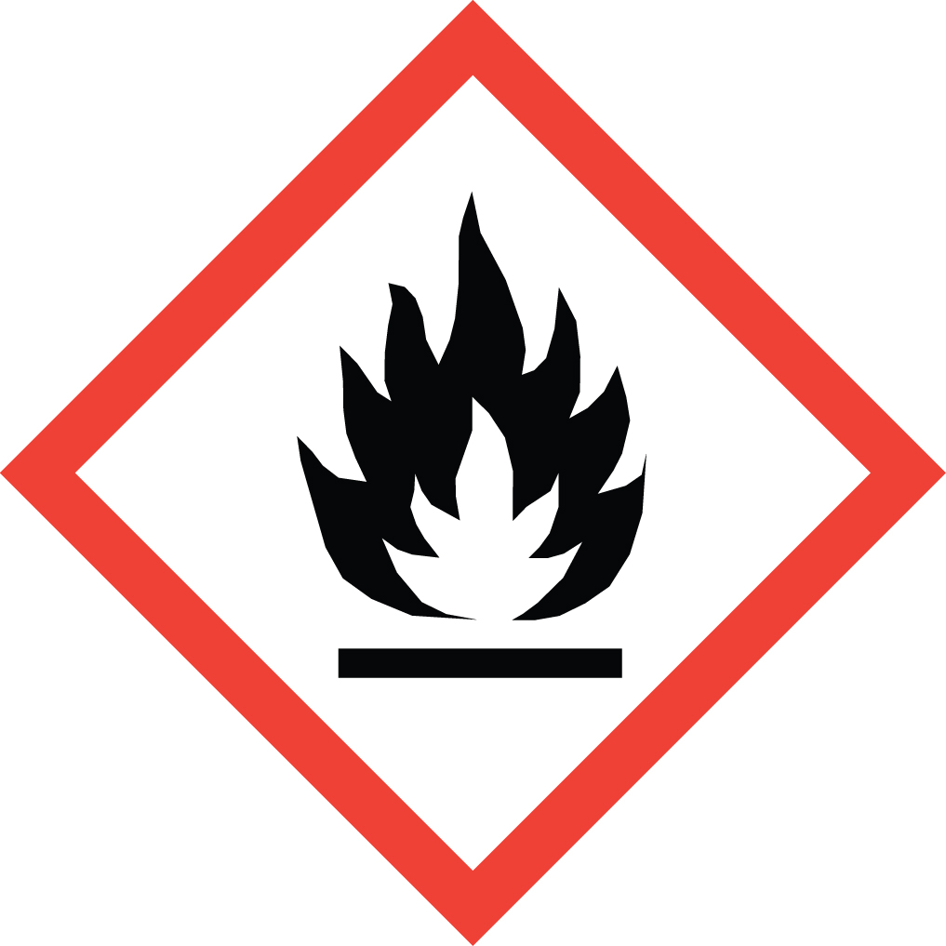Overview
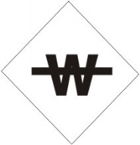
Pyrophoric: Defined by the National Fire Protection Agency (NFPA) as having an autoigintion temperature below 55 °C
Water Reactive: May react violently with aqueous solution s or atmospheric moisture to produce heat and flammable or toxic gases (e.g. H₂, CH₄).
Self-Heating: May react with air, in the absence of external energy, to produce heat. Typically also react violently with water (Water Reactive).
Fire is the predominant risk with these materials, and can occur without an ignition source. The risk is mitigated by handling these materials under an inert atmosphere such as nitrogen or argon gas. This requires sophisticated laboratory technique. All researchers handling these materials must receive thorough hands-on training.

Special Handling and Storage Concerns
Personal Protective Equipment
- Flame Resistant Lab Coat.
- Chloroprene gloves over flame-resistant glove liners if handling outside of a glove box.
- ANSI Z87.1-compliant safety glasses. Safety goggles if a large splash hazard is present.
Special Storage Requirements
Store in a flammable storage cabinet with self-closing hinges, or in a refrigerator rated for flammable storage. Store away from combustible materials, oxidizers, water sources, and aqueous solutions. Store only in fully sprinklered buildings.
Engineering Controls
Glove Box: Whenever possible, these materials should be handled inside of a glove box.
Fume Hood: A Schlenk line inside of a fume hood may be used to provide an inert atmosphere. These techniques are described in the Sigma-Aldrich Technical Bulletins 134 and 164. In addition to reviewing these documents, researchers must receive thorough hands-on training.
Handle these materials only in fully sprinklered buildings.
Special Handling Considerations
Quenching: Do not return unused pyrophoric materials to their original container. Unused pyrophoric materials must be quenched under inert atmosphere with adequate cooling by dropwise addition of isopropanol, then methanol, then water in that order.
Never work alone when handling these materials.
Decontamination
Do not use water! Consult the SDS of the material you are working with for detailed information.

Waste Management
If the material is quenched (see Special Handling Considerations above), then dispose of based on the requirements for the components of the resulting mixture. Unwanted material may also be disposed of as-is: label the container clearly, and contact EH&S for a prompt waste pickup.

First Aid and Emergencies
Spill and Fire
Within a Glove Box: quench the spilled material slowly with isopropanol, absorb with a non-combustible absorbent, and dispose of as hazardous waste.
Outside of a Glove Box: Pyrophoric material will likely catch fire under these conditions. A Class D fire extinguisher may be used to extinguish a small fire. A Class ABC extinguisher should be used if a significant amount of organic solvent as caught fire as well. If you do not feel comfortable using a fire extinguisher, call 911. If the material has not caught on fire, notify others in the area of the spill. Evacuate the location. Call 911. Remain on-site, at a safe distance, to provide information to first responders.
Personnel Exposure
Report any exposure to EH&S.
If an individual’s attire is on fire, guide them to the safety shower if it is in immediate proximity. If more than a few feet away, help the individual to stop, drop and roll, then guide them to the safety shower for further cooling and decontamination. It is also acceptable to use a fire extinguisher on a person. Get medical attention immediately.

Laboratory Specific Information
Prior Approval is Required for these Materials
NO
☒ YES (describe):

Designated Area
☐ Entire Laboratory Area
☐ Other (describe):

Experimental Conditions of Use
Temperature Range:

Pressure Range:

Scale Range:

Other Relevant Details:

