Standard Operating Procedure

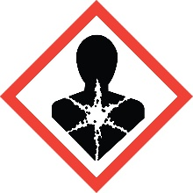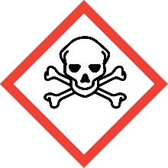

Ethidium Bromide

Overview
Ethidium bromide is acutely toxic. Although toxicity by ingestion is only moderate, toxicity by inhalation is quite high. It is also irritating to the eyes, skin and mucous membranes. Ethidium bromide has been shown to be strongly mutagenic in vitro. It should therefore be assumed to be a carcinogen and a reproductive toxin.

Special Handling and Storage Concerns
Personal Protective Equipment
- Traditional lab coat.
- Nitrile gloves. Use proper glove removal technique to ensure no skin contact.
- ANSI Z87.1-compliant safety glasses. Safety goggles if a large splash hazard is present.
Engineering Controls
Ethidium bromide is a significant inhalation hazards. If your protocol does not permit the handling of this material in a fume hood, contact EH&S for an assessment of alternate ventilation options.
Special Handling Considerations
Avoid forming dusts or aerosols. Handle solid form only in a fume hood to reduce inhalation risk. This includes the weighing process.
Decontamination
Deactivation with hypophosphorous acid solution is the most-effective means of decontamination. See Lunn, G. and Sansone, E.B. Appl Ind Hyg 1989, 4 (9), 234-237.

Waste Management
Gels, filters, and other solids containing ethidium bromide must be managed as a hazardous chemical waste and disposed of through EH&S. Charcoal filtration treatment is an effective way to remove ethidium bromide from electrophoresis buffers.

First Aid and Emergencies
Personnel Exposure
Skin or eye contact: Immediately remove contaminated clothing. Flush skin/eyes with water for at least 15 minutes. Get medical attention. Immediately.
Inhalation: Move person into fresh air. Get medical attention immediately.
Ingestion: Get medical attention immediately.

Laboratory Specific Information
Prior Approval Required
☐ NO
☐ YES (describe):

Designated Area
☐ Entire Laboratory Area
☐ Other (describe):

Experimental Conditions of Use
Temperature Range:

Pressure Range:

Scale Range:

Other Relevant Details:

