Standard Operating Procedure

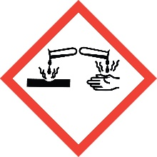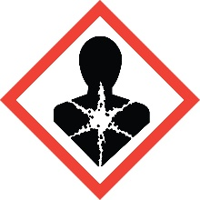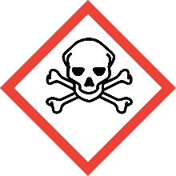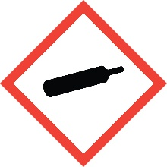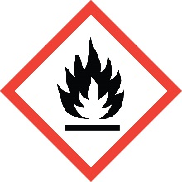

Ethylene Oxide

Overview
Ethylene oxide, or oxirane, is an extremely flammable gas at room temperature. Dissolved in water, it remains flammable at a concentration of 4% by volume, making it a serious explosion hazard if poured down the drain.
Ethylene oxide can self-polymerize violently upon exposure to heat, acid, or base. Violent reaction can occur with exposure to copper or its alloys, and rust. The heat of burning in a fire may cause the additional hazard of self-polymerization, resulting in explosion.
Ethylene oxide is classified as Category 1B carcinogen.
Ethylene oxide is acutely toxic if inhaled, causing a variety of symptoms up to and including headaches, nausea, edema of the lungs, paralysis, convulsions and death. Its odor threshold is > 200 ppm, while its permissible exposure limit is 1 ppm, therefore the sense of smell does not provide adequate protection against its toxic effects.
Ethylene oxide is corrosive to tissue. Symptoms may be delayed. Skin sensitization may also occur. Contact with liquid ethylene oxide can cause severe frostbite.

Special Handling and Storage Concerns
Personal Protective Equipment
- Flame Resistant Lab Coat
- Butyl rubber, Teflon or Silvershield gloves are recommended.
- ANSI Z87.1-compliant safety glasses for very small quantities. Safety goggles/face shield if any splash hazard is present.
- OSHA recommends against contact lens use when working with ethylene oxide.
Special Storage Requirements
Store at 2-8 °C. Incompatible with acids, alkaline salts, copper and rust.
Engineering Controls
All laboratory use must occur inside of a fume hood. This includes the container any plumbing being used to deliver the ethylene oxide into the reaction vessel.
Special Handling Considerations
This material has poor warning properties, as its odor threshold is more than 200 times higher than the permissible exposure limit. Great care must be taken to ensure that there is no leakage of the material into the laboratory.
Explosion-proof equipment and proper grounding and bonding should be used.
Keep away from flame.
Decontamination
Standard decontamination procedures apply. Use great caution in avoiding exposure.

Waste Management
Standard waste disposal procedures apply. Great care must be taken to ensure that any unreacted material is not released into the laboratory.

First Aid and Emergencies
Spill
Treat all spills of benzene as major spills. Do not attempt to clean up the spill yourself. Notify others in the area of the spill, including your supervisor. Evacuate the area and call 911. Remain on-site at a safe distance to provide detailed response to first responders. Report any exposures to EH&S.
Fire
Standard firefighting measures apply.
Personnel Exposure
Skin or eye contact: Remove contaminated attire. Flush affected area with water for 15 minutes. Get medical attention immediately.
Inhalation: Move person to fresh air. Get medical attention immediately.
Ingestion: DO NOT induce vomiting. Rinse mouth with water. Get medical attention immediately.

Laboratory Specific Information
Prior Approval Required
☐ NO
☐ YES (describe):

Designated Area
☐ Entire Laboratory Area
☐ Other (describe):

Experimental Conditions of Use
Temperature Range:

Pressure Range:

Scale Range:

Other Relevant Details:

