Standard Operating Procedure

Incidents Report Procedures

and Medical Assistance

Overview
An incident is an event that results in or causes injury or damage to someone or something, or an event that has the potential to result in or cause injury or damage. The University responds differently to different types of incidents.

Which Incidents Are Reportable?
ALL incidents must be reported.
Report Right Away | Report within 24 hours
- Fatality  - Inpatient hospitalization  - Loss of any body part (e.g., fingertip)  - Serious injury or illness (medical treatment beyond first aid) | - Any other types of incidents (examples below):  - Any other type of bodily injuries regardless of severity  - Needle stick injuries and cuts from sharp objects that are contaminated with another person's blood or other potentially infectious material  - Loss of consciousness  - Incidents which disrupt the normal work process  - Use of any safety equipment: emergency eyewash or shower, fire extinguisher, spill kits, first aid kits, satellite communicators (SOS button)  - Hazardous chemical exposure or spills  - Large hazardous chemical spills (more than 1 L )  - Fire  - Event during which property damage or disruption of facility operations occurred  - Near miss  - Behavioral problems, emotional unwellness, distress  - Any unsafe conditions, hazards.
To report:
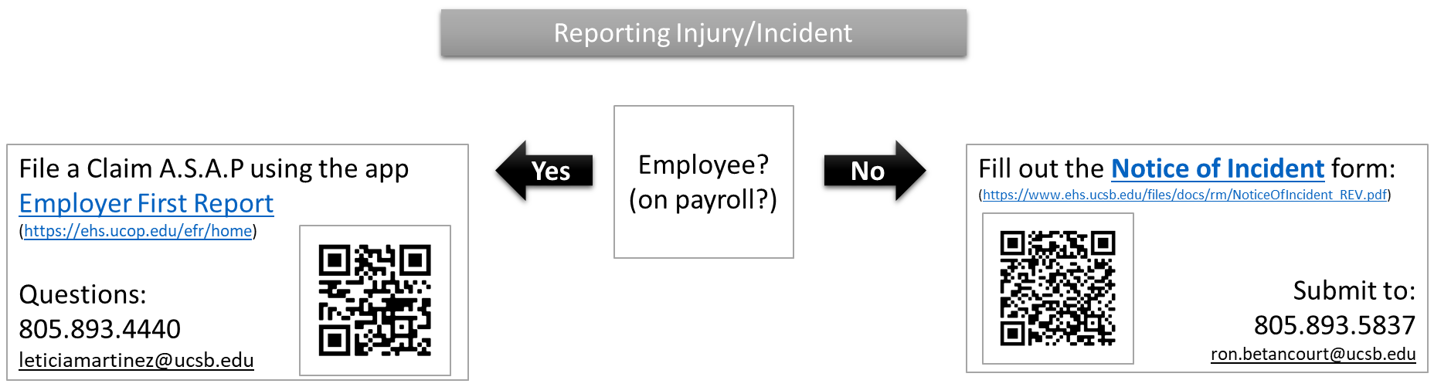

For Medical Assistance
