Approved Ergonomics Products – Laboratory Stools

Product | Item No. | Description/Features | Image | Price
Bodybilt 1757-F1 | J757 CRE | - seat depth adjuster (seat slider) 2.5” range  - adjustable backrest height and angle  - adjustable seat tilt and tension control  - 26” five-star base  - height-adjusting chrome footing  - 360-degree swivel  - hard floor casters | 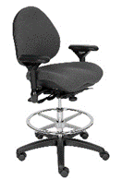 | Verify with the vendor for current UC pricing
Bodybilt  J707-B6 | J707-B6 | - mid-back stool designed for labs, medical  and manufacturing locations  - hydraulic base with fixed-height footing  - foot-activated seat height adjustment  - moderately contoured seat pan  - 10 ergonomic adjustments allow the user to  control their own comfort level | 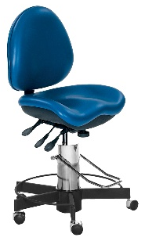 | Verify with the vendor for current UC pricing
ECD Lab Pro | 2300-B | - adjustable back height & angle  - contoured waterfall edge seat (reinforced)  - available in Memory or Molded foam  - multiple seat and back sizes  - three (3) cylinder heights & 2 stool kit  - heights fitting multiple users/applications |  | $332.27
Global  Malaga  Low Back Drafting Stool | 3141.3 | - infinite back angle adjustments  - adjustable seat back height  - seat and back adjust independently and lock  in any position  - tilt tension control  - teardrop adjustable arm rest option is  available  - double radius back with lumbar support | 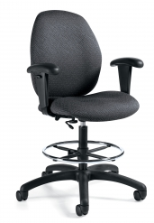 | $680.12
Global  Tye  1924-6  Low-Back | 1924.6 | - air-flow breathable mesh back  - tilt adjustments  - adjustable seat height  - adjustable seat depth  - provides ergonomic comfort and support  - available in vinyl or fabric | 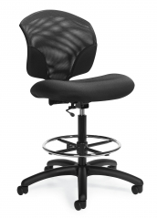 | $305.40
Office Master (Om)  Classic Lab Stool | CLS-61 | - pneumatic lift  - tilting backrest  - sliding seat pan  - adjustable back height  - variety of fabrics and colors  - available in Small/Petite build and  Average/Medium build sizes | 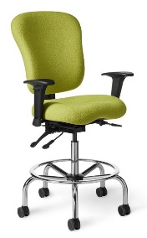 | $350.93
Office Master | DB54 | - backrest shape allows for full rearward  stretch  - ideal for working in frequent side-to-side  tasking  - designed specifically for laboratory, healthcare, and clean room and technical  applications  - various cylinder heights available | 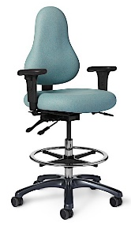 | $419.73
SitOnIt Seating Knack Stool | 3323 Y/e3 A80 FG1 C5 BO AB | - internal back height adjustment  - waterfall seat front promotes circulation  - durable fabric  - 300lb weight capacity  - lifetime warranty | 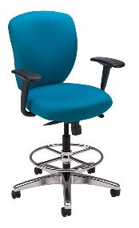 | $405.33
SitOnIt Seating  TR2 Stool | 40 B A43 FG1 C5 S1 BO AB | - multi-function swivel tilt  - waterfall seat front promotes circulation  - height-adjustable back provides lumbar  - support  - 300lb weight capacity  - multiple arm rest options available | 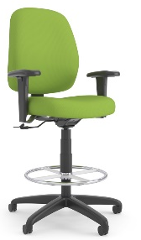 | $384.53
VWR Biofit-MVMT | 76263-552 | - comfortable with full ergonomic support and  functionality with no loss of adjustability or  stability at maximum seat height  able to withstand 3-shift usage 365 days per  year  - designed specifically for laboratory,  healthcare, and clean room and technical  applications  - engineered for easy, efficient, and effective  - cleanability  - LEED compliant  - meets industry standard ANSI-BIFMA X5.1  performance and safety standards | 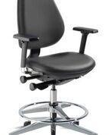 | $961.40*
Products Available  Through Gateway at UC Preferred Pricing |  | Please note: Prices, availability, supply chain issues and shipping delays may change without notice or price guarantees | Gateway Vendors: Global, Perfect Fit Ergo, Santa Barbara Office Interiors,VWR

