Approved Ergonomics Products – Sit to Stand Desks
Product | Item No. | Description/Features | Image | Price
Workrite Table  Sierra Single-level desk | Model # SEHX-4830-U (30” deep x 48” wide) | - desk with ELECTRIC adjustment Model # SEHX-4830-U (30” deep x 48” wide)  - Single-level rectangular table with 2-leg base • Desk height range 22” to 48” • Desk finish is Natural Maple top, Graphite edge and base | 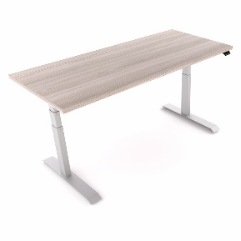 | Verify with the vendor for current UC pricing
Workrite Table  Fundamentals EX & LX  Electric Sit Stand Desk  The Price Fighter | EX & LX  Electric Sit Stand Desks | - the Price Fighters. European engineering and exceptional pricing make the Fundamentals series the right choice for anyone looking for limited budget sit-stand reliability. Two stage (LX) and three stage (EX) options provide additional pricing flexibility depending on your height range requirements. | 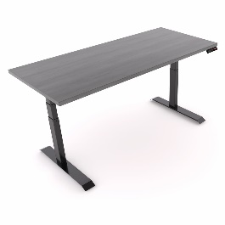 | Verify with the vendor for current UC pricing
AMQ  ACTIV Electric Sit to Stand desk | ACTIV  Options | - choose your way to get ACTIV, with multiple styles and options:  - standard push button handsets with 4 memory presets  - choose 2- or 3-stage legs with T or C foot style  - Linear, 90° and 120° work surfaces in 10 laminate colors  - two feet lengths support 24" and 30" deep work surfaces  - quiet motors with gyroscope/anti-collision technology  - complete workstations: privacy screens, monitor arms, cable management, storage and seating | 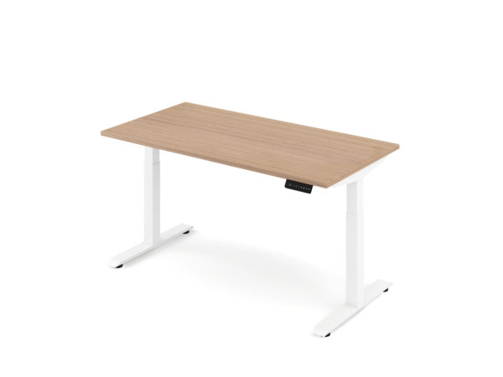 | Verify with the vendor for current UC pricing
Grandstands L3 with ELECTRIC adjustment L3-2L-(FOOT)-MEM-(COLOR) | L3  L3-2L-(FOOT)-MEM-(COLOR | - L3 is a three stage leg  - 25” of height adjustment (meets ANSI HFES)  - it comes standard with “Piezo" technology for impact detection  - no crossbar design, soft start/stop technology with no drift is the perfect retrofit base  - good for shared workstations with ease of Electric adjustment | 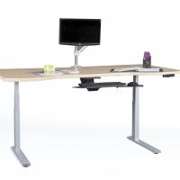 | Verify with the vendor for current UC pricing
Herman Miller  Sit to Stand Desk Renew | Renew | - Adjustable Desk Height of 27-46" or 22”-48  - cable management: Simple or Deluxe  - work surface weight limit: 180 pounds  - glides come with a 1/2" leveling rang | 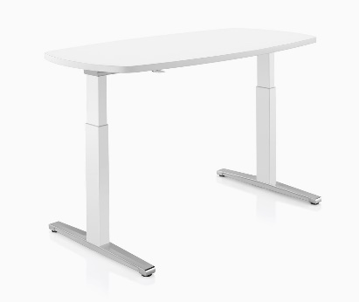 | Verify with the vendor for current UC pricing
Herman Miller  Motia Sit to Stand Desk | Motia | - extensive warranty to  - can handle up to 250 pounds.  - designed to integrate with any workplace  - minimal assembly required. | 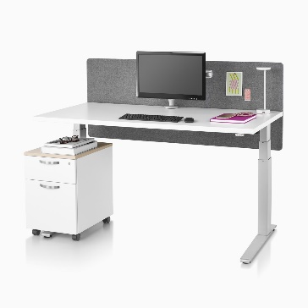 | Verify with the vendor for current UC pricing
Steelcase Ology | Ology | - 22.6″-48.7″  - Obstruction sensing technology  - Simple or Active Touch controls  - Free Rise mobile app allows you to connect to workstations via Bluetooth in order to track sitting and standing activity  - The soft edge embedded into the work surface provides support for wrists and forearms to reduce stress on the neck and shoulders.  - Optional antimicrobial treatment available | 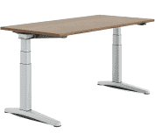 | Verify with the vendor for current UC pricing
Steelcase Migration SE | MigrationSE | - Migration SE meets BIFMA Ergonomic guidelines  - basic and Extended Height Ranges give the option to optimize for storage or BIFMA height range.  - obstruction Sensing Technology comes standard on Migration SE.  - when the desk comes into contact with an object the desk will backtrack to relieve the collision. | 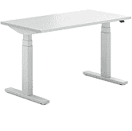 | Verify with the vendor for current UC pricing
Products Available  Through Gateway at UC Preferred Pricing |  | Please note: Prices, availability, supply chain issues and shipping delays may change without notice or price guarantees | Gateway Vendors: EC West Perfect Fit Ergo,  Santa Barbara Office Interiors,  Tangram Interiors ,and Tricounty Office Furniture

