Approved Ergonomics Products – Footrests and Accessories

Product | Item No. | Description | Image | Price
3M Adjust Footrest Model # E6FR330 | Model # E6FR330 | - 18" wide x 13" deep  - rocking mechanism -Rocking tension is adjustable but does not lock | 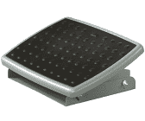 | $54.00
Mind Reader Adjustable Height & Tilt Foot Rest | Mind Reader Adjustable Footrest | - adjustable height to 3 positions  - made of steel  - non-slip feet enhances overall stability  - ergonomic design supports your legs at your preferred angle of tilt | 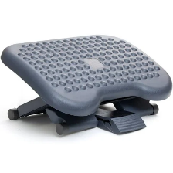 | $28.00
Steelcase | Footrest | - adjustable tilt mechanism that lets you adjust the incline your feet rest | 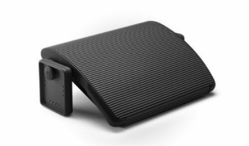 | Verify with vendor for UC pricing
Safeco Anti-fatigue mat | Model # 2110BL | - 1" of padding for standing comfort to help relieve the pain and fatigue that often accompanies standing  - comes complete with molded glides on the bottom of the mat which allows the user to grip the mat with their feet (without having to bend over), slides out of the way when not in use  - thick, yet pliable, allows it to easily fit into tight workspaces  - pairs well with standing desks or tables  - high heels should not be worn with this mat | 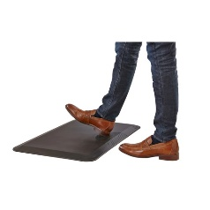 | $99.99
3M™ Privacy Filter Screen for Monitors, 23.8" Widescreen (16:9), Reduces Blue Light, PF238W9B | Item #627400 | - black out privacy from side views  - reversible between a glossy side and a glare-reducing matte side that helps reduce reflections and hide fingerprints  - Micro louver technology delivers effective "black out" privacy from side views outside the 60-degree viewing angle  - nearly 20% more clarity than standard 3M™ Black Privacy Filters  - easy to remove for collaboration, sharing or to clean as needed | 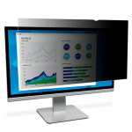 | $105.00
Nuance Dragon Professional Individual 15 for Windows (1 User) [Download] | Item #: 24295864|Model #: AVYPQ34NDCEGE6A | - next-generation speech recognition technology that continues to adapt to your voice even while you’re dictating  - create, format and edit by voice quickly and efficiently in the latest applications  - easily create custom words such as proper names and specific industry terminology  - create custom voice commands to insert frequently-used text and graphics  - use a Nuance-approved digital recorder to capture thoughts on the go for later automatic transcription  - Software Download, delivered electronically | 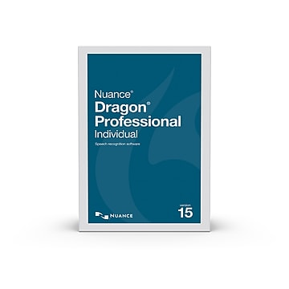 | Verify Price with vendor for UC pricing
Dragon for Mac speech recognition solutions | Nuance for Mac  Professional | - customization and mobility features. |  | Verify Price with vendor for UC pricing
Products Available  Through Gateway at UC Preferred Pricing |  | Please note: Prices, availability, supply chain issues and shipping delays may change without notice or price guarantees | Gateway Vendors: Amazon, CDW, Office Dapot, tSanta Barabara Office Interiors, Tangram and TriCounty Office Furniture

