Approved Ergonomics Products – Keyboards and Accessories

Product | Item No. | Description | Image | Price
Adesso Tru-Form Media 208 Media Contoured Keyboard | PCK-208B | - split key design encourages natural position and reduction of tension in hands, wrists, and forearms  - 8 programmable one-touch “hot keys”  - built-in wrist support and split space bar  - faster, quieter typing | 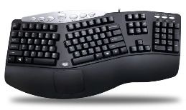 | $40.00
Evoluvent Essentials Full-Featured Compact Keyboard | EKB | - low profile reduces wrist strain  - 12 one-touch hotkeys  - no Fn keys necessary (all functions accessible with one key)  - tactile bumps facilitate touch typing | 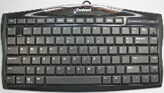 | $49.95
Evoluvent  Reduced Reach Right-Hand Keyboard | R3K | - reduced reach for a more relaxed arm position  - number pad on left side and navigation keys on right  - dedicated short-cut keys for one-touch access to frequently used functions without using any Fn keys | 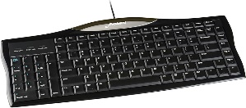 | $55.00
Goldtouch V2 Adjustable Comfort Keyboard for (PC/Mac | GTU-0088 | - 0”-30” of adjustments on horizontal and vertical planes  - straightens hands, wrists, shoulders and back  - fits nicely into limited spaces reducing shoulder abduction  - soft keys, low activation force  - increased tactile feel | 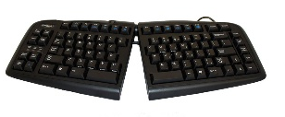 | $119.00
Goldtouch Go2 Mobile Keyboard PC/Mac | GTP-0044W | - highly portable – light, slim, easy to fold and carry  - Bluetooth technology auto syncs with all devices  - 0”-30” of adjustments on horizontal and vertical planes  - keyboard has multimedia key support for Windows and Mac |  | $139.00
Goldtouch Black Gel Filled Palm Supports - Black | 952785 | - Goldtouch Palm Supports provide a safe respite for the hands when not typing.  - Made from durable gel and smooth lycra.  - Goldtouch Palm Supports actively support each palm in alignment with the left and right sides of the keyboard while minimizing risk from contact stress | 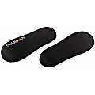 | $21.49
Goldtouch Numeric Keypad for PC | GTC-0077 | - ideal for right and left-hand users  - increases speed and comfort for users | 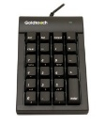 | $60.00
Goldtouch SlimLine Wrist Rest - Black | #872065 | - the Goldtouch SlimLine Wrist Rest provides a safe cushion for typists.  - smooth, stain-resistant Lycra cover  - works well with today's thinner full-sized and mini keyboards |  | $25.19
Goldtouch Go!2 Travel Laptop Stand Aluminum | GTLS-0055 | - works with laptop computers and tablets  - equally light, portable, and intuitive to use  - can accommodate notebooks with up to 17-inch  - Screen height adjustable to bring your laptop screen to eye level with six (6) incline positions  - comes with neoprene travel cover |  | $59.00
Microsoft Ergonomic Sculpt Wireless Desktop Keyboard and number pad | - L5V-00001,Black | - domed keyboard shape to reduce and correct excessive wrist pronation  - natural arc layout follows the curve of your fingertips  - reverse-tilt design positions the keyboard at the correct angle to give you a neutral wrist position | 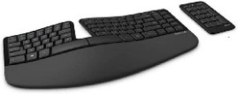 | $110.95
Logitech ERGO K860 Wireless Ergonomic Keyboard - Split Keyboard, Wrist Rest, Natural Typing, Stain-Resistant Fabric | 6684266  K860 | - reduces wrist bending by 25% and offers 54% more wrist support.  - curved, split keyframe  - pillowed wrist rest  - adjustable palm lift feature keeps your wrists in a natural posture, whether you're seated or standing | 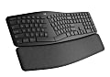 | $130.00
Logitech Wireless Wave Keyboard | PN:920-00255 | - wave shape supports actual varied finger lengths  - adjustable keyboard height  - programmable F keys  - cushioned, contoured palm rest  - wireless with 3-year battery life | 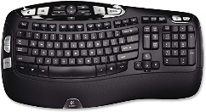 | $59.99
Kinesis Freestyle Pro Split adjustable Keyboard for PC | 989638 | - adjustable splay, 9” or 20” for multiple body types  - has Microsoft Office Hotkeys (8) and media keys  - low-force membrane switches with tactile feedback | 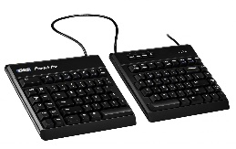 | $109.00
Kinesis VIP 3 Accessory kit with Palm Supports | 981988 | - provides multiple tent settings (5/10/15 degrees)  - includes palm supports  - easy to assemble and operate | 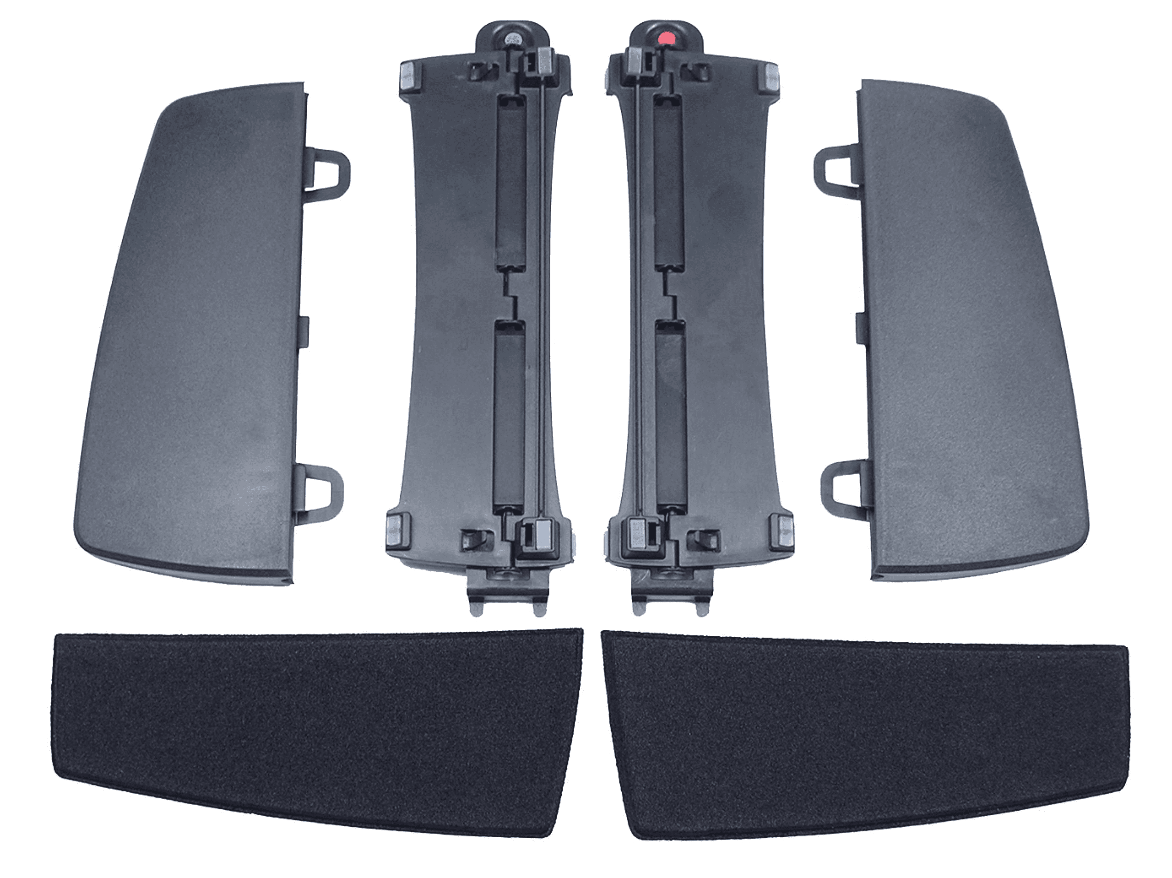 | $54.00
Products Available  Through Gateway at UC Preferred Pricing |  | Please note: Prices, availability, supply chain issues and shipping delays may change without notice or price guarantees | Gateway Vendors: Amazon, CDW, Office Depot, and Office Releif

