Approved Ergonomics Products – Task Chairs

Product | Item No. | Description/Features | Image | Price
All Seating  U Task Chair  Available from Santa Barbara Office Interiors | 84112-4D | - innovative back suspension  - deluxe synchro back tilt mechanism  - back and task arm-height adjustment  - TVO base with 65mm casters  - Video url: https://youtu.be/Vl9YO95Oa-4 | 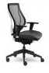 | $599  verify price with the vender for U/C pricing
ergo Centric  tCentric Hybrid  Available from Perfect Fit Ergo | Hybrid – Mesh Back & Upholstered Seat | - the tCentric Hybrid with Airless Cushion Technology™ combines the best attributes of the leading mesh chair with the industry leading benefits of ergoCentric’s fully ergonomic upholstered chairs. | 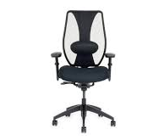 | $600  verify price with the vender for U/C pricing
Bodybilt 2600  Available from Perfect Fit Ergo | 2600 Task Chair | - High back mesh chair  - moderately contoured seat  - seat height range of 18.5” to 24” (standard)  - short cylinder available 16.25”-19”  - height and pivot adjustable armrests  - independent back angle adjustment  - seat slider  - multiple options in lumbar support  - rocking chair style (rock) mechanism w/tension control  - other customizations available. | 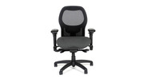 | verify price with the vender for U/C pricing
QT ECD  Task Chair  Available from Santa Barbara Office Interiors | QT Series-2900  Task Chair | - QT  - ECD’s QT Series adjusts fully to support both task and Conference Room assignments. Highly engineered features for seat depth adjustment, back tilt, back angle, seat height, and adjustable lumbar support and height adjustable arms are incorporated into a clean, contemporary Mesh Back design. When you consider comfort, quality and value, QT series provides a smart solution. | 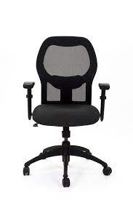 | verify price with the vender for U/C pricing
ECD Quest  Task Chair  Available from Santa Barbara Office Furniture | 2506JSLPXT | - pneumatic seat height adjustment  - ratchet back height adjustment  - adjustable seat depth (seat slider)  - thoracic back foam  - multiple arm options  - mid density, molded, or memory foam seat  - Video: https://youtu.be/y1aTKESLm8I | 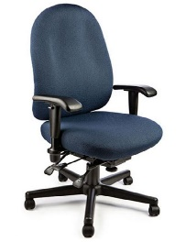 | $600  verify price with the vender for U/C pricing
ECD Vive  Task Chair  Available from Santa Barbara Office Furniture | 1309JSXTFA | - independent seat and backrest adjustment  - adjustable seat depth  - available with four-way adjustable arms  - thoracic back foam with lumbar support  - contoured waterfall edge seat (reinforced)  - available in Memory or Molded foam  - multiple seat and back sizes to meet the needs of the 1st-99th percentile of users  - available in three (3) cylinder heights | 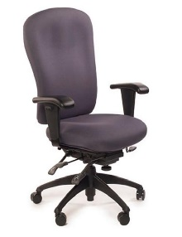 | $580  verify price with the vender for U/C pricing
Herman Miller  Embody Chair  Available from TriCounty Office Furniture | Embody  CN122AWAG1GC73SY12 | - back fit adjustment to fine-tune the chair to your spine.  - arrow tapered design of the back allows for freer movement.  - pixelated Support conforms to your micromovements and  - eliminates pressure buildup.  - four breathable layers in the  - seat for cushioned comfort and enhanced airflow.  - a smooth tilt mimics your natural pivot points for better balance and comfort. | 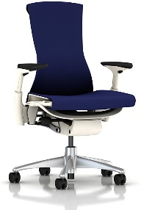 | $971  verify price with the vender for U/C pricing
Herman Miller Aeron “A” Chair  Available from TriCounty Office Furniture | Aeron size A chair | - “A” size fits small size /slender built people up to 130 pounds  - posture Fit Support for active sitting  - seat height range 14.5" to 19.5”  - height and pivot adjust armrests at 16”  - OC armrest breadth  - no seat slider or independent back height  - adjust lumbar support is best for relaxed sitting  - substitute AJ versus PJ for adjustable lumbar pad  - available as a stool | 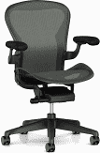 | verify price with the vender for U/C pricing
Herman Miller Aeron “B” Chair  Available from TriCounty Office Furniture | Aeron size B chair | - “B” size fits most average size people from 130 to 230 pounds  - posture fit support for active sitting  - seat height range 15" to 21"  - 3" casters can get to 22" seat height  - height and pivot adjust armrests at 16”  - OC armrest breadth  - no seat slider or independent back height  - adjust lumbar support is best for relaxed sitting  - substitute AJ versus PJ for adjustable lumbar pad  - available as a stool |  | verify price with the vender for U/C pricing
Herman Miller Aeron “C”  Available from TriCounty Office Furniture | Aeron size C chair | - “C” size fits large size/heavy build people  - from 230 to 300 pounds  - posture fit support for active sitting  - seat height range 15" to 21" 3" casters can get to 22" seat height  - height and pivot adjust armrests at 16”  - OC armrest breadth  - no seat slider or independent back height. |  | verify price with the vender for U/C pricing
Herman Miller Mirra 2  Available from Tri-County Furniture | Mirra 2 | - Mirra 2  - high back mesh  - good for medium to larger frames  - dynamic support: A completely reinvented Harmonic tilt provides balanced support when you switch positions | 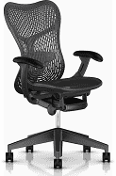 | verify price with the vender for U/C pricing
Office Master  Yes Series  Chair  Available from Santa Barbara Office Interiors | Ys88 | - pneumatic lift  - ez back height adjustment  - tilting backrest  - rocking tilt  - tension knob  - mesh back (high)  - seat depth adjustment  - infinite forward tilting | 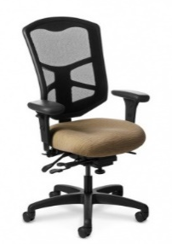 | $550  verify price with the vender for U/C pricing
Office Master  Truly  Available from Santa Barbara Office Interiors | Truly TY-628 | - full multi-function  - independent back & seat angle  - forward tilt  - tilt tension knob  - seat depth | 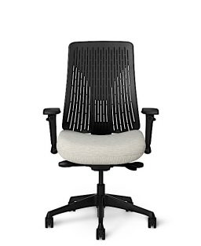 | verify price with the vender for U/C pricing
Sitmatic  Good fit Chair  Available from Tri-County Office Furniture | 163PB-SSt1A/44001 | - complete back support thoracic and sacral cradles merge into a lumbar crest cast.  - pressure cast foam cushions are used rather than cut foam to ensure seating comfort  - intuitive quick back allows you to move the backrest through an unprecedented 6" range in 27 increments  - fingertip control positions the lumbar bolster exactly where you need it. | 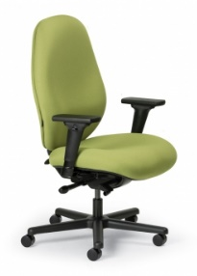 | $600  verify price with the vender for U/C pricing
Steelcase  Amia  Available from Tangram Interiors | Amia | - one size chair with full complement of features to fit most (small-large)  - seat height range 16” to 21”  - height, pivot, and width adjustable arm rests  - seat slider  - height adjustable lumbar  - other options avail | 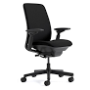 | verify price with the vender for U/C pricing
Steelcase  Leap  Available from Tangram Interiors | Leap | - one size chair with full complement of adjustments to fit most people up to 275 pounds  - seat height range 15.5” to 20.5”  - height, pivot, and width adjustable arm rests  - seat slider  - passive forward seat slope  - lumbar height and firmness control  - available as a stool  - other options available | 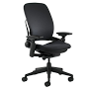 | verify price with the vender for U/C pricing
Steelcase  Gesture  Available from Tangram Interiors | Gesture | - seat moves as a synchronized system moving with each user to provide continuous and persistent support  - the back cradles the user no matter the posture or device  - users can adjust the Gesture chair as easily as adjusting their posture. Fellowes® Professional Series Back Support  - lower lumbar support with memory foam | 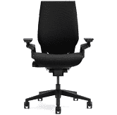 | *verify price with the vender for U/C pricing
Products Available through Gateway at UC pricing | Please note: Prices, availability, supply chain issues and shipping delays may change without notice or price guarantees |  | Gateway Vendors: EC West, Office Relief, Perfect Fit Ergonomics, Santa Barbara Office Interiors, Tangram and Tri-County Office Furniture

