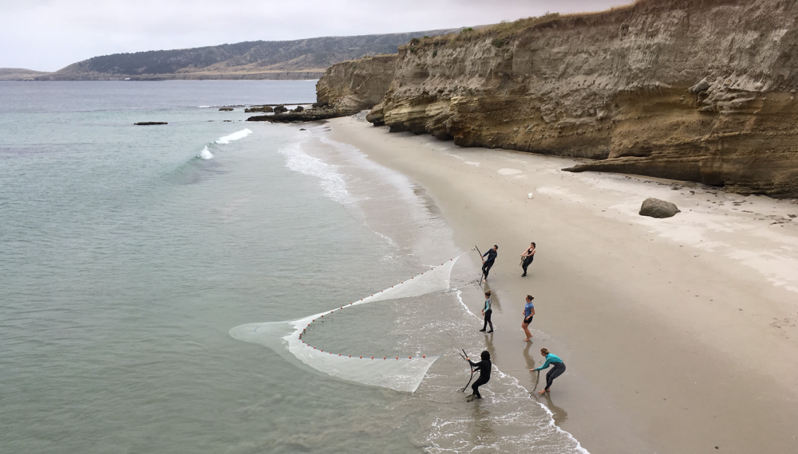
Crisis Management Plan
FIELD OPERATIONS

The following outline is adapted from the crisis management protocol used by NOLS (National Outdoor Leadership School).
It is intended to provide a management framework for campus and departmental response.

CRISIS RESPONSE FLOWCHART AND CHECKLIST:

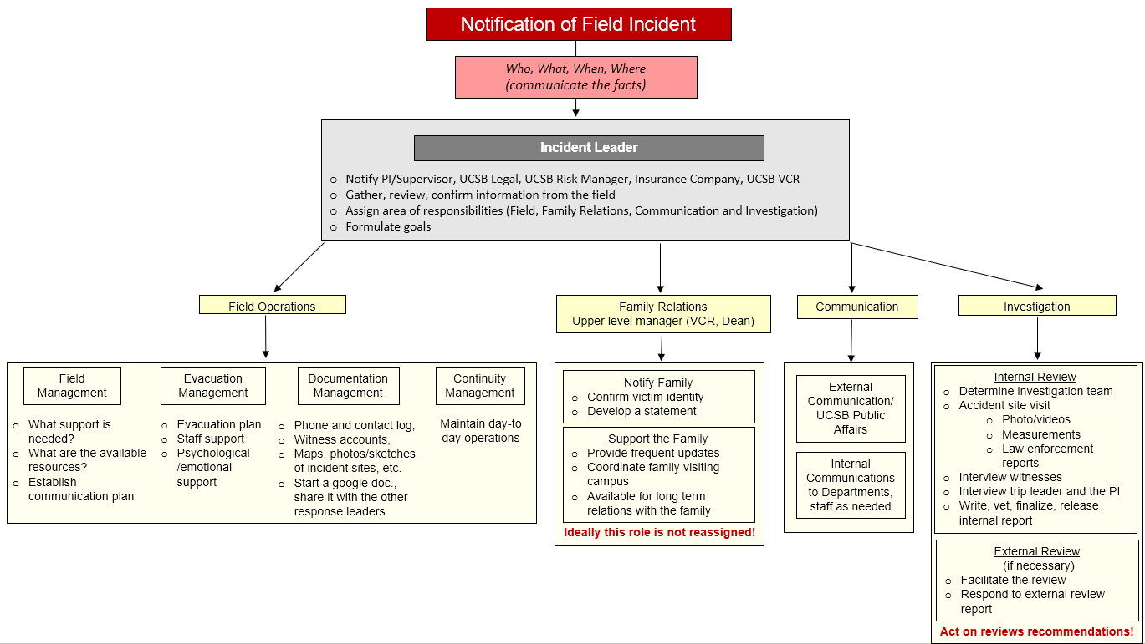
BEFORE THE FIELD:
Customize the table entries with phone numbers for the Principal Investigator, Department Chair or MSO, and back up contacts.
IN THE FIELD:
A crisis in the field is a serious incident:
- Fatality
- Serious injury (threat to life or limb)
- Serious illness (threat to life)
- Major environmental or political disturbance (flood, fire, earthquake, terrorism, etc.)
During a crisis in the field contact:
Role | Main Contact | Secondary Contact | Back up
Principal Investigator
Department Chair or MSO
EH&S Director | Tim Fitzpatrick 805-893-2040 | Alex Moretto 805-893-4899 | EH&S tech line: 805-893-3194
UC Travel Insurance | 24/7 numbers:  1-800-527-0218 (US)  1-410-453-6300 (outside US call collect) | 1-866-451-7606 (From U.S. and Canada)  1-410-453-6330 (From outside the U.S.) | UCSB Risk Analyst: Ron Betancourt 805-893-5837

In case of crisis, initiate first aid response and emergency procedures. Start with the main contacts and leave a message if there is no answer. Continue on to secondary and back up contacts until contact is made. Report:
- Who
- What
- When
- Where
The report should be concise and factual.

ON CAMPUS:
Once notification of a crisis in the field comes in, initiate a response within the first hours following the flow chart and checklist on page 2.
Incident Leaders:  EH&S Director  EH&S Research Safety Manager  Department Chair and/or Chair of appropriate committee | Family Relations Leader:  Vice Chancellor of Research  College Dean
Field Operations Leader:  Lab Manager:  Dive and Boat Safety Officer Eric Hessel 805-451-5099  Field Safety Coordinator Jamie Bishop 805-403-4874 | Communication Leader:  Department MSO  Office of Research
Important phone numbers:
Role | Main Contact | Secondary Contact | Back up
EH&S Director | Tim Fitzpatrick 805-893-2040 | Alex Moretto 805-893-4899 | EH&S tech line: 805-893-3194
EH&S Risk Manager | Tim Fitzpatrick 805-893-2040 | Ron Betancourt 805-893-5837 | Elena Grozeva 805-893-2029
EH&S Field Safety Officer | Jamie Bishop 805-893-8894 | Alex Moretto 805-893-4899 | Hector Acuna 805-893-8243
EH&S Dive Safety Officer | Eric Hessel 805-451-5099 | Jamie Bishop 805-893-8894 | Alex Moretto 805-893-4899
Family Relations | Joe Incandela will be notified by the Incident Commander |  | Cognizant Dean
Chief Campus Counsel (Legal) | Nancy G. Hamill 805-893-3459 | Kelly Drumm 510-987-9765 | Norman Hamill 510-987-9746
Public Affairs | Andrea Estrada 805 893-4620 | Alex Parraga 805-893-3028 | John Longbrake 805-893-2191
Clery Notification Coordinator | Jessica Fougere 805-893-2324 | Matt Bowman 805-729-3288 | UCSB Police 805-893-3446  (request on duty Lieutenant to call back)
UC Travel Insurance | 24/7 numbers:  1-800-527-0218 (US)  1-410-453-6300 (outside US call collect) | 1-410-453-6330 (Outside the U.S.)  1-866-451-7606 (U.S. and Canada) | UCSB Risk Manager:  805-893-4169
UCSB Police | 805-893-3446
CAPS (Counseling & Psychological Services 24/7) 805-893-4411 |  | Academic & Staff Assistance Program 805-893-3318
Title IX | 805-893-2701
Student Health | 24hr Nurse line: 800-539-1387 | Vejas Skripkus, (858) 829-2552 | Edwin Feliciano (805) 8838147

