RESEARCH RAMP-UP GENERAL LAB SAFETY CHECKLIST

Complete a walk trough of the lab and check for obvious hazards or problems.
Ensure lab safety equipment is operating or available (emergency showers and eye wash, fire extinguishers, first aid and spill kits).
Ensure that water, house gasses and other house services are properly functioning.
Review emergency procedures with team members (assembly points, lab safety equipment, etc.).
Ensure engineering controls such as chemical fume hoods, biosafety cabinets, glove boxes, etc. are properly operating. Fume hoods and biosafety cabinets must be certified.
Make sure all administrative controls are in place (Assessment (LHAT) and the CHP are up-to-date, everyone has taken the required safety training, TNA form is completed for each team member).
Evaluate PPE, soap, and hand sanitizer, cleaning materials and paper towels on hand. Consider what needs to be ordered. Plan ahead.
Inspect chemical storage (cabinets, fridges) for expired or leaking containers. Test peroxide forming chemicals before use. Submit a pick-up request for any hazardous waste older than 9 months.
Inspect all compress gas cylinders. Review start-up procedures for compress gas cylinder use systems.
Check in with support facilities (e.g. vivarium, clean rooms, microscopy facility, etc.) regarding scheduling, restrictions and their specific COVID-19 safety plans.
Check with shipping and receiving for your department to understand if new delivery policies are in place.
Radiation Safety: 1. Account for all radioactive materials (RAM); contact EH&S in case of missing RAM. 2. Ensure your survey instruments are calibrated, if applicable. 3. Complete as soon as possible any overdue required lab radiation and contamination surveys.

PHYSICAL DISTANCING

Distancing requirements are discussed in details in Guidelines for Establishing Safe Research Practices by Office of Research. It is important to remember that PIs are encouraged to clarify the new norms and behavioral expectations following these guidelines. Educate all lab members so they understand that it is completely acceptable to ask/tell other people politely to step back a few steps if the required physical distance is not maintained. Remember to wear face coverings at all times while on campus.

Lab Space Planning:

- Review the layout of benches, workstations, and devices within the lab.
- Consider changing work processes, e.g. assign specific tasks to the same person to minimize the use of shared equipment such as confocal microscopy, cell culture, etc.
- Designate foot-traffic lanes, including the lab entrance region, access to the sink, etc. Use one-way traffic patterns between benches wherever possible.
- Designate specific workstations on lab benches, making sure that only 1 person occupies 250 sq.ft; researchers should not be facing each other on work benches. Ideally, every researcher has their own, separate bench or create staggered workspace in a zigzag pattern.
- Remove or label chairs to ensure separation between researchers where they stand or sit at the workbench (see pictures below).
- Mark work stations using gaffer’s tape on counter or floor. Examples are shown in the pictures below.
- Designate no-occupancy or limited–occupancy areas. Post signage indicating the occupancy levels in appropriate locations.
- Post signs in the lab reminding researchers to maintain a safe distance and regularly wash their hands.
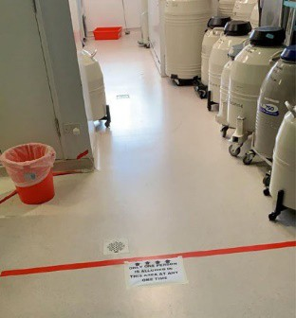
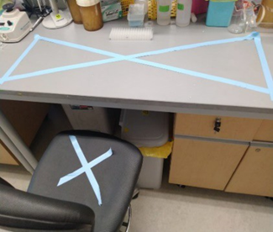
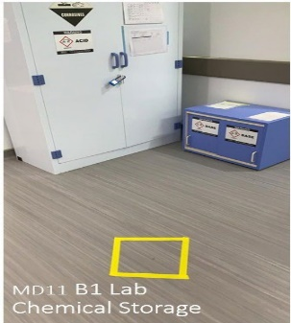
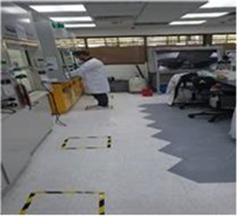
Labels for out-of-bound
bench area and a chair

Floor Labels showing work stations

Floor Labels showing waiting area for shared equipment

Floor label indicating a constricted space that others should not enter if someone is inside

Scheduling:

Schedule staggered access to shared instruments, microscopes, etc. to reduce overlaps.
Work in Shifts. Consider having the same team members work together to make tracking easier should one of them become COVID-19 positive.
Have a mean of communication with all group members. It will be important to be able to notify everyone of general lab space usage as well as shared equipment. Options include an online calendar, Slack, etc. In the online communication, specify shift schedules for individual researchers, so that a maximum level of physical distancing can be maintained and overlap/waiting is minimized. See examples below.
When designing a work plan, keep in mind the following: If an individual tests positive for COVID-19 virus, follow medical care consultation and quarantine for up to 14 days. A possible solution could be to form distinct “teams” which would work on alternate days or alternate shifts with no temporal overlap. Using this strategy, a whole lab might not necessarily have to go out of commission all at once (details would need to be discussed and determined with the Building Committee assigned to your lab location. (Please check with your department for contact information.)

Option 1
Option 2
Option 3

Day # | T1 | T2 | No Use
1
2
3
4
5
6
7
8
9
10
11
12
13
14
Day # | T1 | T2 | T3
1a
1b
1c
2a
2b
2c
3a
3b
3c
4a
4b
4c

T1 = Team 1; T2 = Team 2; T3 = Team 3
Day # | T1 | T2 | T3
1
2
3
4
5
6
7
8
9
10
11
12
13 | X | X | X
14 | X | X | X

Example work schedules for lab groups with two or three teams of researchers.
In Option 1, each team works 4 days on and 8 days off with 2 days between groups of the lab being empty.
In Option 2, each team works a portion of every day in the lab, e.g. 4-hour shifts.
In Option 3, each team works in 4-day increments, with the following 10 days off. The lab will be empty days 13 and 14 of any cycle.
These options are only suggestions. Every PI needs to determine the best schedule for their lab and researchers.

